1 A retailer advertises that items will be discounted by 10% every Monday until they are sold. In how many weeks will an item costing $50 first be sold for under half price?
1) | 7
2) | 6
3) | 5
4) | 4

2 The amount A, in milligrams, of a 10-milligram dose of a drug remaining in the body after t hours is given by the formula . Find, to the nearest tenth of an hour, how long it takes for half of the drug dose to be left in the body.

3 Depreciation (the decline in cash value) on a car can be determined by the formula , where V is the value of the car after t years, C is the original cost, and r is the rate of depreciation. If a car’s cost, when new, is $15,000, the rate of depreciation is 30%, and the value of the car now is $3,000, how old is the car to the nearest tenth of a year?

4 The current population of Little Pond, New York, is 20,000. The population is decreasing, as represented by the formula , where population, , in years, and population. What will the population be 3 years from now? Round your answer to the nearest hundred people. To the nearest tenth of a year, how many years will it take for the population to reach half the present population? [The use of the grid is optional.]



5 Megan is performing an experiment in a lab where the air temperature is a constant 73ºF and the liquid is 237ºF. One and a half hours later, the temperature of the liquid is 112ºF. Newton's law of cooling states where:
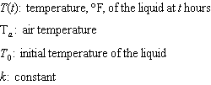
Determine the value of k, to the nearest thousandth, for this liquid. Determine the temperature of the liquid using your value for k, to the nearest degree, after two and a half hours. Megan needs the temperature of the liquid to be 80ºF to perform the next step in her experiment. Use your value for k to determine, to the nearest tenth of an hour, how much time she must wait since she first began the experiment.

6 Objects cool at different rates based on the formula below.
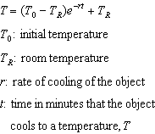
Mark makes T-shirts using a hot press to transfer designs to the shirts. He removes a shirt from a press that heats the shirt to 400°F. The rate of cooling for the shirt is 0.0735 and the room temperature is 75°F. Using this information, write an equation for the temperature of the shirt, T, after t minutes. Use the equation to find the temperature of the shirt, to the nearest degree, after five minutes. At the same time, Mark's friend Jeanine removes a hoodie from a press that heats the hoodie to 450°F. After eight minutes, the hoodie measured 270°F. The room temperature is still 75°F. Determine the rate of cooling of the hoodie, to the nearest ten thousandth. The T-shirt and hoodie were removed at the same time. Determine when the temperature will be the same, to the nearest minute.
1 ANS: 1
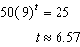

REF: 082317aii

2 ANS:
3.1. Half the dose is left, 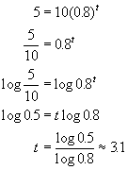. 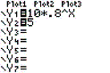. 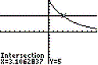

REF: 080132b

3 ANS:
4.5. 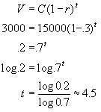. 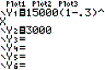. 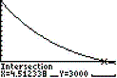

REF: 010230b

4 ANS:
16,600, 11.3. . Half of Little Pond’s present population is 10,000. 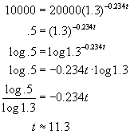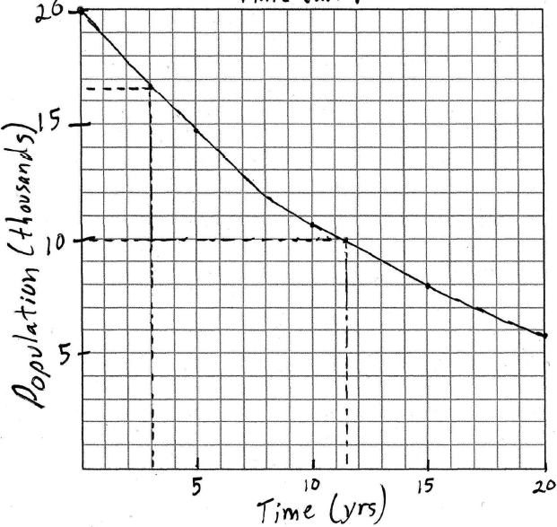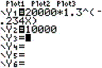 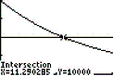

REF: 010632b

5 ANS:
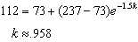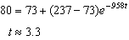

REF: 062437aii

6 ANS:
, , 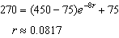, 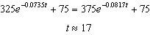

REF: 012337aii

