1 In a molecule of water, there are two atoms of hydrogen and one atom of oxygen. How many atoms of hydrogen are in 28 molecules of water?
1) | 14
2) | 29
3) | 42
4) | 56

2 A cake recipe calls for 1.5 cups of milk and 3 cups of flour. Seth made a mistake and used 5 cups of flour. How many cups of milk should he use to keep the proportions correct?
1) | 1.75
2) | 2
3) | 2.25
4) | 2.5

3 The number of calories burned while jogging varies directly with the number of minutes spent jogging. If George burns 150 calories by jogging for 20 minutes, how many calories does he burn by jogging for 30 minutes?
1) | 100
2) | 180
3) | 200
4) | 225

4 If a machine that prints designs on T-shirts prints 500 shirts in 3 hours, how many hours will it take to print designs on 1,800 shirts?
1) | 6
2) | 9.8
3) | 10.8
4) | 12

5 The amount of money spent at a parking meter varies directly with the amount of time spent parked in the parking space. Noah spent $1.50 to park 90 minutes. How many minutes can he park for $4.00?
1) | 667
2) | 360
3) | 240
4) | 135

6 Jordan and Missy are standing together in the schoolyard. Jordan, who is 6 feet tall, casts a shadow that is 54 inches long. At the same time, Missy casts a shadow that is 45 inches long. How tall is Missy?
1) | 38 in
2) | 86.4 in
3) | 5 ft
4) | 5 ft 6 in

7 On a map, 1 centimeter represents 40 kilometers. How many kilometers are represented by 8 centimeters?
1) | 5
2) | 48
3) | 280
4) | 320

8 On a map, 1 inch represents 3 miles. How many miles long is a road that is inches long on the map?
1)
2)
3)
4)

9 The perimeter of an equilateral triangle varies directly as the length of a side. When the length of a side is doubled, the perimeter of the triangle is
1) | halved
2) | doubled
3) | multiplied by 3
4) | divided by 3

10 Granola bars cost $0.55 each. Which table represents this relationship?
1) | 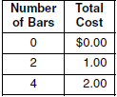
2) | 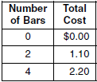
3) | 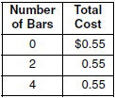
4) | 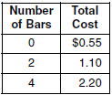

11 Which table does not show an example of direct variation?
1) | 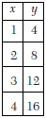
2) | 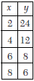
3) | 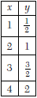
4) | 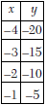

12 If x varies directly as y, and when , what is the value of x when ?
1) | 1
2) | 2
3) | 3
4) | 4

13 Which equation represents the direct variation relationship of the equation 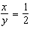?
1) | 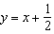
2)
3)
4)

14 If the instructions for cooking a turkey state “Roast turkey at 325° for 20 minutes per pound,” how many hours will it take to roast a 20-pound turkey at 325°?

15 Julio’s wages vary directly as the number of hours that he works. If his wages for 5 hours are $29.75, how much will he earn for 30 hours?

16 If a girl 1.2 meters tall casts a shadow 2 meters long, how many meters tall is a tree that casts a shadow 75 meters long at the same time?

17 A 12-foot tree casts a 16-foot shadow. How many feet tall is a nearby tree that casts a 20-foot shadow at the same time?

18 An image of a building in a photograph is 6 centimeters wide and 11 centimeters tall. If the image is similar to the actual building and the actual building is 174 meters wide, how tall is the actual building, in meters?

19 Fran’s favorite photograph has a length of 6 inches and a width of 4 inches. She wants to have it made into a poster with dimensions that are similar to those of the photograph. She determined that the poster should have a length of 24 inches. How many inches wide will the poster be?

1 ANS: 4
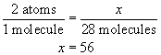
REF: 010117a

2 ANS: 4
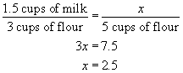
REF: 060505a

3 ANS: 4
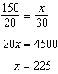
REF: 081101ia

4 ANS: 3
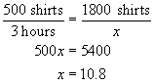
REF: 080809a

5 ANS: 3
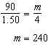
REF: 061602ia

6 ANS: 3
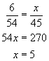
REF: 080603a

7 ANS: 4
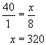
REF: 080201a

8 ANS: 4
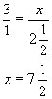
REF: 010818a

9 ANS: 2 REF: 080101a

10 ANS: 2 REF: 010902a

11 ANS: 2
In (1), (3) and (4), the quotient of y and x remains constant at 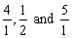. In (2) , the product of y and x remains constant at 48.
REF: 080005a

12 ANS: 2
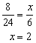
REF: 010806a

13 ANS: 2 REF: 010708a

14 ANS:
. 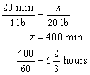
REF: 060223a

15 ANS:
$178.50. 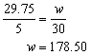
REF: 010431a

16 ANS:
45. 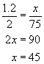
REF: 060124a

17 ANS:
15. 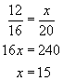
REF: 010222a

18 ANS:
319. 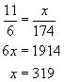
REF: 080223a

19 ANS:
16. 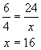
REF: 010532a

