1 Simplify: 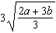

2 Simplify: 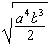

3 Simplify:

4 Simplify: 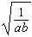

5 Simplify:

6 For all values for which the function is defined, the expression 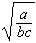 is equivalent to
1) 2) 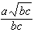 3) 4) 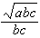

7 Simplify: 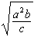

8 Simplify: 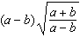

9 Simplify: 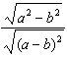

10 The fraction 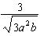 is equivalent to
1) 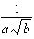 2) 3) 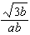 4)

11 The expression 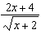 is equivalent to
1) 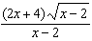 2) 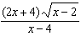 3) 4)

12 The expression 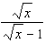 is equivalent to
1) 2) 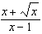 3) 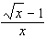 4)

13 Expressed with a rational denominator and in simplest form, 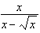 is
1) 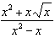 2) 3) 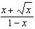 4)

14 Simplify: 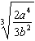

15 Simplify: 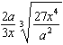

16 Simplify: 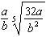

17 Simplify: 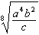

18 Simplify: 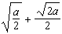

19 Simplify: 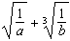

20 Simplify: 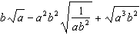

21 Simplify: 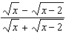
1 ANS:
REF: 089312al

2 ANS:
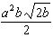
REF: 019415al

3 ANS:
REF: 039413al

4 ANS:
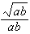
REF: 039505al

5 ANS:
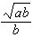
REF: 119411al

6 ANS: 4
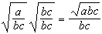
REF: 081610a2

7 ANS:
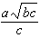
REF: 019615al

8 ANS:
REF: 099414al

9 ANS:
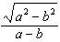
REF: 060012al

10 ANS: 3
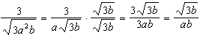
REF: 081019a2

11 ANS: 4
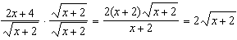
REF: 011122a2

12 ANS: 2 REF: 080221siii

13 ANS: 4
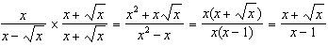
REF: 061325a2

14 ANS:
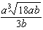
REF: 099602al

15 ANS:
REF: 019811al

16 ANS:
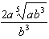
REF: 039807al

17 ANS:
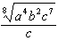
REF: 099911al

18 ANS:
REF: 119411al

19 ANS:
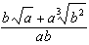
REF: 089710al

20 ANS:
REF: 060505al

21 ANS:
REF: 030504al

