1 Simplify: 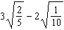

2 Simplify: 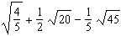

3 Simplify: 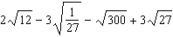

4 Simplify: 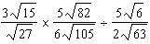

5 Simplify: 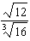

6 Simplify: 

7 Simplify: 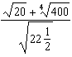

8 Simplify: 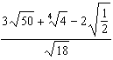

9 Simplify: 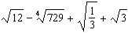

10 Simplify: 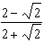

11 Simplify: 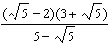
1 ANS:
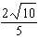
REF: 089710al

2 ANS:
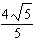
REF: 090404al

3 ANS:
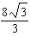
REF: 010511al

4 ANS:
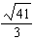
REF: 060505al

5 ANS:
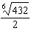
REF: 019713al

6 ANS:
REF: 069307al

7 ANS:
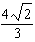
REF: 019309al

8 ANS:
REF: 099810al

9 ANS:
REF: 030504al

10 ANS:
REF: 090404al

11 ANS:
REF: 010610al

