1 The expression 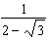 is equivalent to
1) 2) 3) 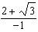 4) 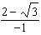

2 The expression 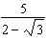 is equivalent to
1) 2) 3) 4)

3 The expression 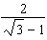 is equivalent to
1) 2) 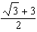 3) 4)

4 The expression 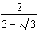 is equivalent to
1) 2) 3) 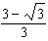 4) 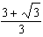

5 The expression 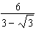 is equivalent to
1) 2) 3) 4)

6 The expression 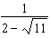 is equivalent to
1) 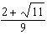 2) 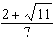 3) 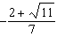 4) 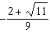

7 The expression 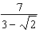 is equivalent to
1) 2) 3) 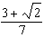 4) 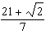

8 The expression 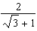 is equivalent to
1) 2) 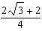 3) 4)

9 The expression 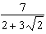 is equivalent to
1) 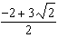 2) 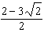 3) 4)

10 What is the reciprocal of ?
1) 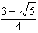 2) 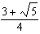 3) 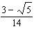 4) 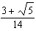

11 The expression 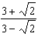 is equivalent to
1) 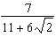 2) 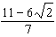 3) 4) 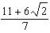

12 The expression 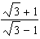 is equivalent to
1) 2) 2 3) 4)

13 Expressed in simplest form, 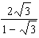 is equivalent to
1) 2) 3) 4)

14 The expression 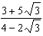 is equivalent to
1) 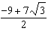 2) 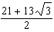 3) 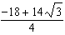 4) 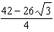

15 The expression 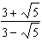 is equivalent to
1) 2) 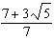 3) 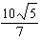 4) 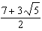

16 Express 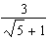 as an equivalent fraction with a rational denominator.

17 Express 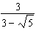 as a fraction with a rational denominator.

18 Express 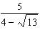 as an equivalent fraction with a rational denominator.

19 Express 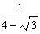 as an equivalent fraction with a rational denominator.

20 Express 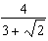 as an equivalent fraction with a rational denominator.

21 Express 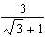 as an equivalent fraction with a rational denominator.

22 Express 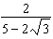 as a fraction with a rational denominator.

23 Write the fraction 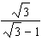 with a rational denominator.

24 Express in simplest form: 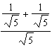
1 ANS: 1 REF: 018432siii

2 ANS: 1 REF: 068131siii

3 ANS: 1 REF: 088435siii

4 ANS: 4 REF: 068831siii

5 ANS: 3 REF: 018918siii

6 ANS: 3 REF: 089319siii

7 ANS: 1 REF: 019030siii

8 ANS: 3 REF: 010328siii

9 ANS: 1 REF: 060333siii

10 ANS: 2 REF: 060218siii

11 ANS: 4 REF: 068928siii

12 ANS: 3 REF: 069433siii

13 ANS: 1 REF: 089434siii

14 ANS: 2 REF: 080333siii

15 ANS: 4 REF: 018527siii

16 ANS:
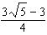
REF: 018610siii

17 ANS:
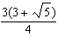
REF: 068613siii

18 ANS:
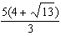
REF: 069512siii

19 ANS:
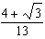
REF: 088612siii

20 ANS:
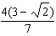
REF: 068712siii

21 ANS:
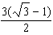
REF: 088907siii

22 ANS:
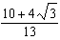
REF: 089009siii

23 ANS:
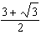
REF: 069014siii

24 ANS:
REF: 089410siii

