1 Which expression represents the sum of 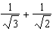?
1) 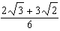 2) 3) 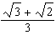 4) 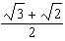

2 What is 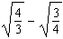 expressed in simplest form?
1) 1 2) 0 3) 4)

3 The expression 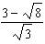 is equivalent to
1) 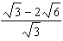 2) 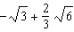 3) 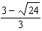 4) 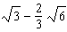

4 Which expression is equivalent to 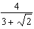?
1) 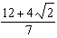 2) 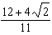 3) 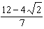 4) 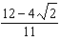

5 The expression 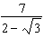 is equivalent to
1) 2) 3) 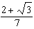 4) 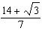

6 The expression 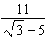 is equivalent to
1) 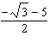 2) 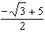 3) 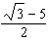 4) 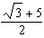

7 The expression 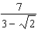 is equivalent to
1) 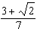 2) 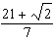 3) 4)

8 The expression 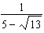 is equivalent, to
1) 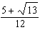 2) 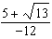 3) 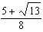 4) 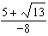

9 The expression 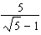 is equivalent to
1) 2) 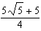 3) 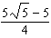 4) 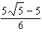

10 The expression 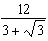 is equivalent to
1) 2) 3) 4)

11 The expression 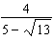 is equivalent to
1) 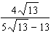 2) 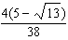 3) 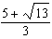 4) 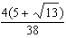

12 The fraction 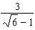 is equivalent to
1) 2) 3) 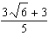 4) 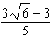

13 The expression 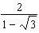 is equivalent to
1) 2) 3) 4)

14 The expression 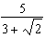 is equivalent to
1) 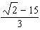 2) 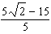 3) 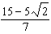 4)

15 The expression 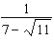 is equivalent to
1) 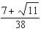 2) 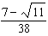 3) 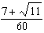 4) 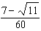

16 The expression 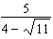 is equivalent to
1) 2) 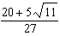 3) 4) 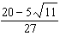

17 The expression 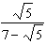 is equivalent to
1) 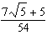 2) 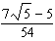 3) 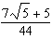 4) 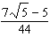

18 Which expression is equivalent to 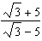?
1) 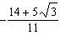 2) 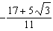 3) 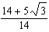 4) 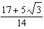

19 Which expression is equal to 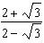?
1) 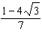 2) 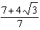 3) 4)

20 The expression 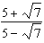 is equivalent to
1) 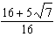 2) 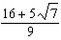 3) 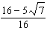 4) 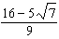

21 Which expression is equivalent to 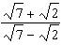?
1) 2) 3) 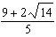 4) 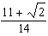

22 Express 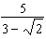 with a rational denominator, in simplest radical form.

23 Express the reciprocal of in simplest radical form with a rational denominator.
1 ANS: 1

REF: 080210b

2 ANS: 3
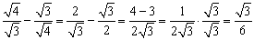

REF: 080910b

3 ANS: 4
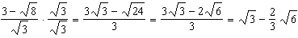

REF: 081518a2

4 ANS: 3
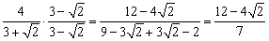

REF: 060305b

5 ANS: 2
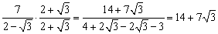

REF: 010405b

6 ANS: 1

REF: 080420b

7 ANS: 3
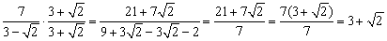

REF: 010516b

8 ANS: 1
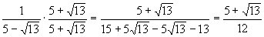

REF: 080506b

9 ANS: 2
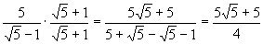

REF: 010613b

10 ANS: 2
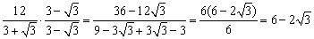

REF: 080606b

11 ANS: 3
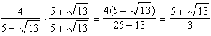

REF: 061116a2

12 ANS: 3
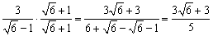

REF: 060709b

13 ANS: 4
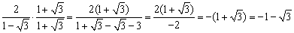

REF: 080716b

14 ANS: 3
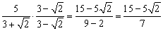

REF: 010902b

15 ANS: 1
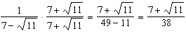

REF: 011404a2

16 ANS: 1
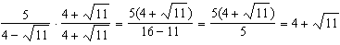

REF: 061509a2

17 ANS: 3
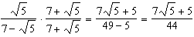

REF: 061603a2

18 ANS: 1
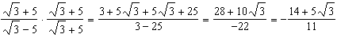

REF: 061012a2

19 ANS: 4
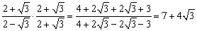

REF: 080307b

20 ANS: 2
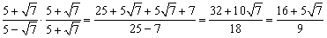

REF: 060905b

21 ANS: 3
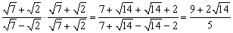

REF: fall9906b

22 ANS:
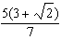. 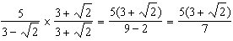

REF: fall0928a2

23 ANS:
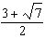

REF: 011026b

