1 Which graph represents the solution set of 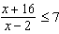?
1) |  | 3)
2) |  | 4)

2 The cost (C) of selling x calculators in a store is modeled by the equation 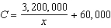. The store profit (P) for these sales is modeled by the equation . What is the minimum number of calculators that have to be sold for profit to be greater than cost?
1 ANS: 3
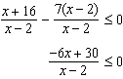 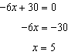 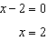. Check points such that , , and . If , 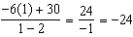, which is less than 0. If , 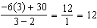, which is greater than 0. If , 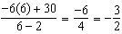, which is less than 0.

REF: 011424a2

2 ANS:
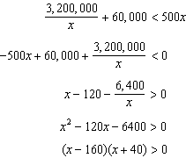. 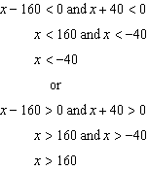. 161

REF: 080227b

