1 Perform the indicated operation and express in simplest form: 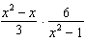

2 Perform the indicated operation and express in simplest form: 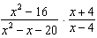

3 Express the product in simplest form: 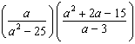

4 Perform the indicated operations and express in simplest form: 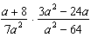

5 Express the product in simplest form: 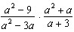

6 Express the product 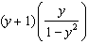

7 Simplify: 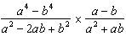

8 Express in simplest form: 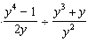

9 Express in simplest form: 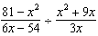

10 Express in simplest form: 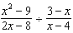

11 Perform the indicated operation and express in simplest form: 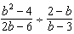

12 Express in simplest form: 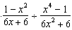

13 Express in simplest form: 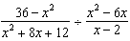

14 Perform the indicated operation and express in simplest form: 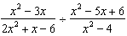

15 Express in simplest form: 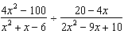

16 Express in simplest form: 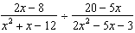

17 Express in simplest form: 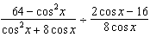

18 Express in simplest form: 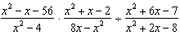

19 Perform the indicated operations and express in lowest terms: 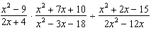

20 Express in simplest form: 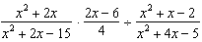

21 Perform the indicated operations and simplify: 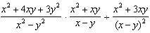

22 Express in simplest form: 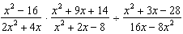
1 ANS:
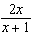
REF: 018607siii

2 ANS:
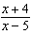
REF: 068806siii

3 ANS:
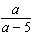
REF: 069006siii

4 ANS:
REF: 089707siii

5 ANS:
REF: 089602siii

6 ANS:
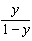
REF: 088417siii

7 ANS:
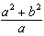
REF: 019702al

8 ANS:
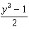
REF: 069440siii

9 ANS:
REF: 060042siii

10 ANS:
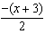
REF: 010141siii

11 ANS:
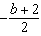
REF: 018637siii

12 ANS:
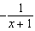
REF: 069540siii

13 ANS:
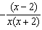
REF: 010339siii

14 ANS:
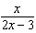
REF: 018537siii

15 ANS:
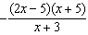
REF: 080238siii

16 ANS:
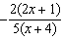
REF: 019938siii

17 ANS:
REF: 080139siii

18 ANS:
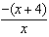
REF: 060237siii

19 ANS:
REF: 089939siii

20 ANS:
REF: 019636siii

21 ANS:
REF: 089037siii

22 ANS:
REF: 010438siii

