1 What is the product of 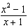 and 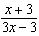 expressed in simplest form?
1) | x
2)
3)
4) | 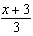

2 What is the product of 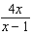 and 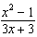 expressed in simplest form?
1)
2)
3) | 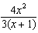
4) | 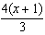

3 Express the product of 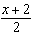 and 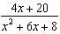 in simplest form.

4 If the length of a rectangular garden is represented by 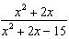 and its width is represented by 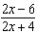, which expression represents the area of the garden?
1)
2)
3) | 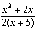
4) | 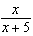

5 What is the quotient of 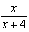 divided by 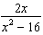?
1) | 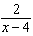
2) | 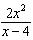
3) | 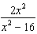
4) | 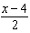

6 The expression 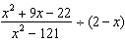 is equivalent to
1)
2) | 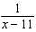
3)
4) | 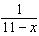

7 Perform the indicated operation and express the result in simplest terms: 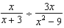

8 Express in simplest form: 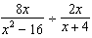

9 Perform the indicated operation and simplify: 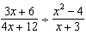

10 Express in simplest form: 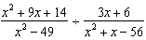

11 Express 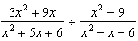 in simplest form.

12 Express in simplest form: 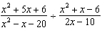

13 Perform the indicated operations and express in simplest form: 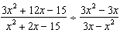

14 Express in simplest form: 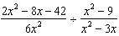

15 Express 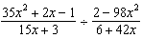 in simplest form.

16 If 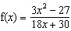 and 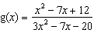, find for all values of x for which the expression is defined and express your answer in simplest form.

17 Perform the indicated operations and express the result in simplest form: 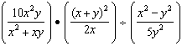

18 Perform the indicated operations and simplify completely: 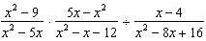

19 Express in simplest form: 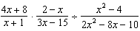

20 Perform the indicated operations and simplify completely: 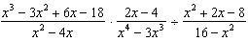
1 ANS: 4
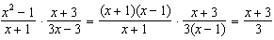

REF: 060815ia

2 ANS: 1
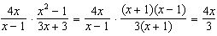

REF: 080826ia

3 ANS:
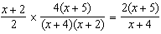

REF: 081232ia

4 ANS: 4
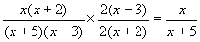

REF: 080117b

5 ANS: 4
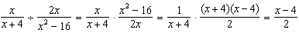

REF: 081130ia

6 ANS: 4
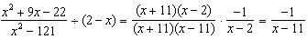

REF: 011423a2

7 ANS:
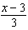. 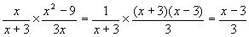

REF: 080022a

8 ANS:
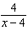. 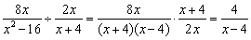

REF: 010935a

9 ANS:
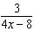. 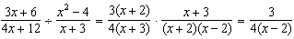

REF: 010935ia

10 ANS:
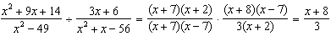

REF: 061037ia

11 ANS:
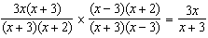

REF: 081338ia

12 ANS:
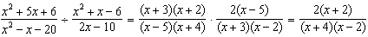

REF: 061638ia

13 ANS:
.

REF: 010928b

14 ANS:
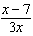.

REF: 080937ia

15 ANS:
. 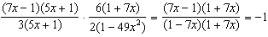

REF: 061028b

16 ANS:
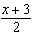.

REF: 060727b

17 ANS:
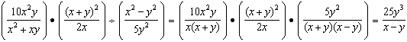

REF: 011539ia

18 ANS:
.

REF: 010733b

19 ANS:
.

REF: 010434b

20 ANS:
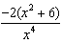. 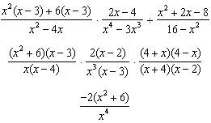

REF: 011239a2

