1 For all values of n for which the expressions are defined, 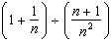 is equivalent to
1) 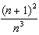 2) 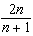 3) 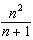 4) n

2 Express in simplest form: 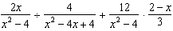

3 Simplify: 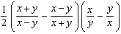

4 Simplify: 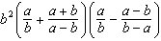

5 Simplify: 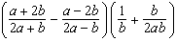

6 Reduce to simplest form: 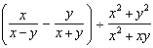

7 Simplify: 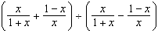

8 Simplify: 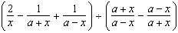

9 Reduce the following to simplest form: 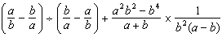
1 ANS: 4 REF: 088531siii

2 ANS:
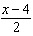. 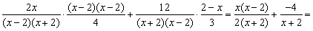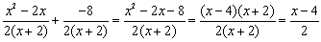

REF: 080733b

3 ANS:
2

REF: 099402al

4 ANS:
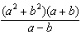

REF: 019502al

5 ANS:
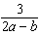

REF: 089701al

6 ANS:
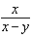

REF: 069104al

7 ANS:
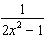

REF: 039802al

8 ANS:

REF: 039901al

9 ANS:
0

REF: 119303al

