1 Which equation shows that p varies inversely as q?
1)
2)
3)
4)

2 Which statement is true if r varies inversely as s?
1) | Their difference will be constant.
2) | Their sum will be constant.
3) | Their quotient will be constant.
4) | Their product will be constant.

3 If x varies inversely as y, which statement is true?
1) | When x is multiplied by 2, y is multiplied by 2.
2) | When x is multiplied by 2, y is divided by 2.
3) | When x is divided by 2, y is divided by 2.
4) | When x is increased by 2, y is decreased by 2.

4 If x varies inversely as y and when , what is the value of x when ?
1) | 36
2)
3)
4) | 4

5 If d varies inversely as t, and when , what is the value of t when ?
1) | 8
2) | 2
3)
4)

6 If R is inversely proportional to A, and when , what is the value of R when ?
1) | 0.625
2) | 1.6
3) | 10
4) | 6,250

7 If p varies inversely as q, and when 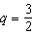, what is the value of p when 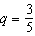?
1) | 25
2) | 15
3) | 9
4) | 4

8 The quantities p and q vary inversely. If when , and when , then x equals
1) | and 5
2)
3) | and 4
4)

9 In the table below, y varies inversely as x.
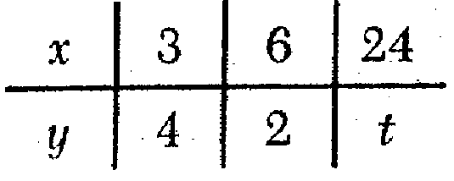
What is the value of t?
1) | 1
2)
3) | 3
4)

10 In the accompanying table, y varies inversely as x.
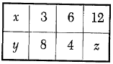
What is the value of z?
1)
2) | 2
3) | 3
4)

11 Tracy, a political campaign organizer, realizes that the number of hours needed to get out a mailing for her candidate is inversely proportional to the number of campaign workers she has. If she uses the information in the accompanying graph, how many hours would it take to do the mailing if 125 workers are used?

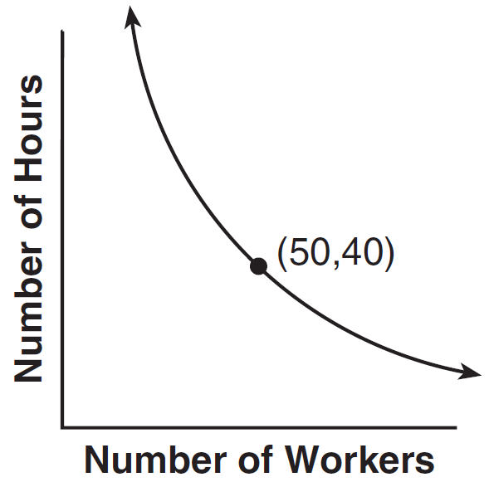
1) | 12
2) | 16
3) | 20
4) | 24

12 The points , 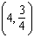, and lie on the graph of a function. If y is inversely proportional to the square of x, what is the value of d?
1) | 1
2)
3) | 3
4) | 27

13 To balance a seesaw, the distance, in feet, a person is from the fulcrum is inversely proportional to the person’s weight, in pounds. Bill, who weighs 150 pounds, is sitting 4 feet away from the fulcrum. If Dan weighs 120 pounds, how far from the fulcrum should he sit to balance the seesaw?
1) | 4.5 ft
2) | 3.5 ft
3) | 3 ft
4) | 5 ft

14 The speed of a laundry truck varies inversely with the time it takes to reach its destination. If the truck takes 3 hours to reach its destination traveling at a constant speed of 50 miles per hour, how long will it take to reach the same location when it travels at a constant speed of 60 miles per hour?
1) | hours
2) | 2 hours
3) | hours
4) | hours

15 According to Boyle's Law, the pressure, p, of a compressed gas is inversely proportional to the volume, v. If a pressure of 20 pounds per square inch exists when the volume of the gas is 500 cubic inches, what is the pressure when the gas is compressed to 400 cubic inches?
1) | 16 lb/in²
2) | 25 lb/in²
3) | 40 lb/in²
4) | 50 lb/in²

16 Carol notices that the number of customers who visit her coffee shop varies inversely with the average daily temperature. Yesterday, the average temperature was 40° and she had 160 customers. If today’s average temperature is 25°, how many customers should she expect?
1) | 100
2) | 145
3) | 256
4) | 1,000

17 The manager of Stuart Siding Company found that the number of workers used to side a house varies inversely with the number of hours needed to finish the job. If four workers can side the house in 48 hours, how many hours will it take six workers working at the same speed to do the same job?
1) | 32
2) | 36
3) | 42
4) | 72

18 A scholarship committee rewards the school's top math students. The amount of money each winner receives is inversely proportional to the number of scholarship recipients. If there are three winners, they each receive $400. If there are eight winners, how much money will each winner receive?
1) | $1067
2) | $400
3) | $240
4) | $150

19 If R varies inversely as S, when S is doubled, R is multiplied by
1)
2) | 2
3)
4) | 4

20 Given y varies inversely as x, when y is multiplied by , then x is multiplied by
1)
2) | 2
3)
4)

21 In a given rectangle, the length varies inversely as the width. If the length is doubled, the width will
1) | be divided by 2
2) | remain the same
3) | be multiplied by 2
4) | increase by 2

22 In the distance formula, rate varies inversely with time. If rate is doubled, time is
1) | decreased by 2
2) | increased by 2
3) | halved
4) | doubled

23 For a rectangular garden with a fixed area, the length of the garden varies inversely with the width. Which equation represents this situation for an area of 36 square units?
1)
2)
3) | 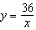
4)

1 ANS: 2 REF: 019433siii

2 ANS: 4 REF: 080229siii

3 ANS: 2 REF: 019532siii

4 ANS: 4 REF: 010035siii

5 ANS: 3
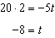

REF: 011412a2

6 ANS: 2 REF: 011017b

7 ANS: 1
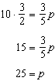

REF: 011226a2

8 ANS: 1
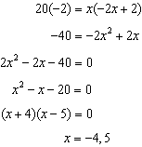

REF: 011321a2

9 ANS: 2 REF: 069432siii

10 ANS: 2 REF: 089716siii

11 ANS: 2 REF: 061005b

12 ANS: 2
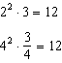. 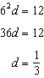

REF: 061310a2

13 ANS: 4
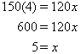

REF: 080207b

14 ANS: 3
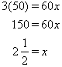

REF: 080402b

15 ANS: 2
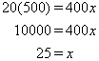

REF: 060618b

16 ANS: 3
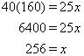

REF: 010913b

17 ANS: 1
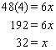

REF: 060918b

18 ANS: 4
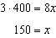
REF: 081507a2

19 ANS: 1
In inverse variation, the product of the two variables must be constant. If one variable is doubled, the other variable must be halved for the product to remain constant.
REF: 010503b

20 ANS: 2 REF: 061510a2

21 ANS: 1 REF: 060508b

22 ANS: 3 REF: 060216siii

23 ANS: 3 REF: 010310b

