1 Express in simplest form:

2 Express as a fraction in simplest form: 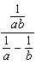

3 Express in simplest form: 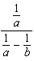

4 Express 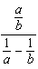 in simplest form.

5 Express in simplest form: 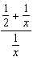

6 Write in simplest form: 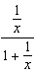

7 Express in simplest form: 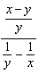

8 Express in simplest form: 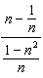

9 Simplify: 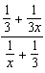

10 Express in simplest form: 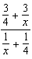

11 Express in simplest form: 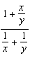

12 In simplest form, express 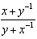 with no negative exponents.

13 Express in simplest form: 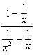

14 Express 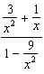 in simplest form.

15 Express in simplest form: 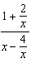

16 Express in simplest form: 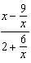

17 Express in simplest form: 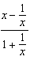

18 Express in simplest form: 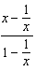

19 Express 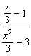 in simplest form.

20 Express in simplest form: 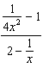

21 Perform the indicated operations and express in simplest form: 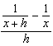

22 Express in simplest form: 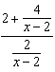

23 Simplify: 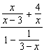

24 Simplify: 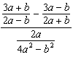

25 Simplify: 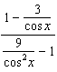

26 Simplify: 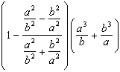

27 Simplify: 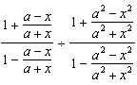

28 Simplify: 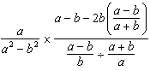
1 ANS:
4

REF: 069505siii

2 ANS:
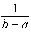

REF: 068608siii

3 ANS:
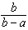

REF: 010209siii

4 ANS:
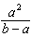

REF: 080312siii

5 ANS:
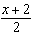

REF: 068004siii

6 ANS:
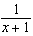

REF: 068508siii

7 ANS:
x

REF: 060012siii

8 ANS:

REF: 068103siii

9 ANS:
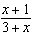

REF: 069010siii

10 ANS:
3

REF: 019910siii

11 ANS:

REF: 089310siii

12 ANS:

REF: 010141siii

13 ANS:

REF: 019740siii

14 ANS:
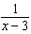

REF: 080014siii

15 ANS:
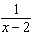

REF: 019016siii

16 ANS:
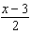

REF: 060210siii

17 ANS:

REF: 080213siii

18 ANS:

REF: 018404siii

19 ANS:
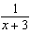

REF: 010012siii

20 ANS:
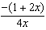

REF: 068838siii

21 ANS:
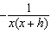

REF: 088437siii

22 ANS:

REF: 018717siii

23 ANS:
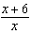

REF: 089838siii

24 ANS:

REF: 099801al

25 ANS:
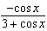

REF: 019539siii

26 ANS:

REF: 039702al

27 ANS:

REF: 069702al

28 ANS:
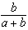

REF: 019803al

