1 Simplify completely: 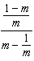

2 Express in simplest form: 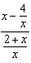

3 Simplify: 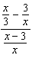

4 Express in simplest form: 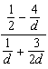

5 Simplify: 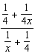

6 Express in simplest form: 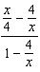

7 Express in simplest form: 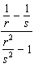

8 Simplify for all values of a for which the expression is defined: 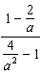

9 Express in simplest form: 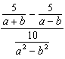

10 Express 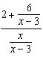 in simplest form, where and .

11 Express in simplest form: 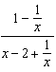

12 Express in simplest terms: 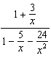

13 Express in simplest form: 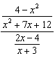

14 Express in simplest form: 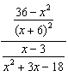

15 Express in simplest form: 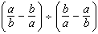
1 ANS:
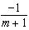.

REF: 010629b

2 ANS:
. 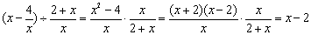

REF: 010826b

3 ANS:
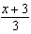.

REF: 060823b

4 ANS:
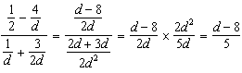

REF: 061035a2

5 ANS:
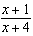. 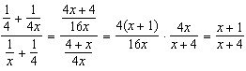

REF: 061021b

6 ANS:
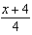. 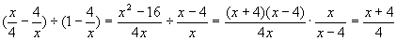

REF: 080323b

7 ANS:
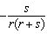

REF: 080425b

8 ANS:
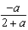.

REF: 060628b

9 ANS:
.

REF: 080930b

10 ANS:
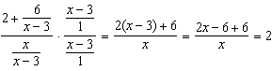

REF: 061631a2

11 ANS:
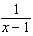. 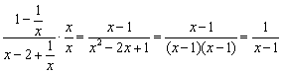

REF: 080824b

12 ANS:
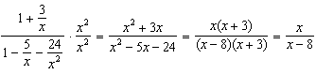

REF: 061436a2

13 ANS:
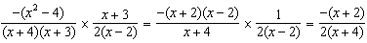

REF: 061236a2

14 ANS:
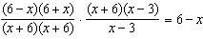

REF: 011529a2

15 ANS:
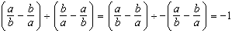

REF: 081633a2

