1 The expression 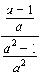 is equivalent to
1) 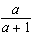 2) 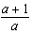 3) 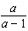 4) 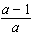

2 The expression 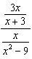 is equivalent to
1) 2) 3) 4) 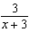

3 In a science experiment, when resistor A and resistor B are connected in a parallel circuit, the total resistance is 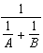. This complex fraction is equivalent to
1) 1 2) 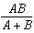 3) 4)

4 The expression 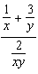 is equivalent to
1) 2) 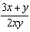 3) 4) 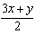

5 The expression 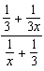 is equivalent to
1) 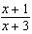 2) 2 3) 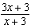 4)

6 Written in simplest form, the expression 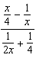 is equivalent to
1) 2) 3) 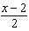 4) 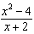

7 The expression 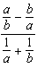 is equivalent to
1) 2) 3) 4) 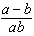

8 In simplest form, 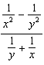 is equal to
1) 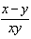 2) 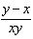 3) 4)

9 The expression 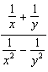 is equivalent to
1) 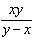 2) 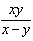 3) 4)

10 The expression 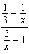 is equivalent to
1) 2) 3) 3 4)

11 The expression 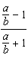 is equivalent to
1) 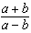 2) 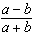 3) 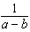 4) 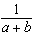

12 The fraction 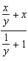 is equivalent to
1) 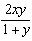 2) 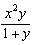 3) 4)

13 When simplified, the complex fraction 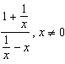, is equivalent to
1) 1 2) 3) 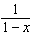 4) 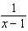

14 Which expression is equivalent to the complex fraction 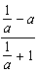?
1) 2) 3) 4)

15 In simplest form, the expression 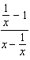 is equivalent to
1) 2) 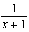 3) 4) 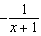

16 The complex fraction 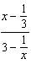 is equivalent to
1) 1 2) 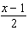 3) 4) 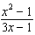

17 The expression 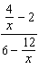 is equal to
1) 2) 3) 4)

18 The fraction 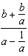 is equivalent to
1) b 2) 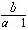 3) 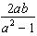 4) 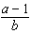

19 The expression 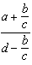 is equivalent to
1) 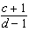 2) 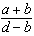 3) 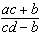 4) 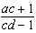

20 The complex fraction 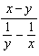 is equivalent to
1) 2) 0 3) 4)

21 The fraction 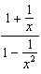 is equivalent to
1) 2) 3) 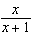 4) 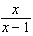

22 The expression 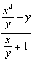 is equivalent to
1) 2) 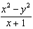 3) 4)

23 Which expression is equivalent to the complex fraction 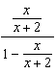?
1) 2) 3) 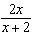 4) 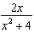

24 The expression 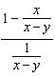 is equivalent to
1) 2) 3) 4)

25 The expression 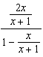 is equivalent to
1) 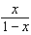 2) 3) 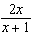 4)

26 The simplest form of 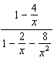 is
1) 2) 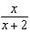 3) 4) 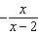

27 When is divided by , the quotient is
1) 2) 3) 4) 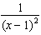

28 When is divided by , the quotient equals
1) 1 2) 3) 4)
1 ANS: 1 REF: 069618siii

2 ANS: 1 REF: 010320siii

3 ANS: 2
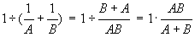

REF: 060112b

4 ANS: 4
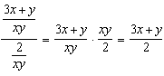

REF: 011603a2

5 ANS: 1
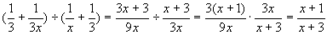

REF: 010706b

6 ANS: 2
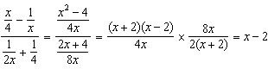

REF: fall0920a2

7 ANS: 2

REF: 010206b

8 ANS: 2

REF: 060317b

9 ANS: 1

REF: 060415b

10 ANS: 2

REF: 060713b

11 ANS: 2 REF: 069818siii

12 ANS: 3
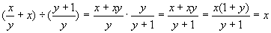

REF: 010312b

13 ANS: 3
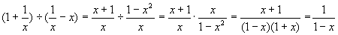

REF: 080513b

14 ANS: 3

REF: 080706b

15 ANS: 4 REF: 089531siii

16 ANS: 3 REF: 068934siii

17 ANS: 4 REF: 089027siii

18 ANS: 2 REF: 060128siii

19 ANS: 3
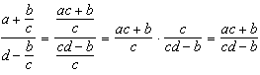

REF: 011405a2

20 ANS: 4 REF: 088735siii

21 ANS: 4 REF: 018924siii

22 ANS: 4 REF: 080119siii

23 ANS: 2

REF: 080220b

24 ANS: 4
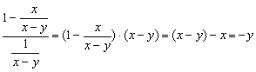

REF: 060919b

25 ANS: 4 REF: 010126siii

26 ANS: 2
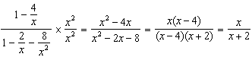

REF: 061305a2

27 ANS: 2
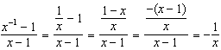

REF: 081018a2

28 ANS: 2
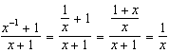

REF: 011211a2

