1 Which expression is equivalent to 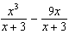?
1) 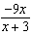 2) 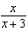 3) 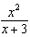 4)

2 For all values of b for which the expressions are defined, 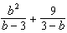 is equivalent to
1) 2) 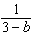 3) 4)

3 Expressed in simplest form, 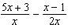 is
1) 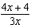 2) 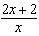 3) 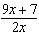 4) 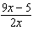

4 Expressed as a single fraction, 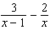 is equivalent to
1) 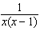 2) 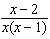 3) 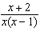 4) 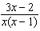

5 Expressed as a single fraction, 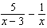 is equivalent to
1) 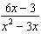 2) 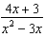 3) 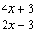 4) 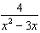

6 The expression 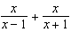 is equivalent to
1) 1 2) 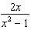 3) 4) 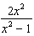

7 The reciprocal of the expression 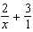 is
1) 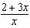 2) 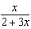 3) 4)

8 If the probability that an event will occur is , then the probability that the event will not occur is
1) 2) 3) 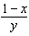 4) 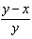

9 If the probability that an event will not occur is , then the probability that the event will occur is represented by
1) 2) 0 3) 4) 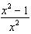

10 If the probability that an event will occur is 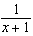, then the probability that the event will not occur is
1) 2) 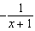 3) 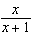 4) 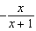

11 Express 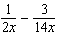 as a single fraction in lowest terms.

12 Express in simplest form: 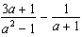

13 Express in simplest form: 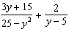

14 Simplify: 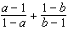

15 Simplify: 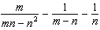

16 Simplify: 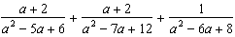
1 ANS: 4 REF: 010218siii

2 ANS: 4 REF: 088931siii

3 ANS: 3 REF: 010118siii

4 ANS: 3 REF: 018734siii

5 ANS: 2 REF: 089919siii

6 ANS: 4 REF: 068421b

7 ANS: 2 REF: 060327siii

8 ANS: 4 REF: 088619siii

9 ANS: 4 REF: 088523siii

10 ANS: 3 REF: 068522siii

11 ANS:

REF: 068708siii

12 ANS:
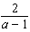

REF: 018439siii

13 ANS:
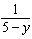

REF: 069740siii

14 ANS:

REF: 119403al

15 ANS:
0

REF: 019103al

16 ANS:
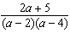

REF: 090501al

