1 Express 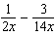 as a single fraction in lowest terms.

2 Express in simplest form: 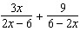

3 Simplify: 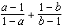

4 Express in simplest form: 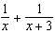

5 Express in simplest form: 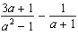

6 Express in simplest form: 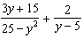

7 Simplify: 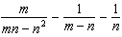

8 Simplify: 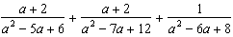
1 ANS:

REF: 068708siii

2 ANS:
. 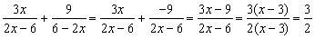

REF: 060929b

3 ANS:

REF: 119403al

4 ANS:
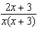. 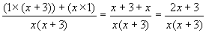

REF: 060524b

5 ANS:
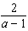

REF: 018439siii

6 ANS:
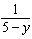

REF: 069740siii

7 ANS:
0

REF: 019103al

8 ANS:
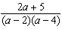

REF: 090501al

