1 What is the least common denominator of , , and ?
1) 2) 3) 4)

2 What is the sum of and ?
1) 1 2) 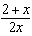 3) 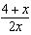 4) 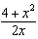

3 The sum of 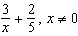, is
1) 2) 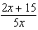 3) 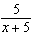 4) 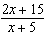

4 The reciprocal of the expression 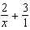 is
1) 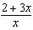 2) 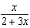 3) 4)

5 The expression 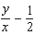 is equivalent to
1) 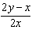 2) 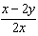 3) 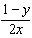 4) 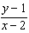

6 Which expression is equivalent to 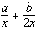?
1) 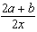 2) 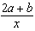 3) 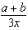 4) 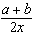

7 What is the sum of and ?
1) 2) 3) 4)

8 Expressed as a single fraction, 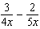 is equal to
1) 2) 3) 4)

9 Expressed in simplest form, 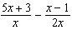 is
1) 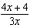 2) 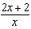 3) 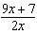 4) 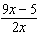

10 Which expression is equivalent to 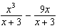?
1) 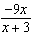 2) 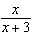 3) 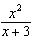 4)

11 What is the sum of 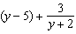?
1) 2) 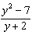 3) 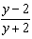 4) 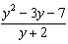

12 Expressed as a single fraction, what is 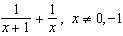?
1) 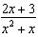 2) 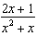 3) 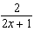 4)

13 The expression 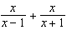 is equivalent to
1) 1 2) 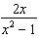 3) 4) 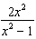

14 Expressed as a single fraction, 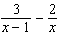 is equivalent to
1) 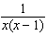 2) 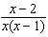 3) 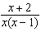 4) 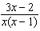

15 Expressed as a single fraction, 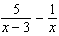 is equivalent to
1) 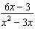 2) 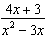 3) 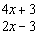 4) 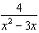

16 The expression 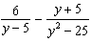 is equivalent to
1) 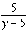 2) 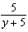 3) 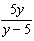 4) 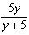

17 What is the sum of 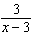 and 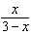?
1) 1 2) 3) 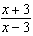 4) 0

18 For all values of b for which the expressions are defined, 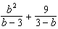 is equivalent to
1) 2) 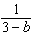 3) 4)

19 The expression 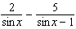 is equivalent to
1) 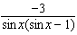 2) 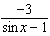 3) 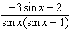 4) 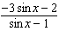

20 If the probability that an event will occur is , then the probability that the event will not occur is
1) 2) 3) 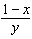 4) 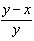

21 If the probability that an event will occur is 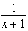, then the probability that the event will not occur is
1) 2) 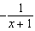 3) 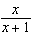 4) 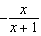

22 If the probability that an event will not occur is , then the probability that the event will occur is represented by
1) 2) 0 3) 4) 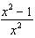
1 ANS: 3
The LCM of 2 and 7 is 14. The LCM of x and x is x. The LCD is 14x.

REF: 060412a

2 ANS: 4
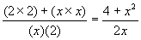

REF: 010423a

3 ANS: 2
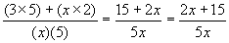

REF: 080207a

4 ANS: 2 REF: 060327siii

5 ANS: 1
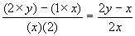

REF: 010016a

6 ANS: 1
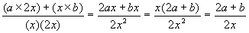

REF: 089911a

7 ANS: 4
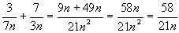

REF: 060727a

8 ANS: 4
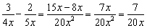

REF: 010921a

9 ANS: 3 REF: 010118siii

10 ANS: 4 REF: 010218siii

11 ANS: 4
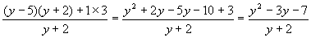

REF: 080505b

12 ANS: 2
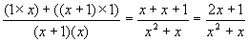

REF: 069906a

13 ANS: 4 REF: 068421b

14 ANS: 3 REF: 018734siii

15 ANS: 2 REF: 089919siii

16 ANS: 1
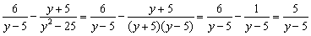

REF: 080805b

17 ANS: 2
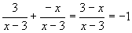

REF: 010315b

18 ANS: 4 REF: 088931siii

19 ANS: 3

REF: 060816b

20 ANS: 4 REF: 088619siii

21 ANS: 3 REF: 068522siii

22 ANS: 4 REF: 088523siii

