1 What is 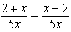 expressed in simplest form?
1) 0 2) 3) 4) 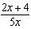

2 What is the sum of and expressed in simplest form?
1) 2) 3) 4)

3 The sum of and is
1) 2) 3) 4)

4 What is the sum of and ?
1) 2) 3) 4)

5 The expression 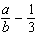 is equivalent to
1) 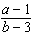 2) 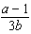 3) 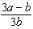 4) 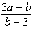

6 What is 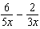 in simplest form?
1) 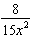 2) 3) 4)

7 What is 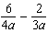 expressed in simplest form?
1) 2) 3) 4)

8 Which fraction is equivalent to 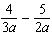?
1) 2) 3) 4) 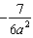

9 What is 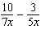 expressed in simplest form?
1) 2) 3) 4)

10 What is 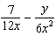 expressed in simplest form?
1) 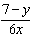 2) 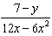 3) 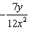 4) 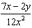

11 What is the sum of 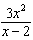 and 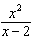?
1) 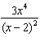 2) 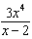 3) 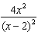 4) 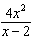

12 What is the sum of 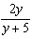 and 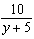 expressed in simplest form?
1) 1 2) 2 3) 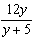 4) 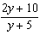

13 The sum of 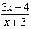 and 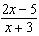 is
1) 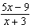 2) 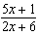 3) 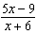 4) 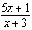

14 What is the sum of 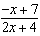 and 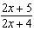?
1) 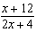 2) 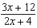 3) 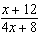 4) 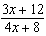

15 The expression 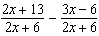 is equivalent to
1) 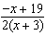 2) 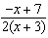 3) 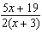 4) 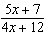

16 The expression 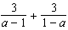 is equivalent to
1) 0 2) 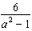 3) 6 4) 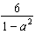

17 Expressed in simplest form, 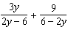 is equivalent to
1) 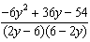 2) 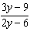 3) 4)

18 What is 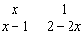 expressed as a single fraction?
1) 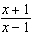 2) 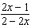 3) 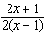 4) 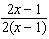

19 The expression 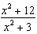 can be rewritten as
1) 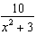 2) 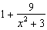 3) 4) 4

20 The expression 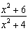 is equivalent to
1) 2) 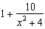 3) 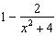 4) 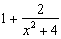

21 The expression 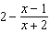 is equivalent to
1) 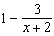 2) 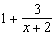 3) 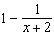 4) 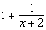

22 Algebraically prove that 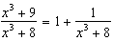, where .
1 ANS: 3
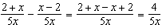

REF: 081027ia

2 ANS: 2
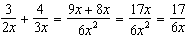

REF: 080917ia

3 ANS: 3
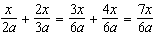

REF: 061630ia

4 ANS: 2
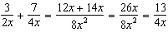

REF: 011120ia

5 ANS: 3 REF: 061424ia

6 ANS: 2
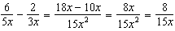

REF: 010921ia

7 ANS: 2
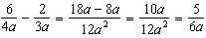

REF: 060929ia

8 ANS: 3
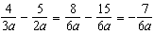

REF: 081328ia

9 ANS: 3
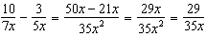

REF: 011511ia

10 ANS: 4
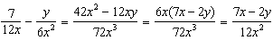

REF: 061129ia

11 ANS: 4 REF: 011025ia

12 ANS: 2
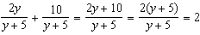

REF: 011230ia

13 ANS: 1 REF: 081409ia

14 ANS: 1 REF: 061024ia

15 ANS: 1 REF: 061220ia

16 ANS: 1
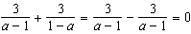

REF: 011716a2

17 ANS: 3
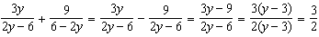

REF: 011325a2

18 ANS: 3
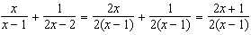

REF: 011608a2

19 ANS: 2
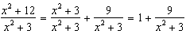

REF: 062218aii

20 ANS: 4
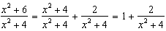

REF: 082321aii

21 ANS: 2
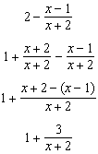

REF: 081907aii

22 ANS:
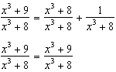

REF: 061631aii

