1 Which value of x makes the expression 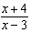 undefined?
1) 2) 3) 3 4) 0

2 The expression 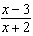 is undefined when the value of x is
1) , only 2) and 3 3) 3, only 4) and 2

3 For which value of x is the expression 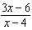 undefined?
1) 0 2) 2 3) 4) 4

4 For which value of x is the expression 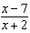 undefined?
1) 2) 2 3) 7 4) 0

5 For which value of x is the expression 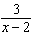 undefined?
1) 2) 2 3) 3 4) 0

6 For which value of x is the expression 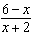 undefined?
1) 2) 2 3) 0 4) 6

7 For which value of x is the expression 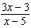 undefined?
1) 1 2) 3) 5 4)

8 For which value of m is the expression 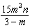 undefined?
1) 1 2) 0 3) 3 4)

9 For which value of x will the fraction 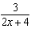 be undefined?
1) 2) 2 3) 0 4)

10 What value of x would make the expression 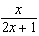 undefined?
1) 0 2) 3) 4)

11 Which value of n makes the expression 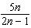 undefined?
1) 1 2) 0 3) 4)

12 For which value or values of n is the expression 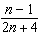 undefined?
1) 1, only 2) , only 3) 1 and 4) 0

13 For which value of x is the expression 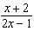 undefined?
1) 0 2) 3) 4)

14 Which value of x makes the expression 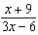 undefined?
1) 2) 2 3) 4) 0

15 The expression 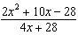 is undefined when x is
1) 7, only 2) , only 3) 7 or 4) or 2

16 For which value of x is 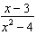 undefined?
1) 2) 0 3) 3 4) 4

17 The expression 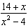 is undefined when x is
1) , only 2) 2, only 3) or 2 4) , , or 2

18 The function 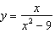 is undefined when the value of x is
1) 0 or 3 2) 3) 3, only 4)

19 The algebraic expression 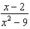 is undefined when x is
1) 0 2) 2 3) 3 4) 9

20 The expression 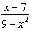 is undefined when x is
1) 3 and 7 2) 3 and 3) 3, only 4) 9

21 The function 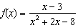 is undefined when x equals
1) 2) 3) 3, only 4)

22 Which value of x makes the expression 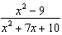 undefined?
1) 2) 2 3) 3 4)

23 For which set of values of x is the algebraic expression 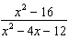 undefined?
1) 2) 3) 4)

24 For which values of x is the fraction 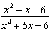 undefined?
1) 1 and 2) 2 and 3) 3 and 4) 6 and

25 A value of x that makes the expression 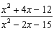 undefined is
1) 2) 3) 3 4) 5

26 For which value of x is 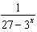 undefined?
1) 1 2) 0 3) 3 4)

27 Which expression is undefined when ?
1) 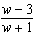 2) 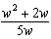 3) 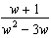 4)

28 For what values of x is the fraction 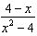 undefined?

29 For which negative values of x is the fraction 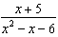 undefined?
1 ANS: 3 REF: 060817ia

2 ANS: 1 REF: 061315ia

3 ANS: 4 REF: 060319a

4 ANS: 1 REF: 080422a

5 ANS: 2 REF: 080610a

6 ANS: 1 REF: 010822a

7 ANS: 3 REF: 080821a

8 ANS: 3 REF: 010917a

9 ANS: 1 REF: 010607a

10 ANS: 2 REF: 061626ia

11 ANS: 4 REF: 060916ia

12 ANS: 2 REF: 060217siii

13 ANS: 4 REF: 011521ia

14 ANS: 2 REF: 061520ia

15 ANS: 2
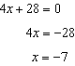

REF: 081417ia

16 ANS: 1 REF: fall0728ia

17 ANS: 3
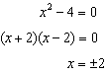

REF: 081225ia

18 ANS: 2 REF: 010925ia

19 ANS: 3
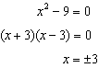

REF: 061014ia

20 ANS: 2 REF: 061429ia

21 ANS: 1
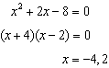

REF: 081701aii

22 ANS: 1
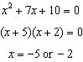

REF: 080918ia

23 ANS: 4
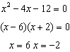

REF: 061125ia

24 ANS: 1
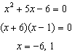

REF: 011214ia

25 ANS: 4
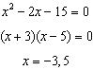

REF: 081316ia

26 ANS: 3 REF: 060801b

27 ANS: 3 REF: 010716a

28 ANS:

REF: 060308siii

29 ANS:

REF: 089906siii

