1 Given , the expression 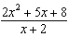 is equivalent to
1) | 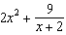
2) | 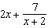
3) | 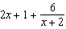
4) | 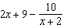

2 The expression 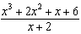 is equivalent to
1)
2) | 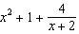
3)
4) | 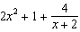

3 Given , which expression is equivalent to 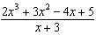?
1)
2) | 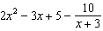
3)
4) | 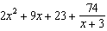

4 Given , the expression 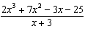 is equivalent to
1) | 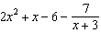
2) | 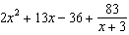
3)
4) | 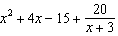

5 Which expression is equivalent to 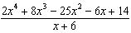?
1) | 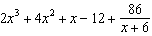
2)
3) | 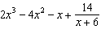
4)

6 Which expression is equivalent to 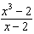?
1)
2) | 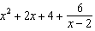
3)
4) | 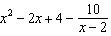

7 The expression 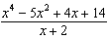 is equivalent to
1) | 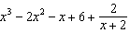
2) | 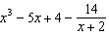
3) | 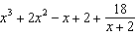
4) | 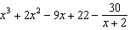

8 The rational expression 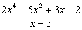 is equivalent to
1) | 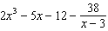
2) | 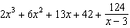
3) | 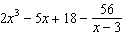
4) | 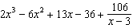

9 Which expression is equivalent to 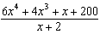?
1) | 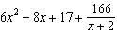
2) | 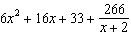
3) | 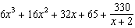
4) | 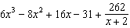

10 What is the quotient when is divided by ?
1)
2)
3)
4)

11 The expression 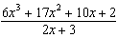 equals
1) | 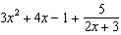
2) | 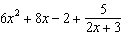
3) | 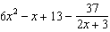
4) | 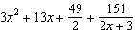

12 The expression 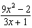 is equivalent to
1) | 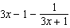
2) | 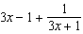
3) | 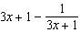
4) | 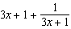

13 Which expression is equivalent to 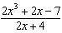?
1) | 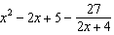
2) | 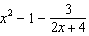
3) | 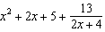
4) | 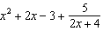

14 Which expression is equivalent to 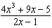, where 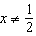?
1)
2) | 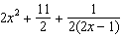
3)
4) | 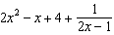

15 The expression 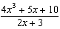 is equivalent to
1) | 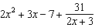
2) | 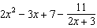
3) | 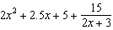
4) | 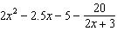

16 Given and , state the quotient and remainder of , in the form 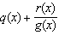.

17 Determine the quotient and remainder when is divided by . Express your answer in the form 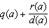.

18 Given and , state the quotient and remainder of , in the form . Is a root of ? Explain your answer.

19 Given and , determine in the form 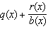. Is a factor of ? Explain.

20 When the function is divided by the quotient is 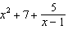. State in standard form.
1 ANS: 3
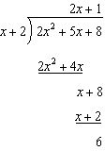

REF: 012007aii

2 ANS: 2
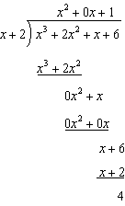

REF: 081611aii

3 ANS: 2
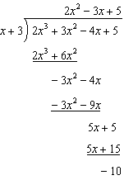

REF: 082302aii

4 ANS: 1
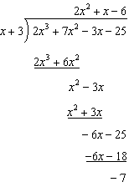

REF: 062203aii

5 ANS: 3
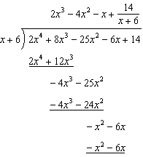

REF: 081805aii

6 ANS: 2
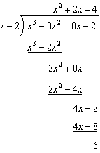

REF: 082217aii

7 ANS: 1
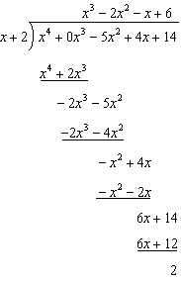

REF: 012305aii

8 ANS: 2
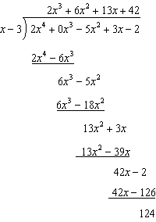

REF: 012408aii

9 ANS: 4
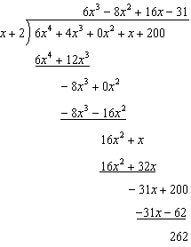

REF: 082407aii

10 ANS: 4
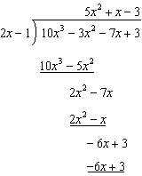

REF: 011809aii

11 ANS: 1
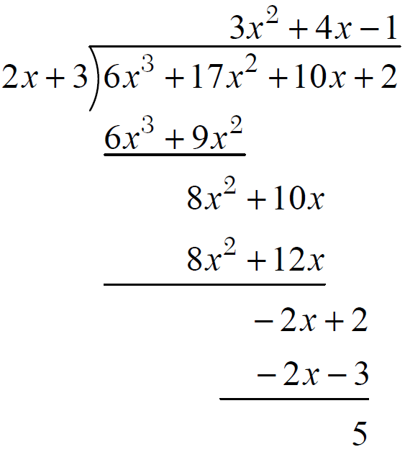

REF: fall1503aii

12 ANS: 1
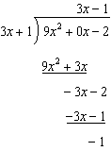

REF: 081910aii

13 ANS: 1
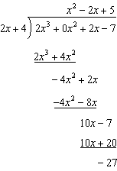

REF: 062313aii

14 ANS: 1
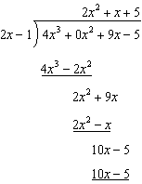

REF: 081713aii

15 ANS: 2
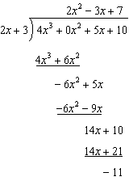

REF: 061614aii

16 ANS:
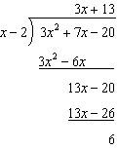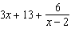

REF: 011732aii

17 ANS:
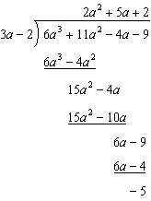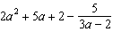

REF: 061829aii

18 ANS:
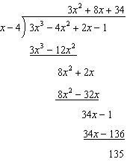 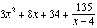 is not a root of because has a remainder.

REF: 082235aii

19 ANS:
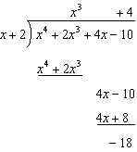 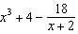. No, because there is a remainder.

REF: 011934aii

20 ANS:
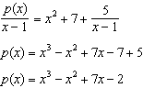

REF: 061930aii

