1 If , the expression 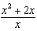 is equivalent to
1)
2) | 2
3)
4) | 4

2 For all values of x for which the expression is defined, 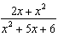 is equivalent to
1) | 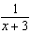
2) | 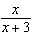
3) | 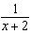
4) | 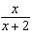

3 Which expression is in simplest form?
1)
2) | 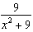
3) | 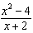
4) | 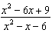

4 Simplify: 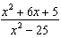

5 Express in simplest form: 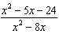

6 Express 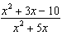 as a fraction in simplest form.

7 Express the following rational expression in simplest form: 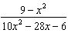

8 Simplify: 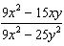

9 The fraction 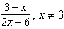, is equivalent to
1)
2)
3)
4)

10 Written in simplest form, the expression 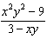 is equivalent to
1)
2) | 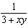
3)
4)

11 Written in simplest form, the expression 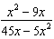 is equivalent to
1)
2)
3) | 5
4)

12 Which expression is equivalent to 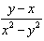?
1) | 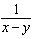
2) | 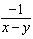
3) | 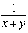
4) | 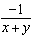

13 Written in simplest form, the expression 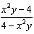 is
1) | 1
2) | 0
3)
4)

14 The expression 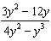 is equivalent to
1)
2)
3)
4) | 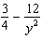

1 ANS: 1
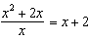

REF: 010109a

2 ANS: 2
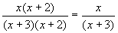

REF: 060202b

3 ANS: 2
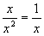. 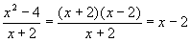. 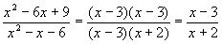

REF: 060712b

4 ANS:
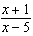. 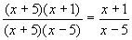

REF: 010631a

5 ANS:
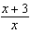. 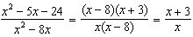

REF: 060837a

6 ANS:
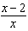

REF: 088704siii

7 ANS:
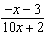. 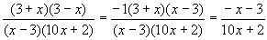

REF: 060325b

8 ANS:
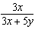

REF: 069924a

9 ANS: 2 REF: 060118siii

10 ANS: 3
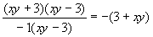

REF: 080305b

11 ANS: 2
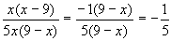

REF: 060504b

12 ANS: 4 REF: 011013b

13 ANS: 4 REF: fall9911b

14 ANS: 2
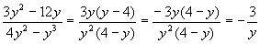

REF: 080619b

