1 Which expression represents 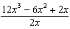 in simplest form?
1)
2)
3)
4)

2 The expression 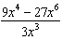 is equivalent to
1)
2)
3)
4)

3 Which expression is equivalent to 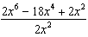?
1)
2)
3) | `
4)

4 Which expression(s) are equivalent to 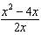, where ?
I. 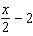 II. 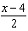 III. 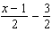
1) | II, only
2) | I and II
3) | II and III
4) | I, II, and III

5 Which expression represents 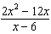 in simplest form?
1) | 0
2)
3)
4)

6 Which expression represents 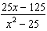 in simplest form?
1)
2)
3) | 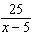
4) | 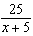

7 Written in simplest form, the fraction 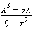, where , is equivalent to
1)
2)
3) | 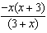
4) | 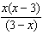

8 Which expression represents 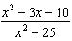 in simplest form?
1)
2) | 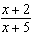
3) | 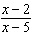
4) | 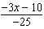

9 Which fraction represents 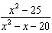 expressed in simplest form?
1)
2) | 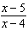
3) | 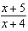
4) | 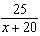

10 Which expression represents 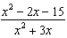 in simplest form?
1)
2) | 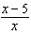
3) | 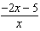
4) | 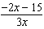

11 For all values of x for which the expression is defined, 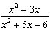 is equivalent to
1) | 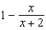
2) | 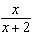
3) | 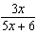
4) | 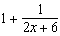

12 The expression 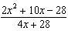 is equivalent to
1) | 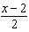
2)
3) | 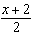
4) | 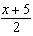

13 Which expression represents 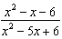 in simplest form?
1) | 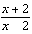
2) | 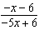
3)
4)

14 If the area of a rectangle is represented by and its length is represented by , which expression represents the width of the rectangle?
1)
2)
3)
4)

15 Express in simplest form: 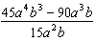

16 Express in simplest form: 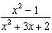

17 The area of a rectangle is represented by . If the width of the rectangle is represented by , express the length of the rectangle as a binomial.

18 The expression 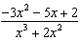 can be rewritten as
1) | 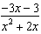
2) | 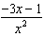
3)
4)

19 For all values of x for which the expression is defined, 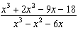, in simplest form, is equivalent to
1) | 3
2)
3) | 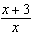
4) | 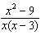

20 Which expression can be rewritten as ?
1)
2)
3) | 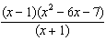
4) | 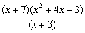

21 For all values of x for which the expression is defined, write the expression below in simplest form.

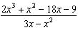

22 Written in simplest form, 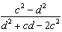 where , is equivalent to
1) | 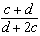
2) | 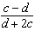
3) | 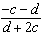
4) | 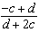

1 ANS: 3
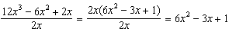

REF: 011011ia

2 ANS: 2
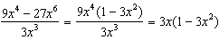

REF: fall0718ia

3 ANS: 4
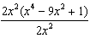

REF: 081222ia

4 ANS: 4
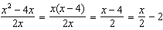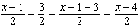

REF: 011921aii

5 ANS: 2
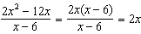

REF: 060824ia

6 ANS: 4
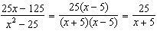

REF: 080821ia

7 ANS: 1
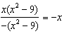

REF: 012023aii

8 ANS: 2
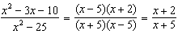

REF: 061216ia

9 ANS: 3
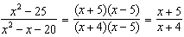

REF: 011424ia

10 ANS: 2
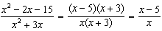

REF: 060921ia

11 ANS: 2
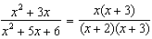

REF: 082215aii

12 ANS: 1
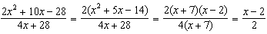

REF: 011327ia

13 ANS: 1
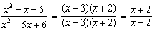

REF: 011130ia

14 ANS: 1
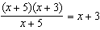

REF: 061307ia

15 ANS:
. 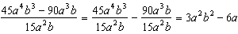

REF: 081031ia

16 ANS:
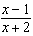. 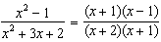

REF: 011233ia

17 ANS:
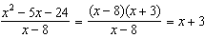

REF: 061131ia

18 ANS: 4
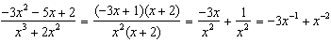

REF: 061723aii

19 ANS: 3
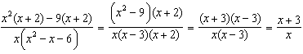

REF: 061803aii

20 ANS: 1
1) ; 2) 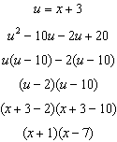; 3) 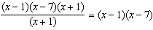; 4) 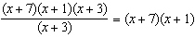

REF: 061808aii

21 ANS:

REF: 062331ai

22 ANS: 3
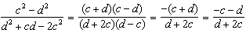

REF: 011818aii

