1 Which expression is equivalent to ?
1)
2)
3)
4) | 0

2 Which expression is equivalent to ?
1)
2)
3)
4)

3 The expression is equivalent to
1)
2)
3)
4) | 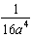

4 The expression is equivalent to
1)
2)
3)
4)

5 Which expression is equivalent to 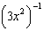?
1)
2)
3)
4)

6 Which expression is equivalent to ?
1) | 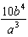
2) | 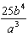
3) | 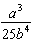
4) | 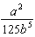

7 Which expression is equivalent to 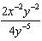?
1)
2)
3)
4)

8 The expression 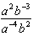 is equivalent to
1)
2)
3)
4)

9 Which expression is equivalent to 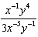?
1) | 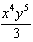
2) | 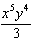
3)
4)

10 Which expression is equivalent to 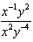?
1)
2)
3)
4)

11 If and , what is the value of the expression 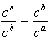, when ?
1) | 0
2) | 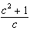
3)
4) | 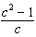

12 Which equation is equivalent to ?
1)
2)
3) | 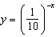
4) | 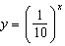

13 If n is a negative integer, then which statement is always true?
1)
2) | 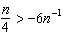
3)
4)

14 Express 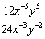 in simplest form, using only positive exponents.

15 Simplify the expression 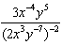 and write the answer using only positive exponents.
1 ANS: 1 REF: 010511a

2 ANS: 2 REF: 080119a

3 ANS: 4 REF: 061402a2

4 ANS: 3
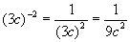

REF: 060826a

5 ANS: 1 REF: 011402a2

6 ANS: 2
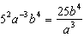

REF: 011514a2

7 ANS: 1 REF: 061324a2

8 ANS: 1 REF: fall0914a2

9 ANS: 1 REF: 061210a2

10 ANS: 4 REF: 061506a2

11 ANS: 4
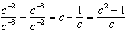

REF: 061621a2

12 ANS: 3 REF: 019515siii

13 ANS: 3
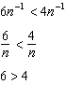. Flip sign when multiplying each side of the inequality by n, since a negative number.

REF: 061314a2

14 ANS:

REF: 011731a2

15 ANS:
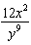. 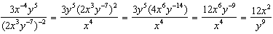

REF: 061134a2

