1 What is the value of ?
1) 2) 3) 9 4)

2 What is the value of
1) 2) 3) 4)

3 What is the value of ?
1) 0 2) 3) 4) 6

4 The expression is equivalent to
1) 2) 3) 4)

5 The expression 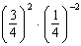 is equivalent to
1) 2) 3) 3 4) 9

6 If and , what is the value of the expression ?
1) 2) 3) 4)

7 If , what is the value of ?
1) 2) 0 3) 4)

8 If , then is equal to
1) 2) 3) 4)

9 Evaluate:

10 If , find the value of .

11 If , find the value of .

12 If , find .

13 If , find .

14 If a function p is defined by 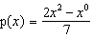, find the value of .
1 ANS: 1 REF: 060020a

2 ANS: 2 REF: 080522a

3 ANS: 3 REF: 010723a

4 ANS: 3 REF: 010413a

5 ANS: 4
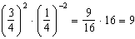

REF: 080730a

6 ANS: 3
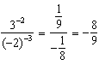

REF: 061003a2

7 ANS: 4
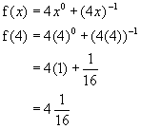

REF: 060406b

8 ANS: 2
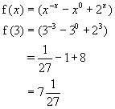

REF: 080701b

9 ANS:

REF: 089306siii

10 ANS:

REF: 018403siii

11 ANS:

REF: 088403siii

12 ANS:

REF: 060302siii

13 ANS:

REF: 068812siii

14 ANS:
1

REF: 068503siii

