1 What is the fourth term in the expansion of ?

2 What is the third term in the expansion of ?

3 Find, in simplest form, the middle term in the expansion of 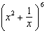.

4 Expand and express in simplest form: 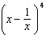.

5 Write the binomial expansion of as a polynomial in simplest form.

1 ANS:
.

REF: 010726b

2 ANS:

REF: 069515siii

3 ANS:

REF: 019941siii

4 ANS:
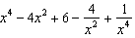

REF: 069641siii

5 ANS:
. . . . . .

REF: 011136a2

