1 What are the zeros of ?
1) | 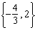
2)
3) | 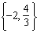
4)

2 The zeros of the function are
1) | and 3
2) | and 4
3) | and 6
4) | and 8

3 The zeros of the function are
1) | and 6
2) | 1 and
3) | 2 and
4) | and 3

4 What are the zeros of the function ?
1) | and 3
2) | 10 and
3) | and 2
4) | 15 and

5 The zeros of the function are
1) | 3 and
2) | 3 and 1
3) | and 1
4) | and

6 The zeros of the function are
1) | and
2) | 1 and
3) | 1 and 2
4) | and 2

7 The zeros of the function are
1) | and 5
2) | and 7
3) | and 2
4) | and 3

8 Keith determines the zeros of the function to be and 5. What could be Keith's function?
1)
2)
3)
4)

9 For which function defined by a polynomial are the zeros of the polynomial and ?
1)
2)
3)
4)

10 If , which equation can be used to determine the zeros of the function?
1)
2)
3)
4)

11 Determine all the zeros of , algebraically.

12 The function is defined by the expression . Use factoring to determine the zeros of . Explain what the zeros represent on the graph of .

13 Find the zeros of , algebraically.

14 The zeros of the function are
1) | 0,, and 2
2) | 0, 5, and
3) | and 2, only
4) | 5 and , only

15 What are the zeros of ?
1) | and 4, only
2) | and 8, only
3)
4)

16 If the zeros of the function are , which function could represent ?
1)
2)
3)
4)

17 Which function has the zeros , 3, and ?
1)
2)
3)
4)

18 Which polynomial function has zeros at , 0, and 4?
1)
2)
3)
4)

19 The zeros of a polynomial function are , 4, and 0. What are all the factors of this function?
1)
2)
3)
4)

20 Explain how to determine the zeros of . State the zeros of the function.
1 ANS: 1
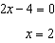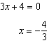

REF: 062212ai

2 ANS: 3
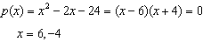

REF: 061804ai

3 ANS: 1
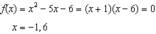

REF: 061612ai

4 ANS: 4
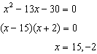

REF: 061510ai

5 ANS: 1
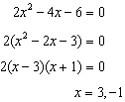

REF: 011609ai

6 ANS: 4
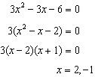

REF: 081513ai

7 ANS: 4
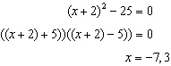

REF: 081418ai

8 ANS: 3 REF: 061412ai

9 ANS: 2
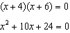

REF: spr1303ai

10 ANS: 2 REF: 081816ai

11 ANS:
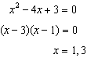

REF: 011826ai

12 ANS:
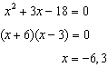 The zeros are the x-intercepts of .

REF: 061733ai

13 ANS:
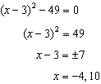

REF: 081631ai

14 ANS: 2 REF: 062409ai

15 ANS: 3

REF: 082313ai

16 ANS: 3 REF: 012322ai

17 ANS: 3 REF: 082421ai

18 ANS: 3 REF: 061710ai

19 ANS: 3 REF: 012423ai

20 ANS:
Graph and find x-intercepts.

REF: 081825ai

