1 When factoring to reveal the roots of the equation , which equations can be used?
I.
II.
III.
1) | I and II, only
2) | I and III, only
3) | II and III, only
4) | I, II, and III

2 How many negative solutions to the equation exist?
1) | 1
2) | 2
3) | 3
4) | 0

3 The zeros of the function are
1) | 9, only
2) | 0 and 9
3) | 0 and 3, only
4) | , 0, and 3

4 Which values of x are solutions of the equation ?
1)
2)
3)
4)

5 The zeros of the function are
1)
2)
3)
4)

6 Given , the solution of is
1)
2) | 2, only
3)
4)

7 Evan graphed a cubic function, , and determined the roots of to be and 2. What is the value of b, if ?
1) | 1
2) | 2
3)
4)

8 Which statement regarding polynomials and their zeros is true?
1) | has zeros of 1 and , only.
2) | has zeros of 4 and a, only.
3) | has zeros of and .
4) | has zeros of and a.

9 What are the zeros of ?
1)
2)
3)
4)

10 Given and , which values satisfy ?
1) | only
2) | only
3)
4)

11 The zeros for are
1)
2)
3)
4)

12 What is the solution set of the equation ?
1)
2)
3)
4)

13 What are the zeros of ?
1)
2)
3)
4)

14 Given 3 is a root of , what are the other unique roots of ?
1) | , only
2) | and 0
3) | , 1 and 5
4) | , and 0

15 Determine algebraically the zeros of .

16 Solve the equation algebraically for all values of x.

17 Algebraically determine the zeros of the function below.

18 Solve the equation algebraically for all values of x.

19 Solve algebraically.

20 Solve algebraically for all values of x:

21 Solve, giving 4 roots,

22 Solve: (Find 4 roots.)

23 Solve: . Find 4 roots.

24 Find four roots of the following equation:

25 Given , , and , algebraically determine all the zeros of .

26 Denise is designing a storage box in the shape of a cube. Each side of the box has a length of 10 inches. She needs more room and decides to construct a larger box in the shape of a cube with a volume of 2,000 cubic inches. By how many inches, to the nearest tenth, should she increase the length of each side of the original box?
1 ANS: 1
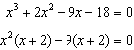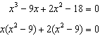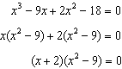

REF: 011903aii

2 ANS: 4
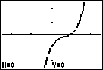

REF: 061222a2

3 ANS: 2
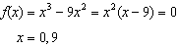

REF: 012009ai

4 ANS: 2
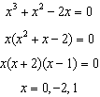

REF: 011103a2

5 ANS: 3
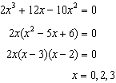

REF: 081719ai

6 ANS: 4
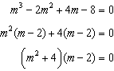

REF: 081821aii

7 ANS: 4

REF: 081921aii

8 ANS: 4
1) is also a zero. 2) a is the only zero. 3) is the only zero. 4) .

REF: 012019aii

9 ANS: 4 REF: 081708aii

10 ANS: 3
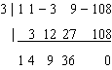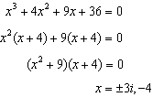

REF: 062420aii

11 ANS: 1
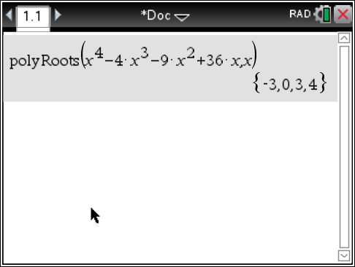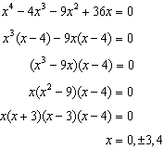

REF: 061606aii

12 ANS: 3
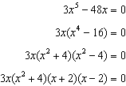

REF: 011216a2

13 ANS: 4
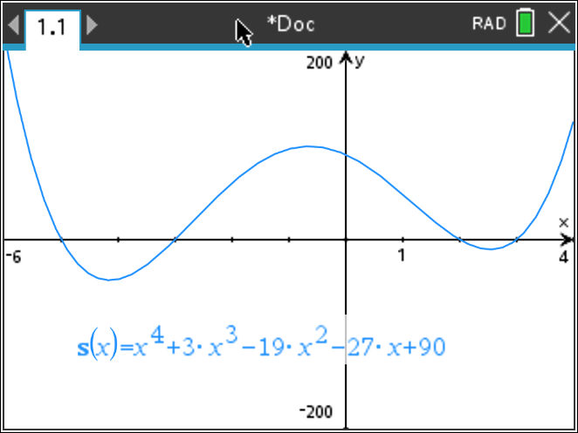

REF: 062303aii

14 ANS: 2
3 | 1 | -1 | -21 | 45 | 0
 |  | 3 | 6 | -45 | 0
 | 1 | 2 | -15 | 0 | 0
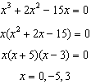

REF: 012403aii

15 ANS:
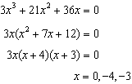

REF: 011930ai

16 ANS:
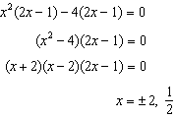

REF: 081537a2

17 ANS:
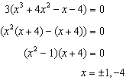

REF: 012325aii

18 ANS:
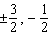. 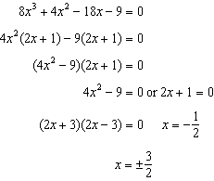

REF: fall0937a2

19 ANS:
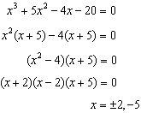

REF: 061437a2

20 ANS:
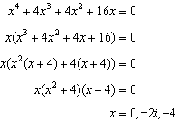

REF: 061339a2

21 ANS:

REF: 089604al

22 ANS:

REF: 069407al

23 ANS:

REF: 089409al

24 ANS:
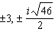

REF: 089812al

25 ANS:
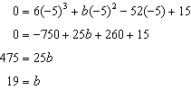
-5 | 6 | 19 | -52 | 15
 |  | -30 | 55 | 15
 | 6 | -11 | 3 | 0
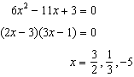

REF: fall1515aii

26 ANS:
2.6. 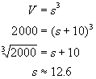. Increase the length of each side of the box by 2.6 inches (12.6 – 10).

REF: 060724b

