1 A polynomial function contains the factors x, , and . Which graph(s) below could represent the graph of this function?

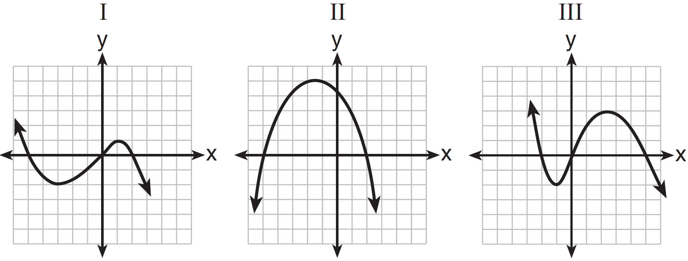
1) | I, only
2) | II, only
3) | I and III
4) | I, II, and III

2 Based on the graph below, which expression is a possible factorization of ?

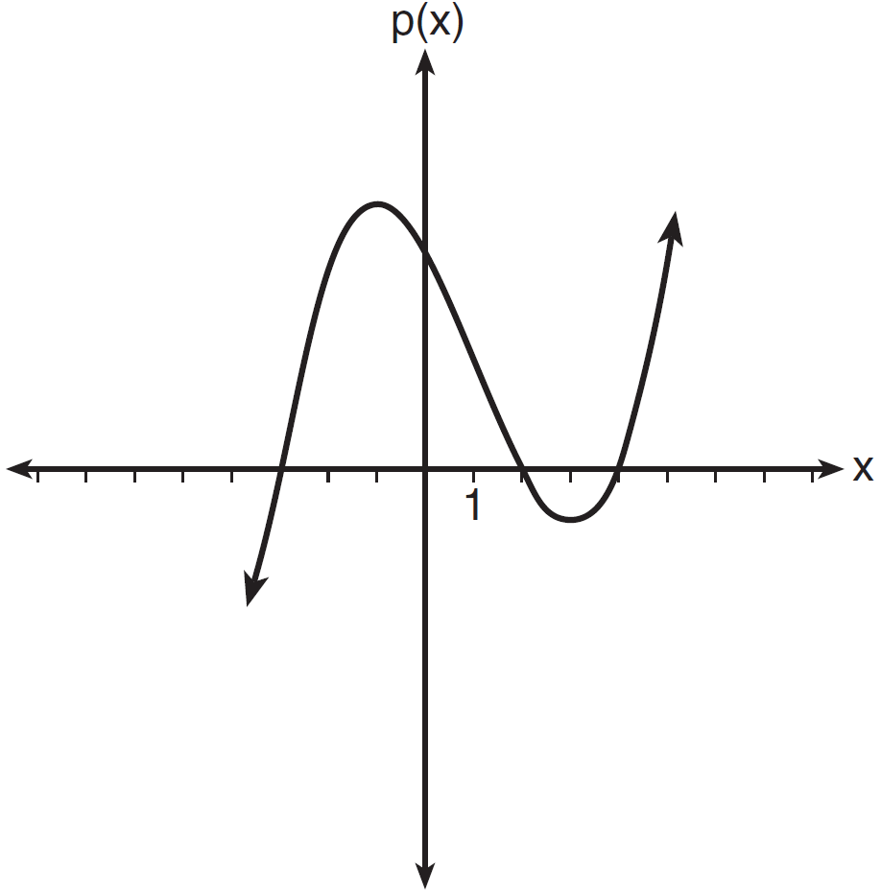
1)
2)
3)
4)

3 A cubic function is graphed on the set of axes below.

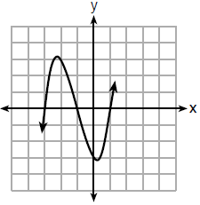

Which function could represent this graph?
1)
2)
3)
4)

4 A polynomial function is graphed below.

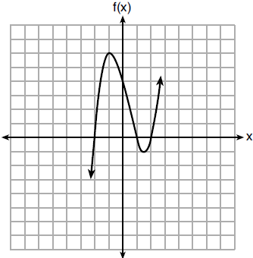

Which function could represent this graph?
1)
2)
3)
4)

5 The graph of a cubic polynomial function is shown below.

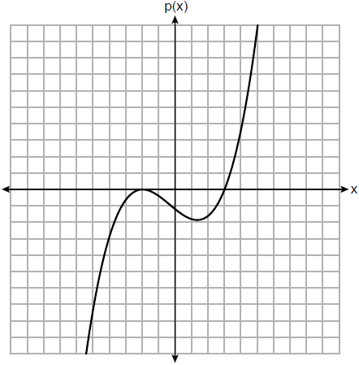

If is written as a product of linear factors, which factor would appear twice?
1)
2)
3)
4)

6 Wenona sketched the polynomial as shown on the axes below.

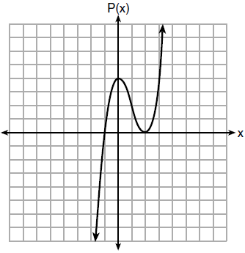

Which equation could represent ?
1)
2)
3)
4)

7 A function is graphed below.
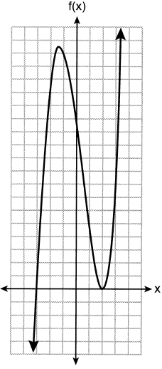
A possible equation for this function is
1)
2)
3)
4)

8 The graph of is shown below.
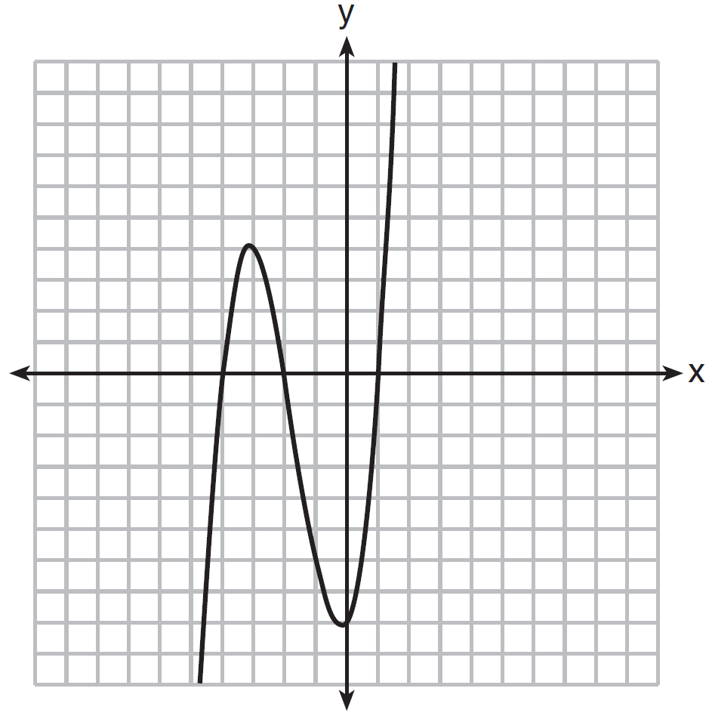

Which function could represent the graph of ?
1)
2)
3)
4)

9 The graph of the function is sketched below.

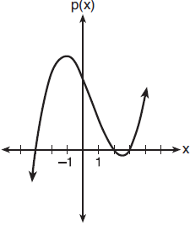

Which equation could represent ?
1)
2)
3)
4)

10 Which equation(s) represent the graph below?
I
II
III

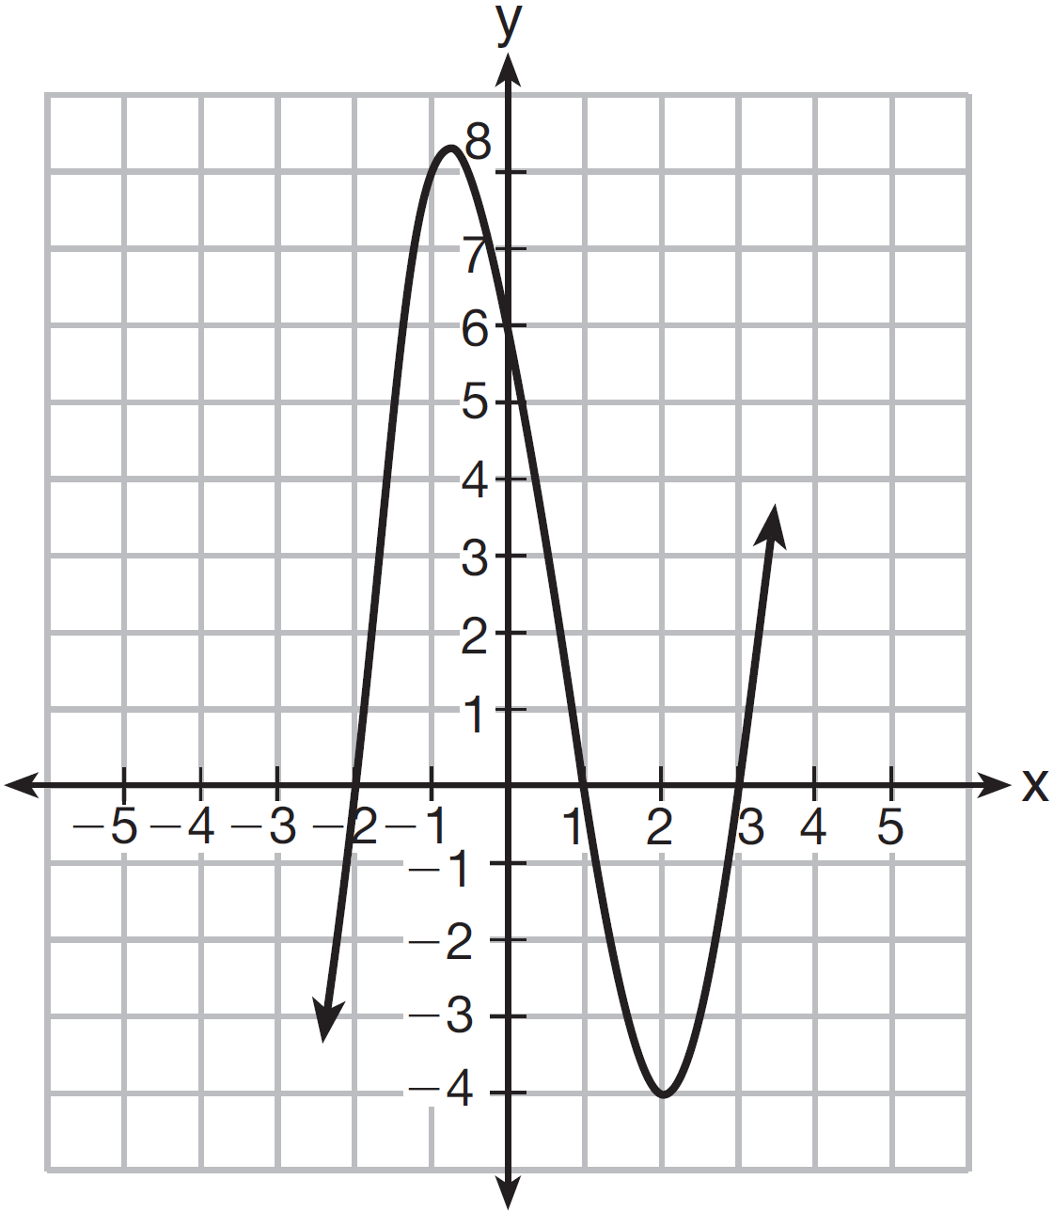
1) | I, only
2) | II, only
3) | I and II
4) | II and III

11 A sketch of is shown below.

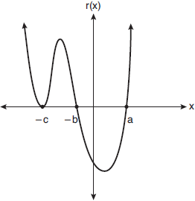

An equation for could be
1)
2)
3)
4)

12 Which sketch represents the polynomial function ?
1) | 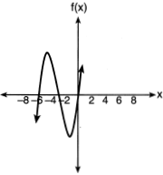
2) | 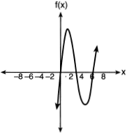
3) | 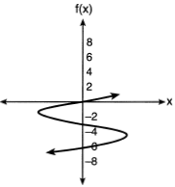
4) | 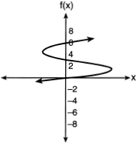

13 Which graph best represents the graph of , where a and b are positive real numbers?
1) | 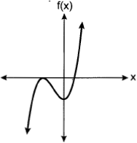
2) | 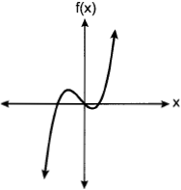
3) | 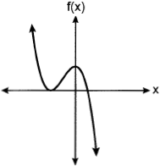
4) | 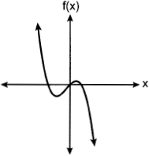

14 Which graph represents a polynomial function that contains as a factor?
1) | 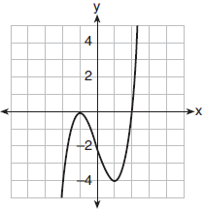
2) | 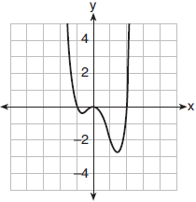
3) | 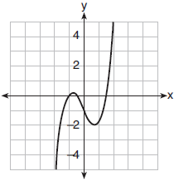
4) | 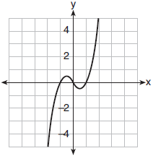

15 If a, b, and c are all positive real numbers, which graph could represent the sketch of the graph of ?
1) | 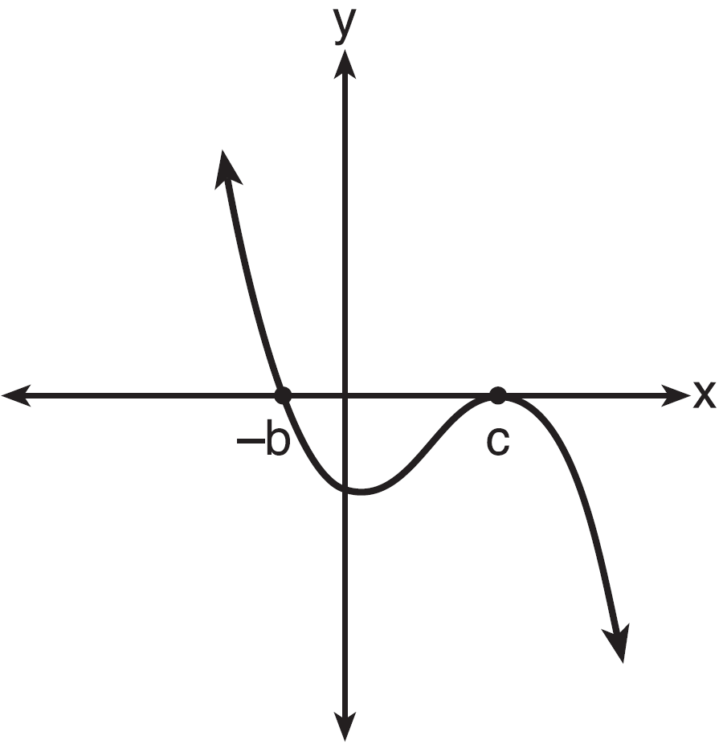
2) | 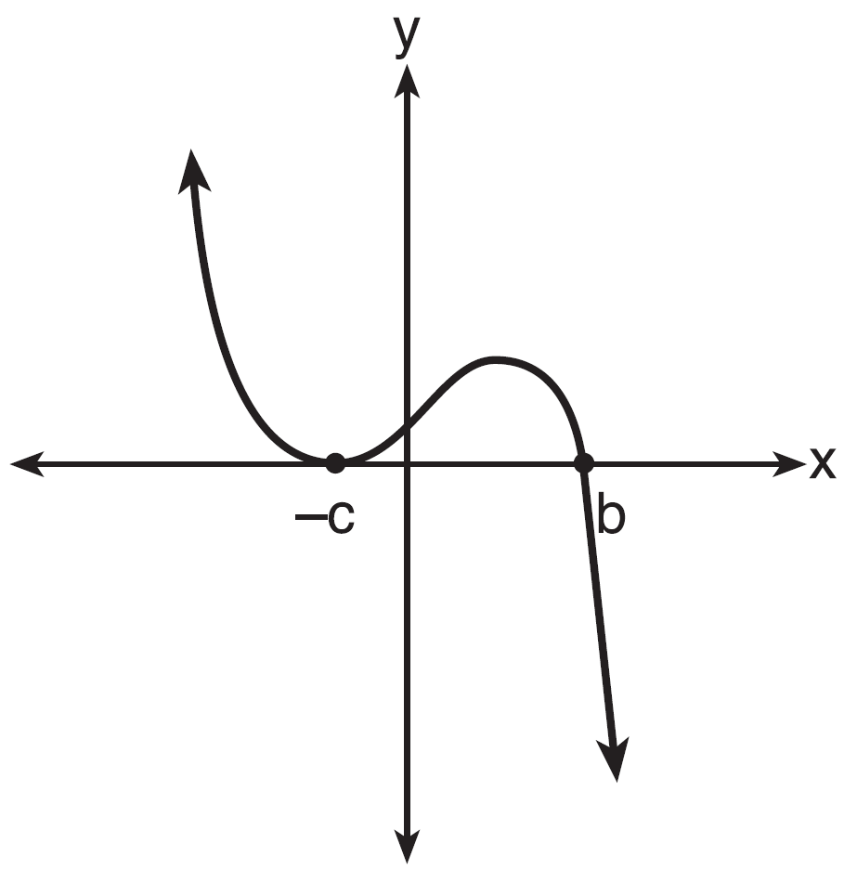
3) | 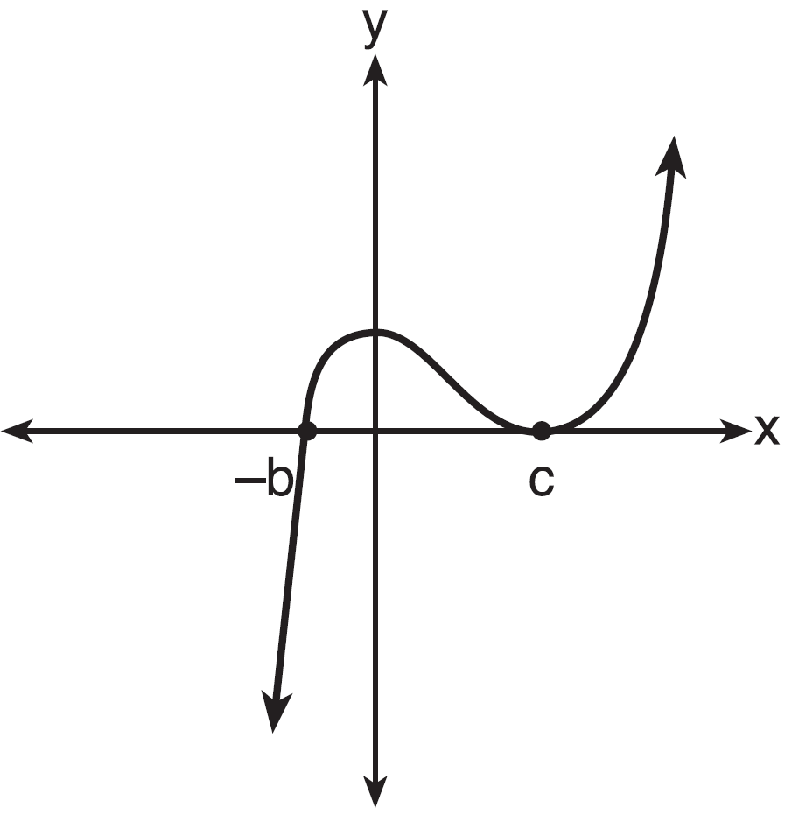
4) | 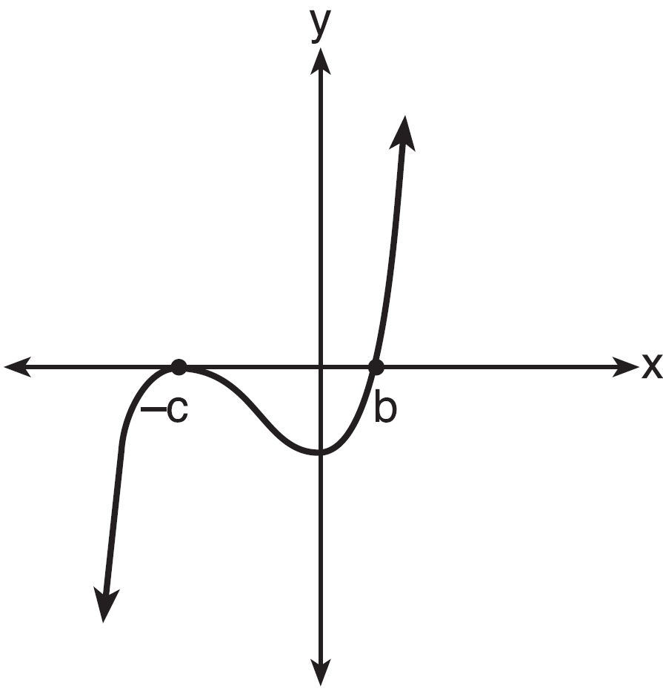

16 On the axes below, sketch a possible function , where a, b, and c are positive, , and has a positive y-intercept of d. Label all intercepts.

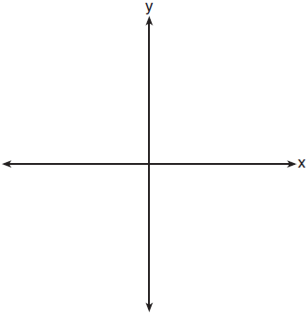
1 ANS: 1 REF: 011524ai

2 ANS: 1 REF: 081623ai

3 ANS: 2 REF: 061818ai

4 ANS: 3

REF: 061908ai

5 ANS: 2 REF: 082324aii

6 ANS: 1 REF: 081707ai

7 ANS: 3 REF: 062310ai

8 ANS: 1

REF: 081504ai

9 ANS: 1 REF: 061701aii

10 ANS: 2

REF: 061512ai

11 ANS: 4 REF: 061921aii

12 ANS: 1
The zeros of f are -6, -3 and 0.

REF: 062112ai

13 ANS: 1 REF: 012405aii
14 ANS: 1

REF: 011919aii

15 ANS: 1
The zeros of the polynomial are at , and c. The sketch of a polynomial of degree 3 with a negative leading coefficient should have end behavior showing as x goes to negative infinity, goes to positive infinity. The multiplicities of the roots are correctly represented in the graph.

REF: spr1501aii

16 ANS:
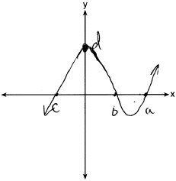

REF: 081732aii

