1 Three expressions are shown below.
I.
II.
III.
Which expressions are equivalent for all positive values of x?
1) | I and II, only
2) | I and III, only
3) | II and III, only
4) | I, II, and III

2 Three expressions are written below.
A.
B.
C.
Which expressions are equivalent to ?
1) | A and B, only
2) | B and C, only
3) | A and C, only
4) | A, B, and C

3 If the expression is equivalent to , what is the value of a?
1) | 12
2) | 2
3) | 32
4) | 4

4 Which expression is equivalent to ?
1)
2)
3)
4)

5 The expression is equivalent to
1)
2)
3)
4)

6 The expression is equivalent to
1)
2)
3)
4)

7 Which expression is equivalent to ?
1)
2)
3)
4)

8 Which expression is not equivalent to 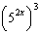?
1) | 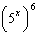
2) | 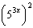
3) | 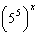
4) | 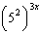

9 Expressed in simplest form, is equivalent to
1)
2)
3)
4)

10 The product of and is
1)
2)
3)
4)

11 If , then 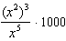 is equivalent to
1)
2)
3) | 1000
4) | 0

12 The expression 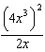 is equivalent to
1)
2)
3)
4)

13 The expression 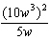 is equivalent to
1)
2)
3)
4)

14 The expression 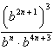 is equivalent to
1)
2)
3)
4)

15 Which equation is true?
1) | 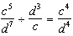
2)
3) | 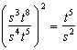
4)

16 Which statement is correct?
1)
2) | 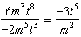
3)
4) | 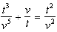

17 If , then is equal to
1)
2)
3)
4)

1 ANS: 4
Each expression equals .

REF: 082311ai

2 ANS: 1

REF: 012419ai

3 ANS: 2 REF: 061312ia

4 ANS: 4 REF: 080827ia

5 ANS: 1 REF: 010728a

6 ANS: 2 REF: 080824a

7 ANS: 3 REF: 062114ai

8 ANS: 3 REF: 062209ai

9 ANS: 4

REF: 010529a

10 ANS: 4

REF: 010506b

11 ANS: 1
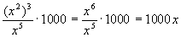

REF: 060518a

12 ANS: 4
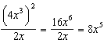

REF: 011216ia

13 ANS: 3
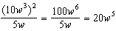

REF: 011124ia

14 ANS: 2
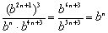

REF: 080415b

15 ANS: 2 REF: 081318ia

16 ANS: 2 REF: 061625ia

17 ANS: 1 REF: 080811b

