1 What is the product of and ?
1)
2)
3)
4)

2 What is the product of and ?
1)
2)
3)
4)

3 What is the product of and ?
1)
2)
3)
4)

4 What is the product of and ?
1)
2)
3)
4)

5 The expression is equivalent to
1)
2)
3)
4)

6 The expression 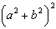 is equivalent to
1)
2)
3)
4)

7 The expression is equivalent to
1)
2)
3) | 3
4)

8 What is the product of and ?
1)
2)
3)
4)

9 Chad had a garden that was in the shape of a rectangle. Its length was twice its width. He decided to make a new garden that was 2 feet longer and 2 feet wider than his first garden. If x represents the original width of the garden, which expression represents the difference between the area of his new garden and the area of the original garden?
1)
2)
3)
4) | 8

10 The length of a rectangle is represented by , and the width is represented by . Express the perimeter of the rectangle as a trinomial. Express the area of the rectangle as a trinomial.

11 What is the product of 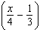 and 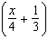?
1) | 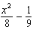
2) | 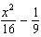
3) | 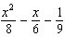
4) | 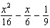

12 What is the product of 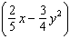 and 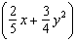?
1) | 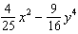
2) | 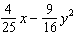
3) | 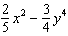
4)

13 The expression 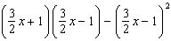 is equivalent to
1) | 0
2)
3) | 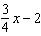
4)

14 Express 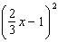 as a trinomial.

15 Express the product of 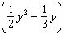 and 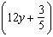 as a trinomial.
1 ANS: 1 REF: 010819a

2 ANS: 1 REF: 060807ia

3 ANS: 1

REF: 060708a

4 ANS: 3

REF: 061210ia

5 ANS: 3

REF: 060015a

6 ANS: 3

REF: 010430a

7 ANS: 1 REF: 088917siii

8 ANS: 1

REF: 061609a2

9 ANS: 1
The area of the original garden is The area of the new garden is 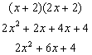.

REF: 010202b

10 ANS:

REF: 061538ia

11 ANS: 2
The binomials are conjugates, so use FL.

REF: 011206a2

12 ANS: 1
The binomials are conjugates, so use FL.

REF: 061201a2

13 ANS: 4
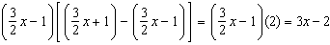

REF: 011524a2

14 ANS:
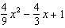. 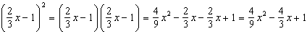

REF: 081034a2

15 ANS:
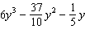. 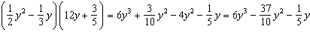

REF: 061128a2

