1 How many times larger than is ?
1) | 20
2) | 9
3)
4)

2 What is half of ?
1)
2)
3)
4)

3 What is one-third of ?
1)
2)
3)
4)

4 The quotient of 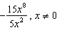, is

1)
2)
3)
4)

5 The expression 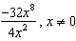, is equivalent to
1)
2)
3)
4)

6 When is divided by , the quotient is
1)
2)
3)
4)

7 Which expression represents 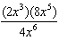 in simplest form?
1)
2)
3)
4)

8 The expression 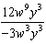 is equivalent to
1)
2)
3)
4)

9 Which expression represents 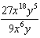 in simplest form?
1)
2)
3)
4)

10 The expression 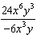 is equivalent to
1)
2)
3)
4)

11 Which expression represents 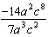 in simplest form?
1)
2)
3) | 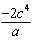
4) | 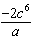

12 The expression 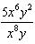 is equivalent to
1)
2)
3)
4)

13 The expression 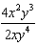 is equivalent to
1)
2)
3)
4)

14 The product of and 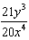, expressed in simplest form, is
1)
2)
3) | 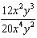
4) | 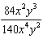

15 Simplify: 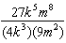
1 ANS: 1
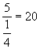

REF: 080213a

2 ANS: 4
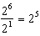

REF: 060813ia

3 ANS: 3
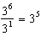

REF: 061219ia

4 ANS: 3 REF: 060005a

5 ANS: 4 REF: 060707a

6 ANS: 2 REF: 080405a

7 ANS: 3
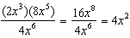

REF: fall0703ia

8 ANS: 1 REF: 061103ia

9 ANS: 1 REF: 060903ia

10 ANS: 4 REF: 011503ia

11 ANS: 4 REF: 061018ia

12 ANS: 2 REF: 080526a

13 ANS: 1 REF: 010817a

14 ANS: 2 REF: 081311ia

15 ANS:
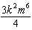

REF: 010932ia

