1 Which expression has the smallest value?
1)
2)
3)
4)

2 Which number has the greatest value?
1)
2)
3)
4) | 1.5

3 In which list are the numbers in order from least to greatest?
1) | 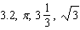
2) | 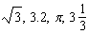
3) | 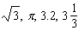
4) | 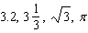

4 Which numbers are arranged from smallest to largest?
1) | 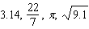
2) | 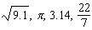
3) | 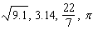
4) | 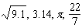

5 Which list is in order from smallest value to largest value?
1) | 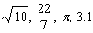
2) | 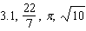
3) | 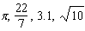
4) | 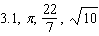

6 Which list shows the numbers 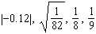 in order from smallest to largest?
1) | 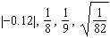
2) | 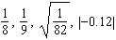
3) | 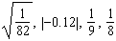
4) | 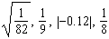

7 In which group are the numbers arranged in order from smallest value to largest value?
1) | 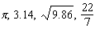
2) | 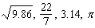
3) | 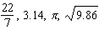
4) | 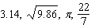

8 Which is the correct arrangement of these terms in order of value, from smallest to greatest?
1) | 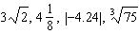
2) | 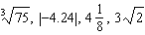
3) | 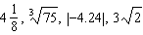
4) | 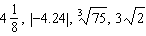

9 Which inequality is true if 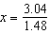, , and ?
1)
2)
3)
4)

10 Kyoko’s mathematics teacher gave her the accompanying cards and asked her to arrange the cards in order from least to greatest. In what order should Kyoko arrange the cards?

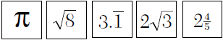

11 Write the following numbers in order from smallest value to largest value: 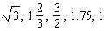
Justify your answer.

12 For what value of t is 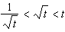 true?
1) | 1
2) | 0
3)
4) | 4

13 If 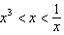, then x could be equal to
1) | 1
2) | 5
3)
4)

14 If , t could be
1) | 0
2) | 2
3)
4) | 4

15 If , then t could be
1)
2) | 0
3)
4) | 4

16 Show that the following can be ordered from smallest to largest for all . Describe the method you used and state the correct order.

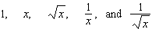

17 If , , and a, b, c, and d are all greater than 0, which expression is always true?
1)
2)
3) | 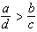
4)

18 Let x and y be numbers such that , and let . Which graph could represent the location of d on the number line?
1) | 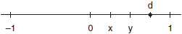
2) | 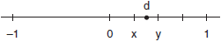
3) | 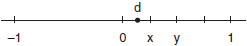
4) | 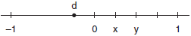

1 ANS: 3
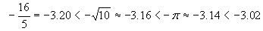

REF: 010526a

2 ANS: 1
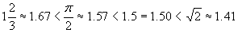

REF: 010002a

3 ANS: 3
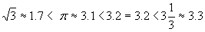

REF: 010304a

4 ANS: 4
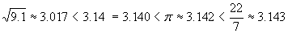

REF: 080516a

5 ANS: 4
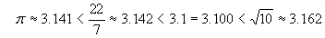

REF: 060609a

6 ANS: 4
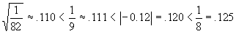

REF: 080621a

7 ANS: 4

REF: 010816a

8 ANS: 3
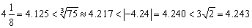

REF: fall9909b

9 ANS: 3
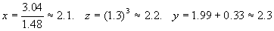

REF: 010213a

10 ANS:
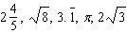. 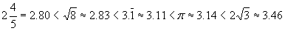

REF: 060433a

11 ANS:
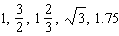. 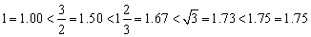

REF: 060835a

12 ANS: 4 REF: spring9813a

13 ANS: 4
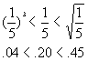

REF: 010512a

14 ANS: 3
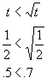
REF: 080717a

15 ANS: 3
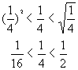
REF: 069917a

16 ANS:
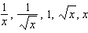. If 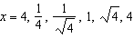
REF: fall9921b

17 ANS: 4
Cross-multiplying, ac < bd
REF: 080006a

18 ANS: 4
Because x < y, x – y must be negative, so d < 0.
REF: 010120a

