1 Which number is rational?
1)
2)
3)
4)

2 Which is a rational number?
1)
2)
3)
4)

3 Which expression is rational?
1)
2)
3)
4)

4 Which is an irrational number?
1)
2)
3)
4)

5 Which is an irrational number?
1) | 0
2)
3)
4)

6 The number 0.14114111411114 . . . is
1) | integral
2) | rational
3) | irrational
4) | whole

7 Which expression represents an irrational number?
1)
2)
3) | 0.17
4) | 0

8 Which number is irrational?
1)
2)
3) | 0.3333
4)

9 Which is an irrational number?
1)
2)
3)
4)

10 Which number is irrational?
1)
2)
3)
4)

11 The value of is a real and irrational number when x is equal to
1) | 5
2) | 0
3)
4) | 4

12 Which number below is irrational?
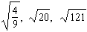
Why is the number you chose an irrational number?

13 Given: 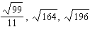
Identify the expression that is a rational number and explain why it is rational.

14 Write an irrational number and explain why it is irrational.

1 ANS: 2
is rational because it is the ratio of two integers.

REF: 060003a

2 ANS: 3
is rational because it is the ratio of two integers, .

REF: 060120a

3 ANS: 4
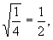 the ratio of two integers.

REF: 080102a

4 ANS: 3
is irrational as it may not be expressed as the ratio of two integers. 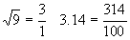

REF: 010219a

5 ANS: 2
π may not be expressed as the ratio of two integers. 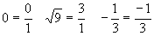

REF: 060211a

6 ANS: 3
The number 0.14114111411114 . . . is irrational because it may not be expressed as the ratio of two integers. It is not a repeating decimal.

REF: 080208a

7 ANS: 1
is irrational as it may not be expressed as the ratio of two integers. 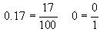

REF: 060303a

8 ANS: 2
is irrational as it may not be expressed as the ratio of two integers. 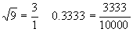

REF: 010416a

9 ANS: 4
π is an irrational number as it may not be expressed as the ratio of two integers. 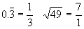

REF: 080523a

10 ANS: 4
π may not be expressed as the ratio of two integers. 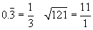

REF: 080718a

11 ANS: 4

REF: 060813b

12 ANS:
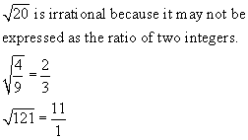

REF: 069923a

13 ANS:
because the number may be written as the ratio of integers. 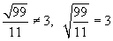

REF: 080432a

14 ANS:
because it may not be expressed as the ratio of two integers.

REF: 010632a

