1 A cube, with faces numbered 1 to 6, is rolled, and a penny is tossed at the same time. How many elements in the sample space consist of an even number and a tail?
1) | 12
2) | 2
3) | 3
4) | 4

2 A sandwich consists of one type of meat, one type of condiment, and one type of cheese. The possible choices are listed below:
Meat: beef, chicken, turkey
Condiment: ketchup, mustard, mayonnaise
Cheese: American, cheddar, provolone, mozzarella
In the sample space of all the possible different sandwiches consisting of one type of meat, one type of condiment, and one type of cheese, how many sandwiches do not include provolone cheese?
1) | 27
2) | 9
3) | 3
4) | 36

3 Clayton is performing some probability experiments consisting of flipping three fair coins. What is the probability that when Clayton flips the three coins, he gets two tails and one head?

4 The Grimaldis have three children born in different years.
a Draw a tree diagram or list a sample space to show all the possible arrangements of boy and girl children in the Grimaldi family.
b Using your information from part a, what is the probability that the Grimaldis have three boys?

5 If Laquisha can enter school by any one of three doors and the school has two staircases to the second floor, in how many different ways can Laquisha reach a room on the second floor? Justify your answer by drawing a tree diagram or listing a sample space.

6 Kimberly has three pair of pants: one black, one red, and one tan. She also has four shirts: one pink, one white, one yellow, and one green. Draw a tree diagram or list the sample space showing all possible outfits that she could wear, if an outfit consists of one pair of pants and one shirt. How many different outfits can Kimberly wear?

7 Samuel is buying a new car. He wants either a convertible or a hatchback. Both types of cars are available in red, white, or blue and with automatic or standard transmission. Draw a tree diagram or list a sample space of all possible choices of cars that are available.

8 Mr. Laub has three children: two girls (Sue and Karen) and one boy (David). After each meal, one child is chosen at random to wash dishes. If the same child can be chosen for both lunch and dinner, construct a tree diagram or list a sample space of all the possible outcomes of who will wash dishes after lunch and dinner on Saturday. Determine the probability that one boy and one girl will wash dishes after lunch and dinner on Saturday.

9 A restaurant sells kids' meals consisting of one main course, one side dish, and one drink, as shown in the table below.

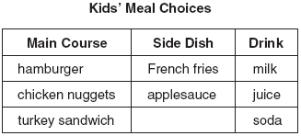

Draw a tree diagram or list the sample space showing all possible kids' meals. How many different kids' meals can a person order? Jose does not drink juice. Determine the number of different kids' meals that do not include juice. Jose's sister will eat only chicken nuggets for her main course. Determine the number of different kids' meals that include chicken nuggets.

10 An outfit Jennifer wears to school consists of a top, a bottom, and shoes. Possible choices are listed below.
Tops: T-shirt, blouse, sweater
Bottoms: jeans, skirt, capris
Shoes: flip-flops, sneakers
List the sample space or draw a tree diagram to represent all possible outfits consisting of one type of top, one type of bottom, and one pair of shoes. Determine how many different outfits contain jeans and flip-flops. Determine how many different outfits do not include a sweater.

11 A sandwich consists of one type of bread, one type of meat, and one type of cheese. The possible choices are listed below.
Bread: white, rye
Meat: ham, turkey, beef
Cheese: American, Swiss
Draw a tree diagram or list a sample space of all the possible different sandwiches consisting of one type of bread, one type of meat, and one type of cheese. Determine the number of sandwiches that will not include turkey. Determine the number of sandwiches that will include rye bread and Swiss cheese.

12 In a game, a player must spin each spinner shown in the diagram below once.

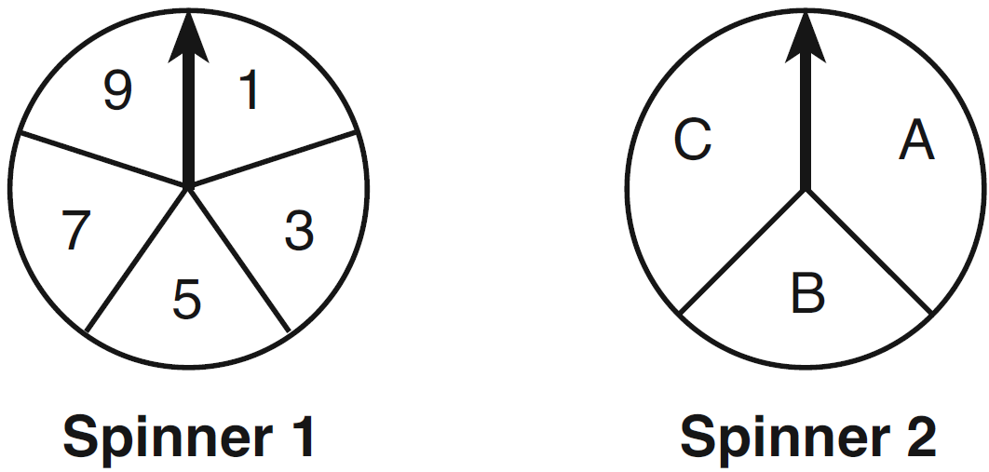

Draw a tree diagram or list a sample space showing all possible outcomes. Determine the number of outcomes that consist of a prime number and a letter in the word “CAT.”

13 A company is running a contest and offering a first, second, and third prize. First prize is a choice of a car or $15,000 cash. Second prize is a choice of a motorbike, a trip to New York City, or $2,000 cash. Third prize is a choice of a television or $500 cash. If each prize is equally likely to be selected, list the sample space or draw a tree diagram of all possible different outcomes of first, second, and third prizes. Determine the number of ways that all three prizes selected could be cash. Determine the number of ways that none of the three prizes selected could be cash.

14 Doug has four baseball caps: one tan, one blue, one red, and one green. He also has three jackets: one blue, one red, and one white. Draw a tree diagram or list a sample space to show all possible outfits consisting of one baseball cap and one jacket. Find the number of Doug’s outfits that consist of a cap and a jacket that are different colors. On Spirit Day, Doug wants to wear either green or white, his school’s colors. Find the number of his outfits from which he can choose.

1 ANS: 3
REF: 081324ia

2 ANS: 1
REF: 081413ia

3 ANS: . (H,H,H), (H,H,T), (H,T,H), (H,T,T), (T,H,H), (T,H,T), (T,T,H), (T,T,T)
REF: 061432ia

4 ANS: (G,G,G), (G,G,B), (G,B,G), (G,B,B), (B,G,G), (B,G,B), (B,B,G), (B,B,B).
REF: 089922a

5 ANS: 6 different ways: (D₁, S₁), (D₁, S₂), (D₂, S₁), (D₂, S₂), (D₃, S₁), (D₃, S₂)
REF: 010321a

6 ANS: (B,P), (B,W), (B,Y), (B,G), (R,P), (R,W), (R,Y), (R,G), (T,P), (T,W), (T,Y), (T,G); 12
REF: 010731a

7 ANS: CRA, CRT, CWA, CWT, CBA, CBT, HRA, HRT, HWA, HWT, HBA, HBT
REF: 060831a

8 ANS: (S,S), (S,K), (S,D), (K,S), (K,K), (K,D), (D,S), (D,K), (D,D),
REF: fall0736ia

9 ANS: (H,F,M), (H,F,J), (H,F,S), (H,A,M), (H,A,J), (H,A,S), (C,F,M), (C,F,J), (C,F,S), (C,A,M), (C,A,J), (C,A,S), (T,F,M), (T,F,J), (T,F,S), (T,A,M), (T,A,J), (T,A,S). There are 18 different kids’ meals, 12 do not include juice and 6 include chicken nuggets.
REF: 010939ia

10 ANS: (T,J,F), (T,J,N), (T,K,F), (T,K,N), (T,C,F), (T,C,N), (B,J,F), (B,J,N), (B,K,F), (B,K,N), (B,C,F), (B,C,N), (S,J,F), (S,J,N), (S,K,F), (S,K,N), (S,C,F), (S,C,N). 3, 12.
REF: 061138ia

11 ANS: (W,H,A), (W,H,S), (W,T,A), (W,T,S), (W,B,A), (W,B,S), (R,H,A), (R,H,S), (R,T,A), (R,T,S), (R,B,A), (R,B,S). 8, 3
REF: 011238ia

12 ANS: (1,A), (1,B), (1,C), (3,A), (3,B), (3,C), (5,A), (5,B), (5,C), (7,A), (7,B), (7,C), (9,A), (9,B), (9,C). 6
REF: 011334ia

13 ANS: (C,B,T), (C,B,5), (C,N,T), (C,N,5), (C,2,T), (C,2,5), (F,B,T), (F,B,5), (F,N,T), (F,N,5), (F,2,T), (F,2,5). 1, 2.
REF: 081237ia

14 ANS: cap-jacket: TT, TR, TW, BB, BR, BW, RB, RR, RW, GB, GR, GW, 10, 6.
REF: 011439ia

