1 The groundskeeper is replacing the turf on a football field. His measurements of the field are 130 yards by 60 yards. The actual measurements are 120 yards by 54 yards. Which expression represents the relative error in the measurement?
1) | 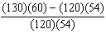
2) | 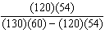
3) | 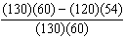
4) | 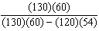

2 Carrie bought new carpet for her living room. She calculated the area of the living room to be 174.2 square feet. The actual area was 149.6 square feet. What is the relative error of the area to the nearest ten-thousandth?
1) | 0.1412
2) | 0.1644
3) | 1.8588
4) | 2.1644

3 Corinne calculated the area of a paper plate to be 50.27 square inches. If the actual area of the plate is 55.42 square inches, what is the relative error in calculating the area, to the nearest thousandth?
1) | 0.092
2) | 0.093
3) | 0.102
4) | 0.103

4 Jack wants to replace the flooring in his rectangular kitchen. He calculates the area of the floor to be 12.8 square meters. The actual area of the floor is 13.5 square meters. What is the relative error in calculating the area of the floor, to the nearest thousandth?
1) | 0.051
2) | 0.052
3) | 0.054
4) | 0.055

5 Students calculated the area of a playing field to be 8,100 square feet. The actual area of the field is 7,678.5 square feet. Find the relative error in the area, to the nearest thousandth.

6 The actual dimensions of a rectangle are 2.6 cm by 6.9 cm. Andy measures the sides as 2.5 cm by 6.8 cm. In calculating the area, what is the relative error, to the nearest thousandth?
1) | 0.055
2) | 0.052
3) | 0.022
4) | 0.021

7 The dimensions of a rectangle are measured to be 12.2 inches by 11.8 inches. The actual dimensions are 12.3 inches by 11.9 inches. What is the relative error, to the nearest ten-thousandth, in calculating the area of the rectangle?
1) | 0.0168
2) | 0.0167
3) | 0.0165
4) | 0.0164

8 Jim calculated the area of a triangle to be 51.75 cm². The actual area of the triangle is 53.24 cm². Find the relative error in Jim's calculation of the area to the nearest thousandth.

9 Linda measures her rectangular bedroom window for a new shade. The measurements she made are 36 inches by 42 inches. The actual measurements of the window are 36.5 inches and 42.5 inches. Determine the relative error in calculating the area. Express your answer as a decimal to the nearest thousandth.

10 Wendy measures the floor in her rectangular bedroom for new carpeting. Her measurements are 24 feet by 14 feet. The actual measurements are 24.2 feet by 14.1 feet. Determine the relative error in calculating the area of her bedroom. Express your answer as a decimal to the nearest thousandth.

11 Janis measures the dimensions of the floor in her rectangular classroom for a rug. Her measurements are 10.50 feet by 12.25 feet. The actual measurements of the floor are 10.75 feet by 12.50 feet. Determine the relative error in calculating the area, to the nearest thousandth.

12 Sophie measured a piece of paper to be 21.7 cm by 28.5 cm. The piece of paper is actually 21.6 cm by 28.4 cm. Determine the number of square centimeters in the area of the piece of paper using Sophie’s measurements. Determine the number of square centimeters in the actual area of the piece of paper. Determine the relative error in calculating the area. Express your answer as a decimal to the nearest thousandth. Sophie does not think there is a significant amount of error. Do you agree or disagree? Justify your answer.

13 Sarah measures her rectangular bedroom window for a new shade. Her measurements are 36 inches by 42 inches. The actual measurements of the window are 36.5 inches and 42.5 inches. Using the measurements that Sarah took, determine the number of square inches in the area of the window. Determine the number of square inches in the actual area of the window. Determine the relative error in calculating the area. Express your answer as a decimal to the nearest thousandth.

14 The actual side of a square tile is 4 inches. The manufacturers allow a relative error of 0.025 in the area of a tile. Two machines are used to cut the tiles. Machine A produces a square tile with a length of 3.97 inches. Machine B produces a square tile with a length of 4.12 inches. Determine which machine produces a tile whose area falls within the allowed relative error.

15 Ryan estimates the measurement of the volume of a popcorn container to be 282 cubic inches. The actual volume of the popcorn container is 289 cubic inches. What is the relative error of Ryan's measurement to the nearest thousandth?
1) | 0.024
2) | 0.025
3) | 0.096
4) | 1.025

16 To calculate the volume of a small wooden cube, Ezra measured an edge of the cube as 2 cm. The actual length of the edge of Ezra’s cube is 2.1 cm. What is the relative error in his volume calculation to the nearest hundredth?
1) | 0.13
2) | 0.14
3) | 0.15
4) | 0.16

17 Using his ruler, Howell measured the sides of a rectangular prism to be 5 cm by 8 cm by 4 cm. The actual measurements are 5.3 cm by 8.2 cm by 4.1 cm. Find Howell’s relative error in calculating the volume of the prism, to the nearest thousandth.

18 Ashley measured the dimensions of a rectangular prism to be 6 cm by 10 cm by 1.5 cm. The actual dimensions are 5.9 cm by 10.3 cm by 1.7 cm. Determine the relative error, to the nearest thousandth, in calculating the volume of the prism.

19 A storage container in the form of a rectangular prism is measured to be 12 inches by 8 inches by 4 inches. Its actual measurements are 11.75 inches by 7.75 inches by 4 inches. Find the relative error in calculating the volume of the container, to the nearest thousandth.

20 Alexis calculates the surface area of a gift box as 600 square inches. The actual surface area of the gift box is 592 square inches. Find the relative error of Alexis' calculation expressed as a decimal to the nearest thousandth.

21 Terry estimated the length of the edge of a cube to be 5 cm. The actual length of the side is 5.2 cm. Find the relative error of the surface area of the cube, to the nearest thousandth.

22 An oil company distributes oil in a metal can shaped like a cylinder that has an actual radius of 5.1 cm and a height of 15.1 cm. A worker incorrectly measured the radius as 5 cm and the height as 15 cm. Determine the relative error in calculating the surface area, to the nearest thousandth.
1 ANS: 1 REF: fall0723ia

2 ANS: 2
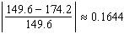
REF: 080926ia

3 ANS: 2
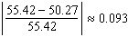
REF: 081023ia

4 ANS: 2
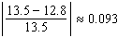
REF: 081123ia

5 ANS:
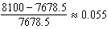
REF: 061233ia

6 ANS: 2
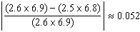
REF: 011209ia

7 ANS: 3
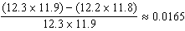
REF: 061120ia

8 ANS:
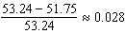
REF: 061631ia

9 ANS:
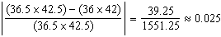
REF: 061535ia

10 ANS:
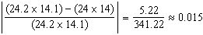
REF: 011336ia

11 ANS:
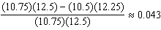
REF: 081336ia

12 ANS:
618.45, 613.44, 0.008. . . 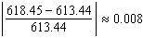. An error of less than 1% would seem to be insignificant.
REF: 060838ia

13 ANS:
1,512, 1,551.25, 0.025. . . 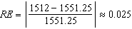.
REF: 010934ia

14 ANS:
Machine A. 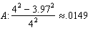 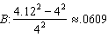
REF: 081438ia

15 ANS: 1
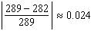
REF: 080828ia

16 ANS: 2
The volume of the cube using Ezra’s measurements is 8 (2³). The actual volume is 9.261 (2.1³). The relative error is 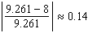.
REF: 060928ia

17 ANS:
0.102. 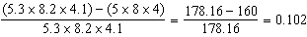
REF: 011036ia

18 ANS:
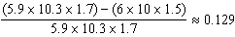
REF: 081235ia

19 ANS:
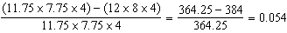
REF: 061435ia

20 ANS:
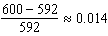
REF: 061031ia

21 ANS: 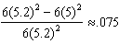
REF: 011435ia

22 ANS: 0.029. 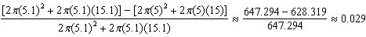
REF: 011137ia

