1 Which inequality represents the probability, x, of any event happening?
1) 2) 3) 4)

2 Mary chooses an integer at random from 1 to 6. What is the probability that the integer she chooses is a prime number?
1) 2) 3) 4)

3 A bag contains eight green marbles, five white marbles, and two red marbles. What is the probability of drawing a red marble from the bag?
1) 2) 3) 4)

4 A box contains six black balls and four white balls. What is the probability of selecting a black ball at random from the box?
1) 2) 3) 4)

5 A six-sided number cube has faces with the numbers 1 through 6 marked on it. What is the probability that a number less than 3 will occur on one toss of the number cube?
1) 2) 3) 4)

6 When a fair coin was tossed ten times, it landed heads up the first seven times. What is the probability that on the eighth toss the coin will land with tails up?
1) 2) 3) 4)

7 As captain of his football team, Jamal gets to call heads or tails for the toss of a fair coin at the beginning of each game. At the last three games, the coin has landed with heads up. What is the probability that the coin will land with heads up at the next game? Explain your answer.

8 If the probability that it will rain on Thursday is , what is the probability that it will not rain on Thursday?
1) 1 2) 0 3) 4)

9 Marilyn selects a piece of candy at random from a jar that contains four peppermint, five cherry, three butterscotch, and two lemon candies. What is the probability that the candy she selects is not a cherry candy?
1) 0 2) 3) 4)

10 The faces of a cube are numbered from 1 to 6. What is the probability of not rolling a 5 on a single toss of this cube?
1) 2) 3) 4)

11 A box contains 6 dimes, 8 nickels, 12 pennies, and 3 quarters. What is the probability that a coin drawn at random is not a dime?
1) 2) 3) 4)

12 If the probability of a spinner landing on red in a game is , what is the probability of it not landing on red?
1) 20% 2) 25% 3) 50% 4) 80%

13 Which event is certain to happen?
1) Everyone walking into a room will have red hair. 2) All babies born in June will be males. 3) The Yankees baseball team will win the World Series. 4) The Sun will rise in the east.

14 The faces of a cube are numbered from 1 to 6. If the cube is rolled once, which outcome is least likely to occur?
1) rolling an odd number 2) rolling an even number 3) rolling a number less than 6 4) rolling a number greater than 4

15 Maria has a set of 10 index cards labeled with the digits 0 through 9. She puts them in a bag and selects one at random. The outcome that is most likely to occur is selecting
1) an odd number 2) a prime number 3) a number that is at most 5 4) a number that is divisible by 3

16 Which event has a probability of zero?
1) choosing a letter from the alphabet that has line symmetry 2) choosing a number that is greater than 6 and is even 3) choosing a pair of parallel lines that have unequal slopes 4) choosing a triangle that is both isosceles and right

17 Three storage bins contain colored blocks. Bin 1 contains 15 red and 14 blue blocks. Bin 2 contains 16 white and 15 blue blocks. Bin 3 contains 15 red and 15 white blocks. All of the blocks from the three bins are placed into one box. If one block is randomly selected from the box, which color block would most likely be picked? Justify your answer.

18 Ryan bought three bags of mixed tulip bulbs at a local garden store. The first bag contained 7 yellow bulbs, 8 red bulbs, and 5 white bulbs. The second bag contained 3 yellow bulbs, 11 red bulbs, and 6 white bulbs. The third bag contained 13 yellow bulbs, 2 red bulbs, and 5 white bulbs. Ryan combined the contents of these three bags into a single container. He randomly selected one bulb, planted it, and then randomly selected another and planted that one. Determine if it is more likely that Ryan planted a red bulb and then another red bulb, or planted a yellow bulb and then a white bulb. Justify your answer.

19 Jon is buying tickets for himself for two concerts. For the jazz concert, 4 tickets are available in the front row, and 32 tickets are available in the other rows. For the orchestra concert, 3 tickets are available in the front row, and 23 tickets are available in the other rows. Jon is randomly assigned one ticket for each concert. Determine the concert for which he is more likely to get a front-row ticket. Justify your answer.

20 Each of the hats shown below has colored marbles placed inside. Hat A contains five green marbles and four red marbles. Hat B contains six blue marbles and five red marbles. Hat C contains five green marbles and five blue marbles.

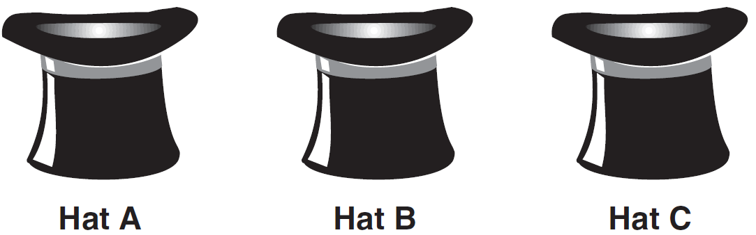

If a student were to randomly pick one marble from each of these three hats, determine from which hat the student would most likely pick a green marble. Justify your answer. Determine the fewest number of marbles, if any, and the color of these marbles that could be added to each hat so that the probability of picking a green marble will be one-half in each of the three hats.

21 A bookshelf contains six mysteries and three biographies. Two books are selected at random without replacement.
a What is the probability that both books are mysteries?
b What is the probability that one book is a mystery and the other is a biography?

22 Three roses will be selected for a flower vase. The florist has 1 red rose, 1 white rose, 1 yellow rose, 1 orange rose and 1 pink rose from which to choose.
a How many different three rose selections can be formed from the 5 roses?
b What is the probability that 3 roses selected at random will contain 1 red rose, 1 white rose, and 1 pink rose?
c What is the probability that 3 roses selected at random will not contain an orange rose?

23 Paul orders a pizza. Chef Carl randomly chooses two different toppings to put on the pizza from the following: pepperoni, onion, sausage, mushrooms, and anchovies. If Paul will not eat pizza with mushrooms, determine the probability that Paul will not eat the pizza Chef Carl has made.

24 Sal has a small bag of candy containing three green candies and two red candies. While waiting for the bus, he ate two candies out of the bag, one after another, without looking. What is the probability that both candies were the same color?

25 Alexi’s wallet contains four $1 bills, three $5 bills, and one $10 bill. If Alexi randomly removes two bills without replacement, determine whether the probability that the bills will total $15 is greater than the probability that the bills will total $2.
1 ANS: 4
An event that will not happen has a probability of 0. An event that will happen has a probability of 1. All other probabilities fall within this range.
REF: 060630a

2 ANS: 2
2, 3 and 5 are the prime numbers in this range.
REF: 060415a

3 ANS: 2 REF: 011002ia

4 ANS: 2
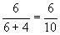
REF: 080011a

5 ANS: 2 REF: 060705a

6 ANS: 2 REF: 060712a

7 ANS:
. A coin has no memory.
REF: 010832a

8 ANS: 3
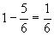
REF: 060202a

9 ANS: 3
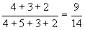
REF: 080803a

10 ANS: 2
Between 1-6, there are 5 numbers that are not 5.
REF: 080604a

11 ANS: 4
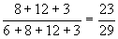
REF: 010805a

12 ANS: 4
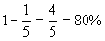
REF: 010907a

13 ANS: 4 REF: 081303ia

14 ANS: 4
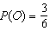, 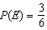, 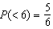, 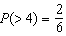
REF: 010903ia

15 ANS: 3
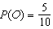, 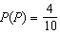, 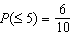, 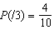
REF: 081125ia

16 ANS: 3 REF: 010811a

17 ANS:
White. There are 31 white blocks, 30 red blocks and 29 blue blocks.
REF: 061232ia

18 ANS:
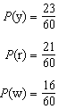 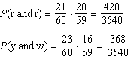 is greater.
REF: 061634ia

19 ANS:
orchestra: 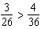
REF: 011033ia

20 ANS:
Hat A, add 1 not green to Hat A, add 11 green to Hat B, and add none to Hat C.
REF: 081038ia

21 ANS:
, . The probability both books are mysteries is 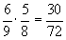. The probability the first book is a mystery and the second book is a biography is 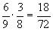 and the probability the first book is a biography and the second book is a mystery is 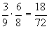. 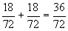.
REF: 069932a

22 ANS:
10, , . 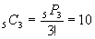. RWY, RWO, RWP, RYO, RYP, ROP, WYO, WYP, WOP, YOP. Out of 10 possible combinations, only 1 is RWP, or and 4 do not contain O, or
REF: 010034a

23 ANS:
. 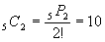. PO, PS, PM, PA, OS, OM, OA, SM, SA, MA.. Since 4 of the combinations have M, the probability that Paul will not eat the pizza is
REF: 060034a

24 ANS:
. . , , , . 4 of the combinations have the same color.
REF: 010126a

25 ANS:
No, 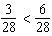. 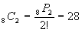. Using the four $1 bills, there are 6 ways 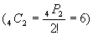 to total $2. 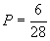. Using the $10 bill and the three $5 bills, there are three ways to total $15. 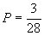
REF: 060234a

