1 The spinner below is divided into eight equal regions and is spun once. What is the probability of not getting red?

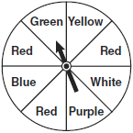
1)
2)
3)
4)

2 The bull's-eye of a dartboard has a radius of 2 inches and the entire board has a radius of 9 inches, as shown in the diagram below.

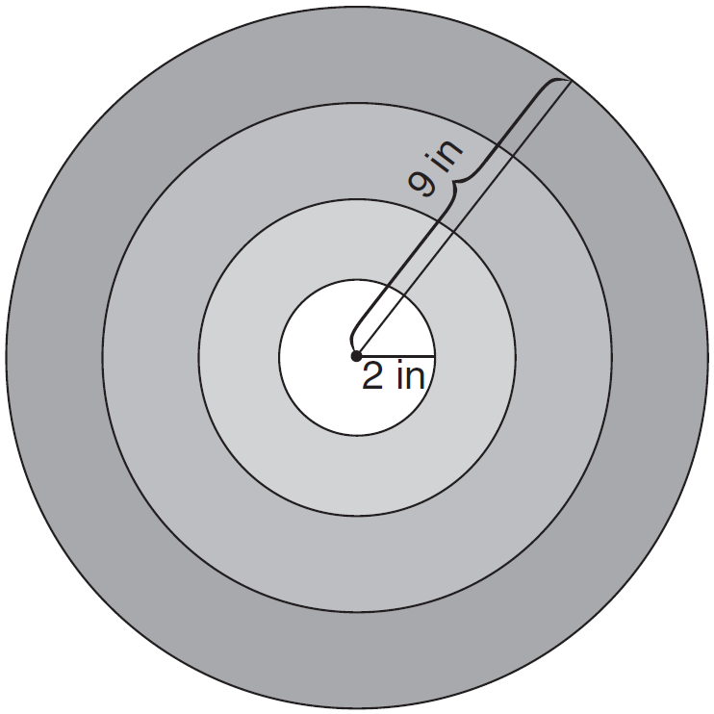

If a dart is thrown and hits the board, what is the probability that the dart will land in the bull's-eye?
1)
2)
3)
4)

3 The square dart board shown below has a side that measures 40 inches. The shaded portion in the center is a square whose side is 15 inches. A dart thrown at the board is equally likely to land on any point on the dartboard.

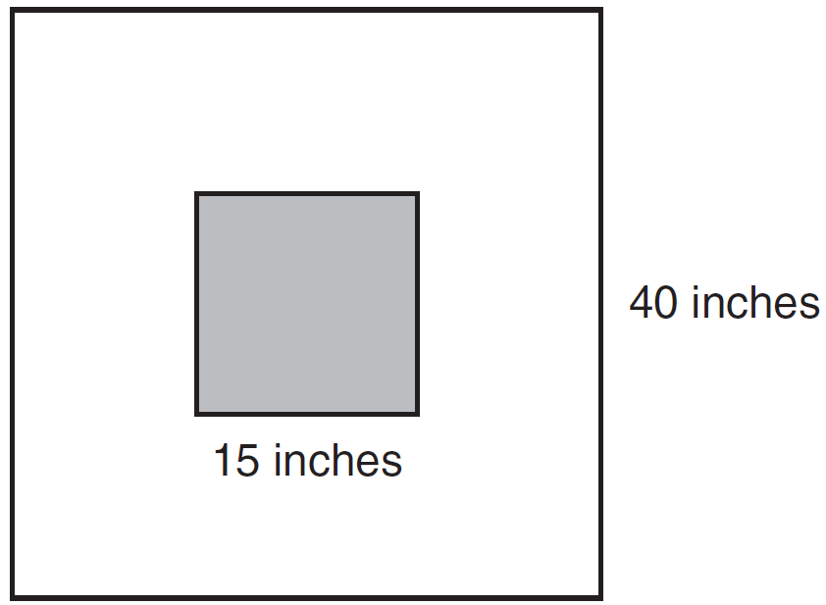

Find the probability that a dart hitting the board will not land in the shaded area.

4 The accompanying diagram shows a square dartboard. The side of the dartboard measures 30 inches. The square shaded region at the center has a side that measures 10 inches. If darts thrown at the board are equally likely to land anywhere on the board, what is the theoretical probability that a dart does not land in the shaded region?

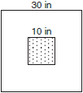

5 A square dartboard is represented in the accompanying diagram. The entire dartboard is the first quadrant from to 6 and from to 6. A triangular region on the dartboard is enclosed by the graphs of the equations , , and . Find the probability that a dart that randomly hits the dartboard will land in the triangular region formed by the three lines.

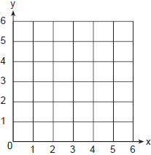

6 A spinner is divided into eight equal regions as shown in the diagram below.

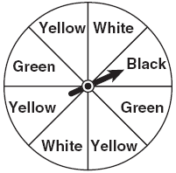

Which event is most likely to occur in one spin?
1) | The arrow will land in a green or white area.
2) | The arrow will land in a green or black area.
3) | The arrow will land in a yellow or black area.
4) | The arrow will land in a yellow or green area.

7 The spinner shown in the diagram below is divided into six equal sections.

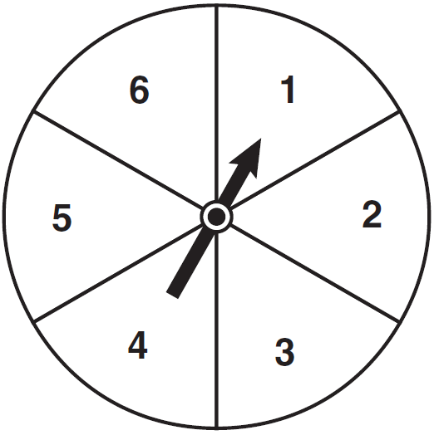

Which outcome is least likely to occur on a single spin?
1) | an odd number
2) | a prime number
3) | a perfect square
4) | a number divisible by 2

1 ANS: 3 REF: 080907ia

2 ANS: 3 REF: 061218ia

3 ANS:
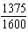. 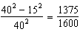

REF: 011132ia

4 ANS:
. 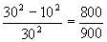

REF: 010634a

5 ANS:
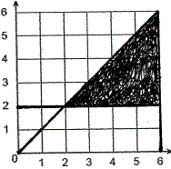, . 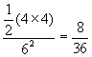

REF: 010231a

6 ANS: 4
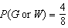, 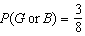, 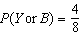, 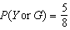

REF: 060802ia

7 ANS: 3
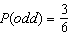, 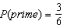, 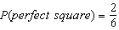, 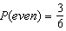

REF: 061104ia

