1 Three high school juniors, Reese, Matthew, and Chris, are running for student council president. A survey is taken a week before the election asking 40 students which candidate they will vote for in the election. The results are shown in the table below.

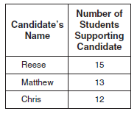

Based on the table, what is the probability that a student will vote for Reese?
1)
2)
3)
4)

2 There are 4 students running for Student Government President. A survey was taken asking 100 students which candidate they would vote for in the election. The results are shown in the table below:
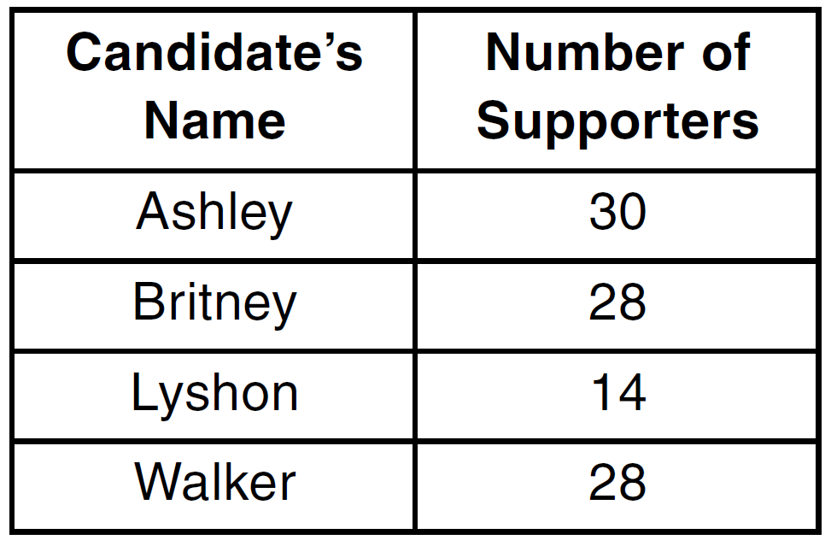
Based on the table, what is the probability that a student chosen at random will vote for Lyshon?
1)
2)
3)
4)

3 Students in Ms. Nazzeer's mathematics class tossed a six-sided number cube whose faces are numbered 1 to 6. The results are recorded in the table below.
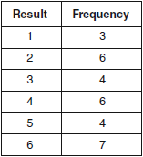
Based on these data, what is the empirical probability of tossing a 4?
1)
2)
3)
4)

4 A spinner that is equally divided into eight numbered sectors is spun 20 times. The table below shows the number of times the arrow landed in each numbered sector.

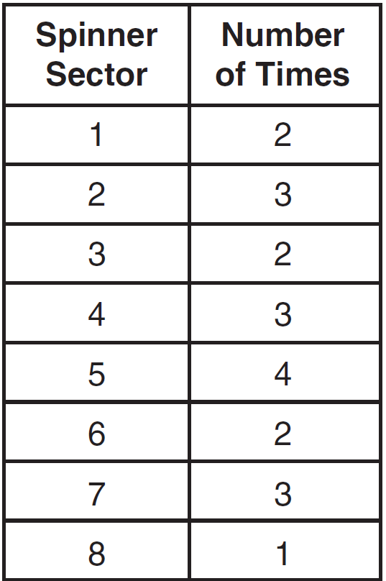

Based on the table, what is the empirical probability that the spinner will land on a prime number on the next spin?
1)
2)
3)
4)

5 The party registration of the voters in Jonesville is shown in the table below.

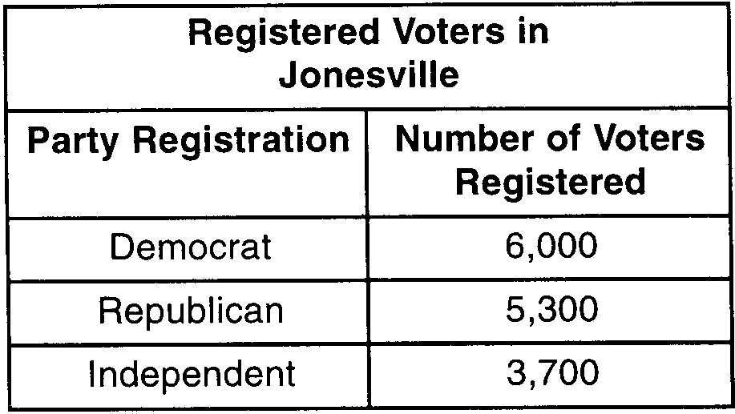

If one of the registered Jonesville voters is selected at random, what is the probability that the person selected is not a Democrat?
1) | 0.333
2) | 0.400
3) | 0.600
4) | 0.667

6 Three students each rolled a wooden cube with faces painted red, white, and blue. The color of the top face is recorded each time the cube is rolled. The table below shows the results.
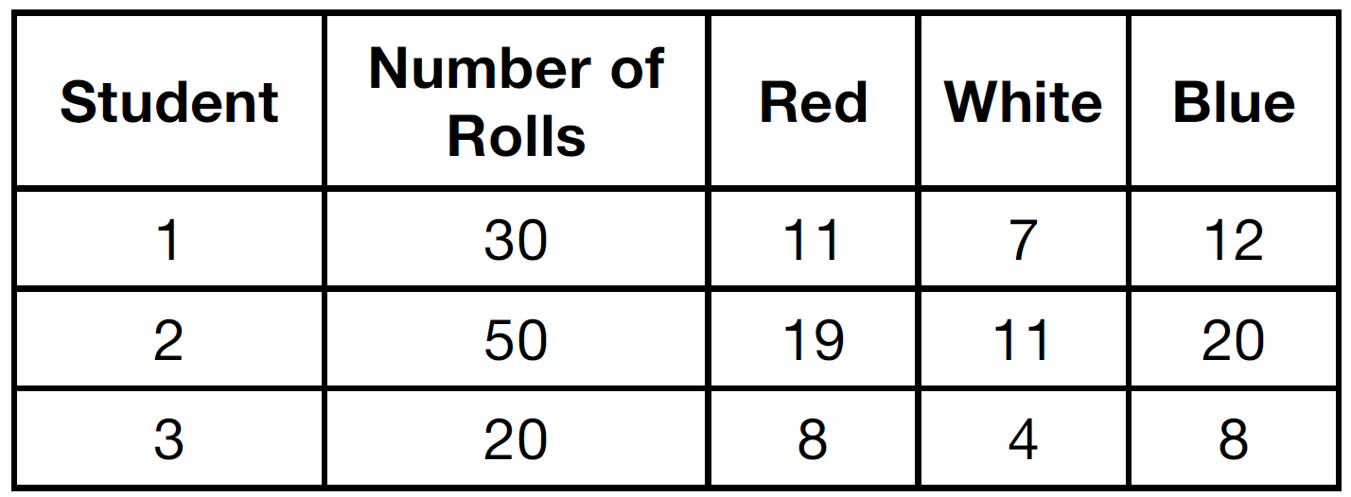

If a fourth student rolled the cube 75 times, based on these experimental data, approximately how many times can the cube be expected to land with blue on top?
1) | 25
2) | 30
3) | 35
4) | 40

7 Two cubes with sides numbered 1 through 6 were rolled 20 times. Their sums are recorded in the table below.
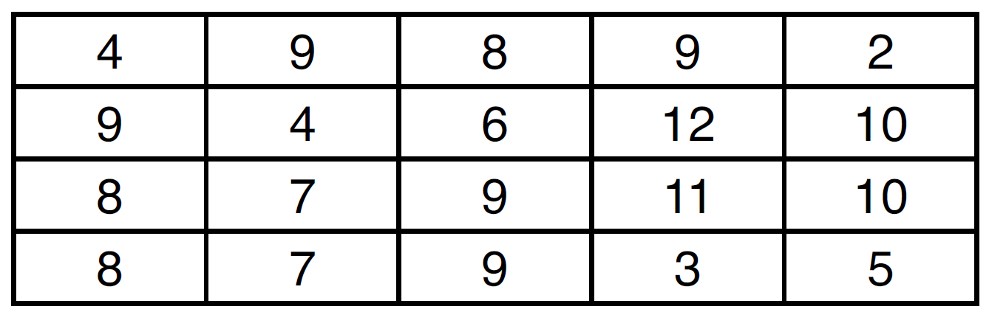

What is the empirical probability of rolling a sum of 9?
1)
2)
3)
4)

8 The accompanying Venn diagram shows the results of a survey asking 100 people if they get news by reading newspapers or by watching television.

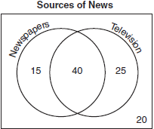

What is the probability that a person selected at random from this survey does not claim television as a source of getting the news?
1)
2)
3)
4)

9 A cube with faces numbered 1 through 6 is rolled 75 times, and the results are given in the table below.
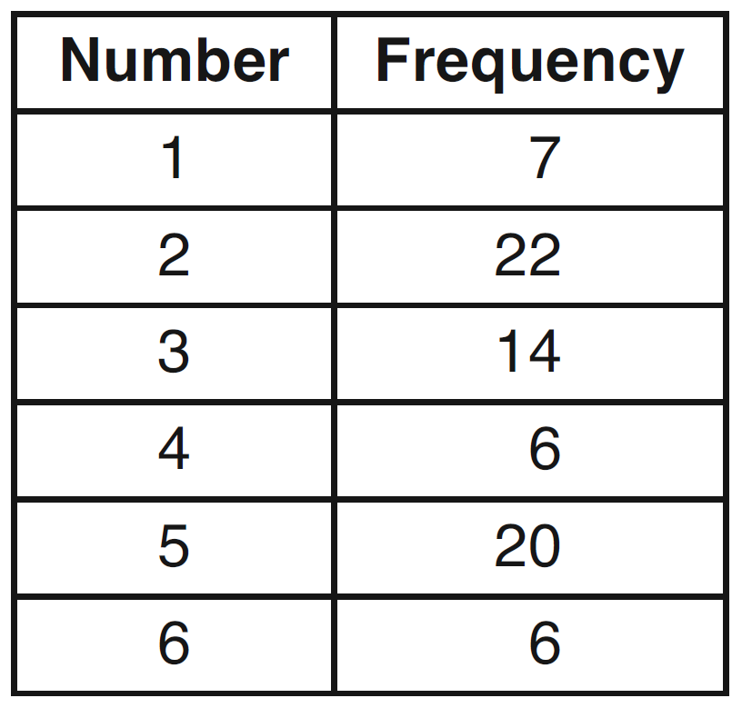

Based on these results, which statement is true?
1)
2)
3)
4)

10 A spinner is divided into three equal regions, as shown in the diagram below. Ray spun the spinner six times and recorded his results: red, blue, blue, green, red, red.
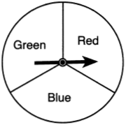

Which statement is true about the outcomes of blue in Ray's experiment?
1) | The empirical probability was less than the theoretical probability.
2) | The empirical probability was greater than the theoretical probability.
3) | The empirical and theoretical probabilities were equal.
4) | The empirical and theoretical probabilities were unrelated.

11 The graph below shows the hair colors of all the students in a class.

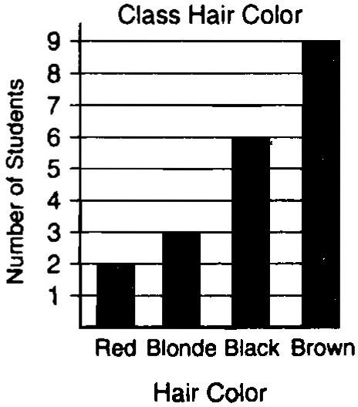

What is the probability that a student chosen at random from this class has black hair?

12 Casey purchased a pack of assorted flower seeds and planted them in her garden. When the first 25 flowers bloomed, 11 were white, 5 were red, 3 were blue, and the rest were yellow. Find the empirical probability that a flower that blooms will be yellow.

1 ANS: 3
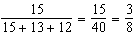
REF: 061006ia

2 ANS: 3
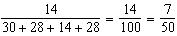
REF: 061502ia

3 ANS: 2 REF: 060908ia

4 ANS: 3
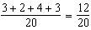
REF: 011129ia

5 ANS: 3
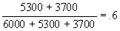
REF: 010017a

6 ANS: 2
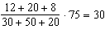
REF: 011528ia

7 ANS: 2 REF: 011415ia

8 ANS: 2
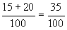
REF: 010621a

9 ANS: 4
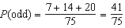. 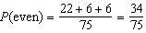. 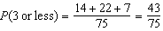. 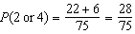
REF: 011325ia

10 ANS: 3
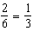
REF: 061628ia

11 ANS:
. 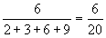
REF: spring9821a

12 ANS:
. 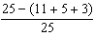
REF: 011232ia

