1 On an English examination, two students received scores of 90, five students received 85, seven students received 75, and one student received 55. The average score on this examination was
1) | 75
2) | 76
3) | 77
4) | 79

2 What is the mean of the data in the accompanying table?

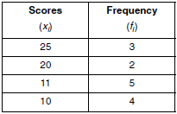
1) | 11
2) | 14.5
3) | 15
4) | 16

3 The table below gives a set of measures and their respective frequencies. Find the mean of these measures.

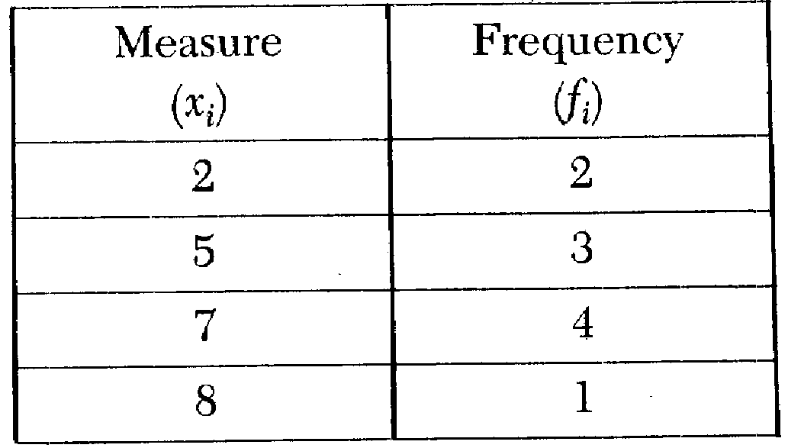

4 What is the mean for the following set of data?
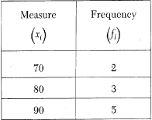

5 What is the median of the set of data shown in the table below?
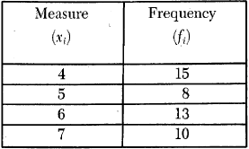
1) | 15
2) | 10.5
3) | 5.5
4) | 4

6 The accompanying table represents the number of cell phone minutes used for one week by 23 users.
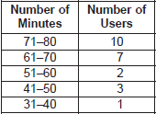
Which interval contains the median?
1)
2)
3)
4)

7 What is the median for the following set of data?

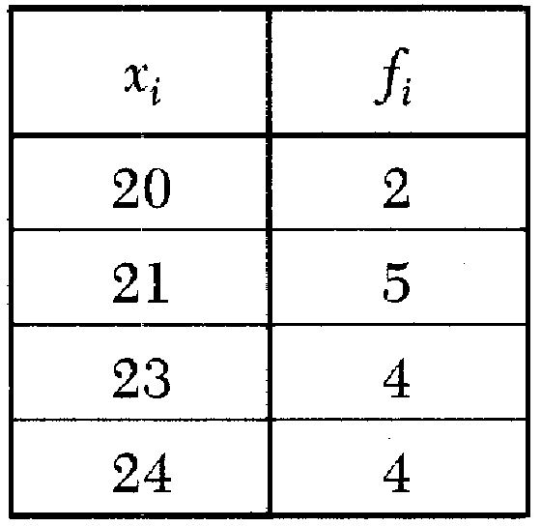

8 What is the mode of the data shown in the following table?

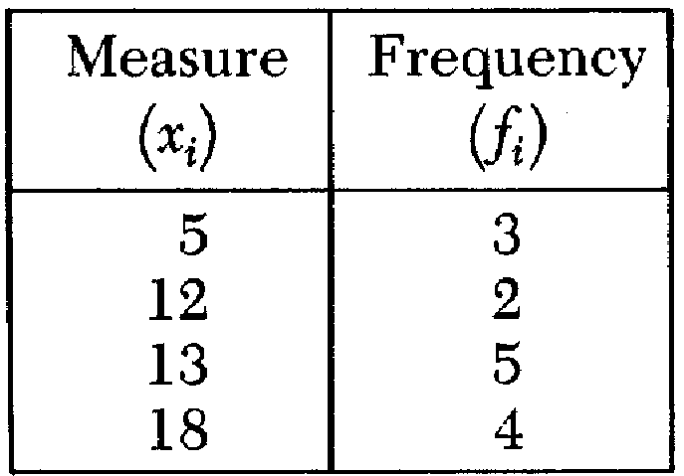
1) | 12
2) | 12.5
3) | 13
4) | 51.5

9 The table below shows five numbers and their frequency of occurrence.

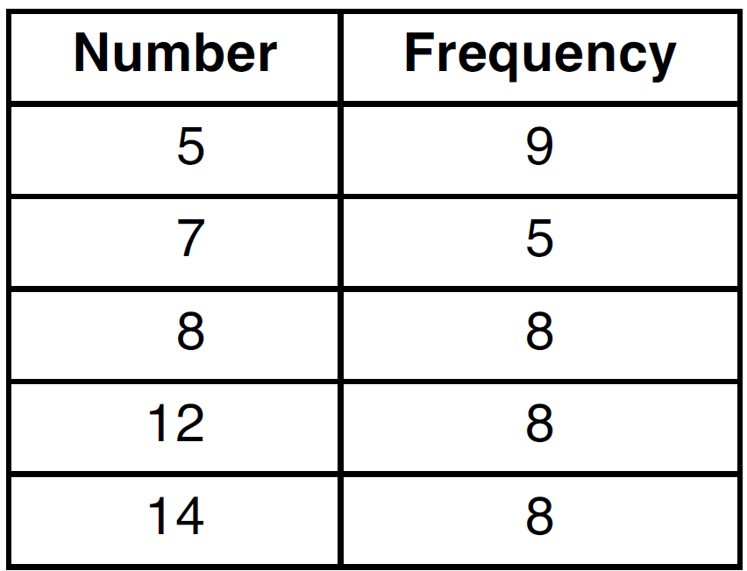

The interquartile range for these data is
1) | 7
2) | 5
3) | 7 to 12
4) | 6 to 13

10 Which correctly compares the mean and median of the set of data shown in the accompanying table?

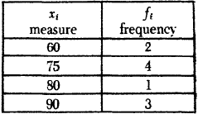
1) | The mean and median are equal.
2) | The mean exceeds the median by 2.
3) | The median exceeds the mean by 2.
4) | The mean exceeds the median by 2.5.

11 Using the data in the accompanying table, which statement is true?

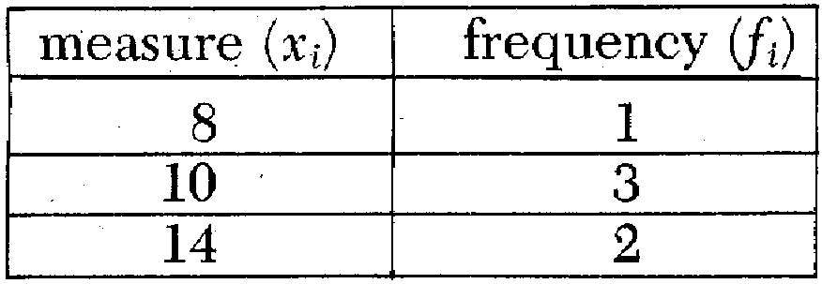
1) | mean = median
2) | mean > median
3) | mean < mode
4) | median > mode

12 Mrs. Porter recorded her students' grades in the frequency table below.

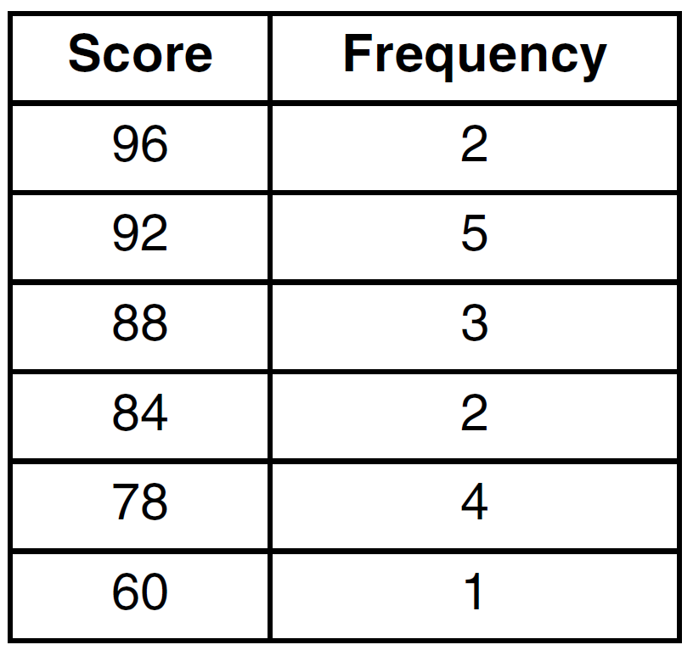

Which statement is true for the data?
1) | mean > median > mode
2) | mean > mode > median
3) | mode > median > mean
4) | median > mean > mode

13 The values of 11 houses on Washington St. are shown in the table below.

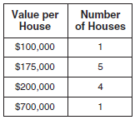

Find the mean value of these houses in dollars. Find the median value of these houses in dollars. State which measure of central tendency, the mean or the median, best represents the values of these 11 houses. Justify your answer.

14 The prices of seven race cars sold last week are listed in the table below.

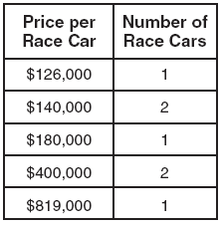

What is the mean value of these race cars, in dollars? What is the median value of these race cars, in dollars? State which of these measures of central tendency best represents the value of the seven race cars. Justify your answer.
1 ANS: 4
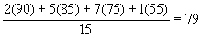

REF: 080008a

2 ANS: 3
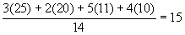

REF: 060507b

3 ANS:
5.5

REF: 088509siii

4 ANS:
83

REF: 088714siii

5 ANS: 3 REF: 068525siii

6 ANS: 3 REF: 060829a

7 ANS:
23

REF: 068909siii

8 ANS: 3 REF: 068720siii

9 ANS: 2

REF: 011525a2

10 ANS: 2 REF: 068134siii

11 ANS: 2 REF: 018525siii

12 ANS: 3
The mean is 86, the median is 88 and the mode is 92.

REF: 061525ia

13 ANS:
225000, 175000, the median better represents the value since it is closer to more values than the mean.

REF: fall0737ia

14 ANS:
315,000, 180,000, the median better represents value since it is closer to more prices than the mean.

REF: 060839ia

