1 What is the range for the following data?
52, 32, 61, 82, 63
1) | 50
2) | 58
3) | 11
4) | 61

2 Find the range of the following data:
72, 89, 41, 89, 73, 72, 91

3 What was the median high temperature in Middletown during the 7-day period shown in the table below?

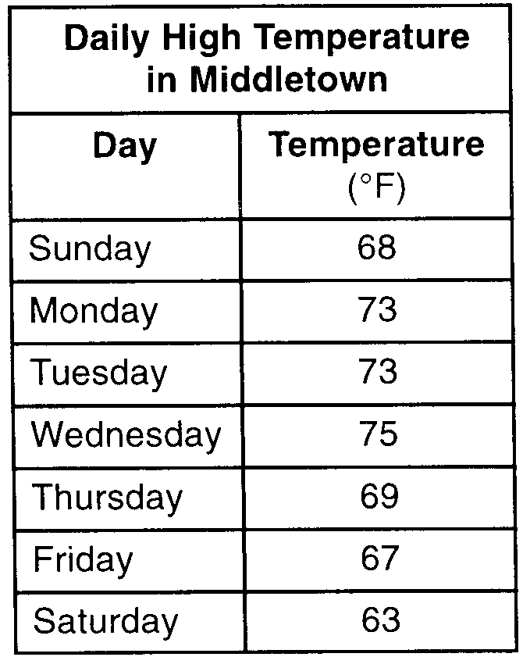
1) | 69
2) | 70
3) | 73
4) | 75

4 The set of numbers has
1) | a range of 3 and a median of 7
2) | a range of 8 and a median of 7
3) | a range of 12 and a median of
4) | a range of 8 and a median of

5 Seth bought a used car that had been driven 20,000 miles. After he owned the car for 2 years, the total mileage of the car was 49,400. Find the average number of miles he drove each month during those 2 years.

6 Sara's test scores in mathematics were 64, 80, 88, 78, 60, 92, 84, 76, 86, 78, 72, and 90. Determine the mean, the median, and the mode of Sara's test scores.

7 The heights, in inches, of 10 high school varsity basketball players are 78, 79, 79, 72, 75, 71, 74, 74, 83, and 71. Find the interquartile range of this data set.

8 The following is a list of the individual points scored by all twelve members of the Webster High School basketball team at a recent game:
Find the interquartile range for this set of data.

9 Mr. Taylor raised all his students’ scores on a recent test by five points. How were the mean and the range of the scores affected?
1) | The mean increased by five and the range increased by five.
2) | The mean increased by five and the range remained the same.
3) | The mean remained the same and the range increased by five.
4) | The mean remained the same and the range remained the same.

10 If each member of the data set is multiplied by 2, which changes will take place in the mean, median, and mode of the data?
1) | The mean, median, and mode will be multiplied by 2.
2) | The median will remain the same; the mean and mode will be multiplied by 2.
3) | The mode will remain the same; the mean and median will be multiplied by 2.
4) | The mean will remain the same; the median and mode will be multiplied by 2.

11 Given the following list of students' scores on a quiz:
5, 12, 7, 15, 20, 14, 7
Determine the median of these scores. Determine the mode of these scores. The teacher decides to adjust these scores by adding three points to each score. Explain the effect, if any, that this will have on the median and mode of these scores.

12 Ms. Mosher recorded the math test scores of six students in the table below.

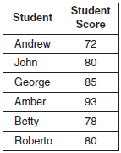

Determine the mean of the student scores, to the nearest tenth. Determine the median of the student scores. Describe the effect on the mean and the median if Ms. Mosher adds 5 bonus points to each of the six students’ scores.

1 ANS: 1 REF: 088428siii

2 ANS:
50

REF: 088708siii

3 ANS: 1 REF: 010005a

4 ANS: 2 REF: 068432siii

5 ANS:
1,225. 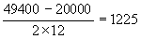

REF: 080535a

6 ANS:
Mean = 79, median = 79, and mode = 78

REF: 060637a

7 ANS:
Ordered, the heights are 71, 71, 72, 74, 74, 75, 78, 79, 79, 83. and . .

REF: 011331a2

8 ANS:
and . .

REF: 011430a2

9 ANS: 2 REF: 081327ia

10 ANS: 1 REF: 061607ia

11 ANS:
12, 7. Both the median and the mode will increase.

REF: 061134ia

12 ANS:
81.3, 80, both increase

REF: 011035ia

