Part I

Answer all questions in this part. Each correct answer will receive 2 credits. No partial credit will be allowed. For each question, write on the separate answer sheet the numeral preceding the word or expression that best completes the statement or answers the question.

What is the turning point, or vertex, of the parabola whose equation is $y=3x^{2}+6x−1?$
(1) (1,8) (3) (-3,8)
(2) (-l,-4) (4) (3,44)

The growth of bacteria in a dish is modeled by the function $f(t)=2^{\frac{t}{3}}\text{.}$ For which value of t is $f(t)=\text{32}?$
(1) 8 (3) 15
(2) 2 (4) 16

The graphs below show the average annual precipitation received at different latitudes on Earth. Which graph is a translated cosine curve?

The accompanying diagram shows two cables of equal length supporting a pole. Both cables are 14 meters long, and they are anchored to points in the ground that are 14 meters apart.
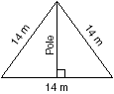
What is the exact height of the pole, in meters?
(1) 7 (3) $7\sqrt{3}$
(2) $7\sqrt{2}$ (4) 14

What is the sum of $(y−5)+\frac{3}{y+2}?$
(1) $y−5$ (3) $\frac{y−2}{y+2}$
(2) $\frac{y^{2}−7}{y+2}$ (4) $\frac{y^{2}−3y−7}{y+2}$

The expression $\frac{1}{5−\sqrt{\text{13}}}$ is equivalent, to
(1) $\frac{5+\sqrt{\text{13}}}{\text{12}}$ (3) $\frac{5+\sqrt{\text{13}}}{8}$
(2) $\frac{5+\sqrt{\text{13}}}{−\text{12}}$ (4) $\frac{5+\sqrt{\text{13}}}{−8}$

When expressed as a monomial in terms of i, $2\sqrt{−\text{32}}−5\sqrt{−8}$ is equivalent to
(1) $2\sqrt{2i}$ (3) $−2i\sqrt{2}$
(2) $2i\sqrt{2}$ (4) $\text{18}i\sqrt{2}$

The image of the origin under a certain translation is the point (2,-6). The image of point (-3,-2) under the same translation is the point
(1) (-6,12) (3) $(−\frac{3}{2},\frac{1}{3})$
(2) (-5,4) (4) (-1,-8)

The solution of $\left|2x−3\right|<5$ is
(1) x < -1 or x > 4 (3) x > -1
(2) -1 < x < 4 (4) x < 4

In the accompanying diagram of a unit circle, the ordered pair $(−\frac{\sqrt{3}}{2},−\frac{1}{2})$ represents the point where the terminal side of $θ$ intersects the unit circle.
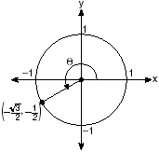
What is $m∠θ?$
(1) 210 (3) 233
(2) 225 (4) 240

Two straight roads intersect at an angle whose measure is 125°. Which expression is equivalent to the cosine of this angle?
(1) cos 35° (3) cos 55°
(2) -cos 35° (4) -cos 55°

Two complex numbers are graphed below.
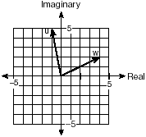
What is the sum of w and u, expressed in standard complex number form?
(1) 7 + 3i (3) 5 + 7i
(2) 3 + 7i (4) -5 + 3i

When simplified, the complex fraction $\frac{1+\frac{1}{x}}{\frac{1}{x}−x}, x≠0,$ is equivalent to
(1) 1 (3) $\frac{1}{1−x}$
(2) -1 (4) $\frac{1}{x−1}$

A certain radio wave travels in a path represented by the equation $y=5\text{sin}2x\text{.}$ What is the period of this wave?
(1) 5 (3) $π$
(2) 2 (4) $2π$

The mean score on a normally distributed exam is 42 with a standard deviation of 12.1. Which score would be expected to occur less than 5% of the time?
(1) 25 (3) 60
(2) 32 (4) 67

For which positive value of m will the equation $4x^{2}+\text{mx}+9=0$ have roots that are real, equal, and rational?
(1) 12 (3) 3
(2) 9 (4) 4

An object orbiting a planet travels in a path represented by the equation $3(y+1)^{2}+5(x+4)^{2}=\text{15}\text{.}$ In which type of pattern does the object travel?
(1) hyperbola (3) circle
(2) ellipse (4) parabola

Kimi wants to determine the radius of a circular pool without getting wet. She is located at point K, which is 4 feet from the pool and 12 feet from the point of tangency, as shown in the accompanying diagram.
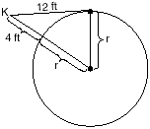
What is the radius of the pool?
(1) 16 ft (3) 32 ft
(2) 20 ft (4) $4\sqrt{\text{10}} \text{ft}$

What is the total number of distinct triangles that can be constructed if AC = 13, BC = 8, and $m∠a=\text{36}?$
(1) 1 (3) 3
(2) 2 (4) 0

The accompanying graph is a sketch of the function $y=f(x)$ over the interval $0≤x≤7\text{.}$
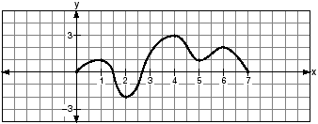
What is the value of $(f∘f)(6)?$
(1) 1 (3) 0
(2) 2 (4) -2

Part II

Answer all questions in this part. Each correct answer will receive 2 credits. Clearly indicate the necessary steps, including appropriate formula substitutions, diagrams, graphs, charts, etc. For all questions in this part, a correct numerical answer with no work shown will receive only 1 credit.

Evaluate: $\sum_{n=1}^{5}{(n^{2}+n)}$

The Coolidge family's favorite television channels are 3, 6, 7, 10, 11, and 13. If the Coolidge family selects a favorite channel at random to view each night, what is the probability that they choose exactly three even-numbered channels in five nights? Express your answer as a fraction or as a decimal rounded to four decimal places.

Boyle's Law states that the pressure of compressed gas is inversely proportional to its volume. The pressure of a certain sample of a gas is 16 kilopascals when its volume is 1,800 liters. What is the pressure, in kilopascals, when its volume is 900 liters?

The accompanying diagram shows the path of a cart traveling on a circular track of radius 2.40 meters. The cart starts at point A and stops at point B, moving in a counterclockwise direction. What is the length of minor arc AB, over which the cart traveled, to the nearest tenth of a meter?
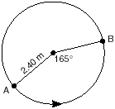

Given the function $y=f(x),$ such that the entire graph of the function lies above the x-axis. Explain why the equation $f(x)=0$ has no real solutions.

Express in simplest terms: $\frac{2−2{\text{sin}}^{2}x}{\text{cos}x}$

Part III

Answer all questions in this part. Each correct answer will receive 4 credits. Clearly indicate the necessary steps, including appropriate formula substitutions, diagrams, graphs, charts, etc. For all questions in this part, a correct numerical answer with no work shown will receive only 1 credit.

The accompanying diagram shows the plans for a cell-phone tower that is to be built near a busy highway. Find the height of the tower, to the nearest foot.
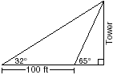

The lateral surface area of a right circular cone, s, is represented by the equation $s=π r\sqrt{r^{2}+h^{2}},$ where r is the radius of the circular base and h is the height of the cone. If the lateral surface area of a large funnel is 236.64 square centimeters and its radius is 4.75 centimeters, find its height, to the nearest hundredth of a centimeter.

Solve for all values of x: $\frac{9}{x}+\frac{9}{x−2}=\text{12}$

A hotel finds that its total annual revenue and the number of rooms occupied daily by guests can best be modeled by the function $R=3\text{log}(n^{2}+\text{10}n), n>0,$ where R is the total annual revenue, in millions of dollars, and n is the number of rooms occupied daily by guests. The hotel needs an annual revenue of $12 million to be profitable. Graph the function on the accompanying grid over the interval $0<n≤\text{100}\text{.}$
Calculate the minimum number of rooms that must be occupied daily to be profitable.


The profit, P, for manufacturing a wireless device is given by the equation $P=−\text{10}x^{2}+\text{750}x−9,\text{000},$ where x is the selling price, in dollars, for each wireless device. What range of selling prices allows the manufacturer to make a profit on this wireless device? [The use of the grid is optional.]


On the accompanying set of axes, graph the equations $y=4\text{cos}x$ and y = 2 in the domain $−π≤x≤π\text{.}$
Express, in terms of $π,$ the interval for which $4\text{cos}x≥2\text{.}$
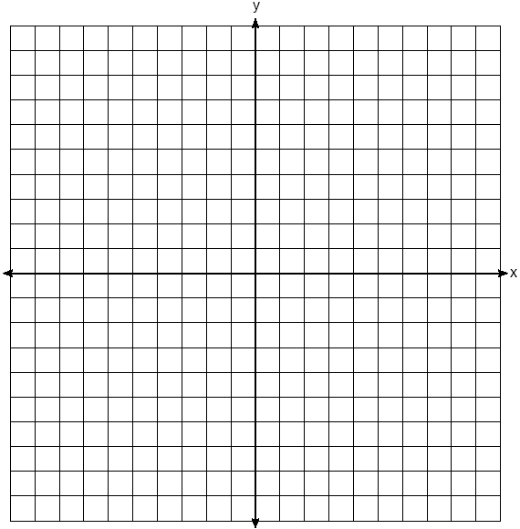

Part IV

Answer all questions in this part. Each correct answer will receive 6 credits. Clearly indicate the necessary steps, including appropriate formula substitutions, diagrams, graphs, charts, etc. For all questions in this part, a correct numerical answer with no work shown will receive only 1 credit.

The accompanying table illustrates the number of movie theaters showing a popular film and the film's weekly gross earnings, in millions of dollars.
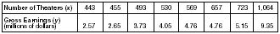
Write the linear regression equation for this set of data, rounding values to five decimal places.
Using this linear regression equation, find the approximate gross earnings, in millions of dollars, generated by 610 theaters. Round your answer to two decimal places.
Find the minimum number of theaters that would generate at least 7.65 million dollars in gross earnings in one week.

In the accompanying diagram of ABCD, where $a≠b,$ prove ABCD is an isosceles trapezoid.
