Part I

Answer all questions in this part. Each correct answer will receive 2 credits. No partial credit will be allowed. For each question, write on the separate answer sheet the numeral preceding the word or expression that best completes the statement or answers the question.

Which condition does not prove that two triangles are congruent?
(1) SSS SSS (3) SAS SAS
(2) SSA SSA (4) ASA ASA

The speed of a laundry truck varies inversely with the time it takes to reach its destination. If the truck takes 3 hours to reach its destination traveling at a constant speed of 50 miles per hour, how long will it take to reach the same location when it travels at a constant speed of 60 miles per hour?
(1) hours (3) hours
(2) hours (4) hours

Which set of ordered pairs is not a function?
(1) {(3,1), (2,1), (1,2), (3,2)}
(2) {(4,1), (5,1), (6,1), (7,1)}
(3) {(1,2), (3,4), (4,5), (5,6)}
(4) {(0,0), (1,1), (2,2), (3,3)}

A circle has the equation What are the coordinates of its center and the length of its radius?
(1) (–1,3) and 4 (3) (–1,3) and 16
(2) (1,–3) and 4 (4) (1,–3) and 16

The mean of a normally distributed set of data is 56, and the standard deviation is 5. In which interval do approximately 95.4% of all cases lie?
(1) 46–56 (3) 51–61
(2) 46–66 (4) 56–71

The graph below represents f(x).

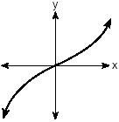

Which graph best represents f(–x)?

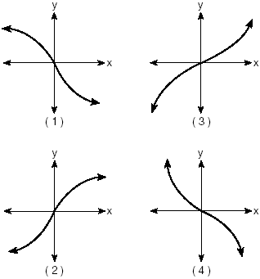

When simplified, is equal to
(1) (3)
(2) (4)

The accompanying diagram shows a child’s spin toy that is constructed from two chords intersecting in a circle. The curved edge of the larger shaded section is one-quarter of the circumference of the circle, and the curved edge of the smaller shaded section is one-fifth of the circumference of the circle.

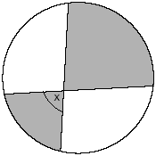

What is the measure of angle x?
(1) 40° (3) 81°
(2) 72° (4) 108°

If , , and angles A and B are in Quadrant I, what is the value of
(1) (3)
(2) (4)

If the tangent of an angle is negative and its secant is positive, in which quadrant does the angle terminate?
(1) I (3) III
(2) II (4) IV

The equation has imaginary roots when n is equal to
(1) 10 (3) 6
(2) 8 (4) 4

What is the middle term in the expansion of
(1) (3)
(2) (4)

What is the image of point (1,1) under
(1) (1,1) (3) (–1,1)
(2) (1,–1) (4) (–1,–1)

How many distinct triangles can be formed if , side $b=\text{12},$ and side $a=8?$
(1) 1 (3) 3
(2) 2 (4) 0

The expression is equivalent to
(1) (3)
(2) (4)

What is the inverse of the function
(1) (3)
(2) (4)

Which angle is coterminal with an angle of 125°?
(1) –125° (3) 235°
(2) –235° (4) 425°

A ball is dropped from a height of 8 feet and allowed to bounce. Each time the ball bounces, it bounces back to half its previous height. The vertical distance the ball travels, d, is given by the formula $d=8+\text{16}\sum_{k=1}^{n}{(\frac{1}{2})^{k},}$ where n is the number of bounces. Based on this formula, what is the total vertical distance that the ball has traveled after four bounces?
(1) 8.9 ft (3) 22.0 ft
(2) 15.0 ft (4) 23.0 ft

The path traveled by a roller coaster is modeled by the equation $y=\text{27}\text{sin}\text{13}x+\text{30}\text{.}$ What is the maximum altitude of the roller coaster?
(1) 13 (3) 30
(2) 27 (4) 57

The expression is equivalent to
(1) (3)
(2) (4)

Part II

Answer all questions in this part. Each correct answer will receive 2 credits. Clearly indicate the necessary steps, including appropriate formula substitutions, diagrams, graphs, charts, etc. For all questions in this part, a correct numerical answer with no work shown will receive only 1 credit.

A ski lift begins at ground level 0.75 mile from the base of a mountain whose face has a 50° angle of elevation, as shown in the accompanying diagram. The ski lift ascends in a straight line at an angle of 20°. Find the length of the ski lift from the beginning of the ski lift to the top of the mountain, to the nearest hundredth of a mile.

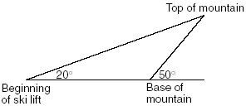

Express in simplest a + bi form.

Solve for x:

The profit a coat manufacturer makes each day is modeled by the equation , where P is the profit and x is the price for each coat sold. For what values of x does the company make a profit? [The use of the accompanying grid is optional.]



Express in simplest form:

Cities H and K are located on the same line of longitude and the difference in the latitude of these cities is 9°, as shown in the accompanying diagram. If Earth’s radius is 3,954 miles, how many miles north of city K is city H along arc HK? Round your answer to the nearest tenth of a mile.

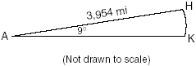

Part III

Answer all questions in this part. Each correct answer will receive 4 credits. Clearly indicate the necessary steps, including appropriate formula substitutions, diagrams, graphs, charts, etc. For all questions in this part, a correct numerical answer with no work shown will receive only 1 credit.

A depth finder shows that the water in a certain place is 620 feet deep. The difference between d, the actual depth of the water, and the reading is and must be less than or equal to 0.05d. Find the minimum and maximum values of d, to the nearest tenth of a foot.

An amount of P dollars is deposited in an account paying an annual interest rate r (as a decimal) compounded n times per year. After t years, the amount of money in the account, in dollars, is given by the equation $A=P(1+\frac{r}{n})^{\text{nt}}\text{.}$
Rachel deposited $1,000 at 2.8% annual interest, compounded monthly. In how many years, to the nearest tenth of a year, will she have $2,500 in the account? [The use of the grid is optional.]



A box containing 1,000 coins is shaken, and the coins are emptied onto a table. Only the coins that land heads up are returned to the box, and then the process is repeated. The accompanying table shows the number of trials and the number of coins returned to the box after each trial.

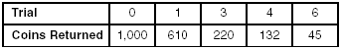

Write an exponential regression equation, rounding the calculated values to the nearest ten-thousandth.
Use the equation to predict how many coins would be returned to the box after the eighth trial.

Tim Parker, a star baseball player, hits one home run for every ten times he is at bat. If Parker goes to bat five times during tonight’s game, what is the probability that he will hit at least four home runs?

A rectangular piece of cardboard is to be formed into an uncovered box. The piece of cardboard is 2 centimeters longer than it is wide. A square that measures 3 centimeters on a side is cut from each corner. When the sides are turned up to form the box, its volume is 765 cubic centimeters. Find the dimensions, in centimeters, of the original piece of cardboard.

Solve algebraically for all values of in the interval that satisfy the equation .

Part IV

Answer all questions in this part. Each correct answer will receive 6 credits. Clearly indicate the necessary steps, including appropriate formula substitutions, diagrams, graphs, charts, etc. For all questions in this part, a correct numerical answer with no work shown will receive only 1 credit.

The tide at a boat dock can be modeled by the equation $y=−2\text{cos}(\frac{π}{6}t)+8,$ where t is the number of hours past noon and y is the height of the tide, in feet. For how many hours between t = 0 and t = 12 is the tide at least 7 feet? [The use of the grid is optional.]



The coordinates of quadrilateral JKLM are J(1,–2), K(13,4), L(6,8), and M(–2,4). Prove that quadrilateral JKLM is a trapezoid but not an isosceles trapezoid. [The use of the grid on the next page is optional.]



