Part I

Answer all questions in this part. Each correct answer will receive 2 credits. No partial credit will be allowed. For each question, write on the separate answer sheet the numeral preceding the word or expression that best completes the statement or answers the question.

Which graph does not represent a function of x?
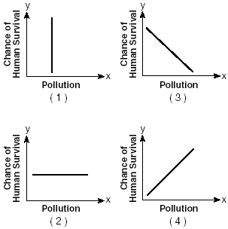

What is the value of x in the equation?
(1) 1 (3) –2
(2) 7 (4) 4

Which graph represents the solution set of ?
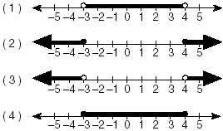

The strength of a medication over time is represented by the equation , where x represents the number of hours since the medication was taken and y represents the number of micrograms per millimeter left in the blood. Which graph best represents this relationship?
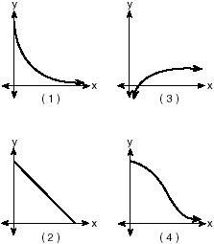

Written in simplest form, the expression is equivalent to
(1) (3)
(2) (4)

Which graph represents data used in a linear regression that produces a correlation coefficient closest to –1?
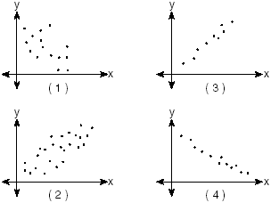

Which expression is equal to
(1) (3)
(2) (4)

Which transformation is not an isometry?
(1) rotation (3) dilation
(2) line reflection (4) translation

A dog has a 20-foot leash attached to the corner where a garage and a fence meet, as shown in the accompanying diagram. When the dog pulls the leash tight and walks from the fence to the garage, the arc the leash makes is 55.8 feet.
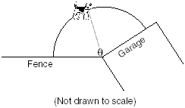
What is the measure of angle between the garage and the fence, in radians?
(1) 0.36 (3) 3.14
(2) 2.79 (4) 160

In the accompanying diagram of parallelogram
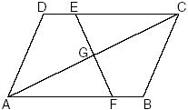
Triangle EGC can be proved congruent to triangle FGA by
(1) HL HL (3) AAS AAS
(2) AAA AAA (4) SSA SSA

An architect commissions a contractor to produce a triangular window. The architect describes the window as , where inches, and inches. How many distinct triangles can the contractor construct using these dimensions?
(1) 1 (3) more than 2
(2) 2 (4) 0

The accompanying graph shows the relationship between a person’s weight and the distance that the person must sit from the center of a seesaw to make it balanced.
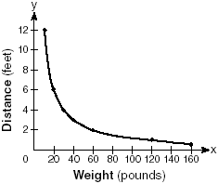
Which equation best represents this graph?
(1) (3)
(2) (4)

If f and g are two functions defined by f(x) = 3x + 5 and , then g(f(x)) is
(1) (3)
(2) (4)

What is the product of and , expressed in simplest a + bi form?
(1) –37 + 41i (3) 47 + 41i
(2) 5 – 71i (4) 47 – 29i

The expression is equivalent to
(1) csc (3) cot
(2) sec (4) sin

If and x and y are acute angles, the value of is
(1) (3)
(2) (4)

The amount of ketchup dispensed from a machine at Hamburger Palace is normally distributed with a mean of 0.9 ounce and a standard deviation of 0.1 ounce. If the machine is used 500 times, approximately how many times will it be expected to dispense 1 or more ounces of ketchup?
(1) 5 (3) 80
(2) 16 (4) 100

A commercial artist plans to include an ellipse in a design and wants the length of the horizontal axis to equal 10 and the length of the vertical axis to equal 6. Which equation could represent this ellipse?
(1) (3)
(2) (4)

A function is defined by the equation . Which equation defines the inverse of this function?
(1) (3)
(2) (4)

In the equation , imaginary roots will be generated if
(1) –1 < a <1 (3) a > –1, only
(2) a < 1, only (4) a < –1

Part II

Answer all questions in this part. Each correct answer will receive 2 credits. Clearly indicate the necessary steps, including appropriate formula substitutions, diagrams, graphs, charts, etc. For all questions in this part, a correct numerical answer with no work shown will receive only 1 credit.

The height, h, in feet, a ball will reach when thrown in the air is a function of time, t, in seconds, given by the equation . Find, to the nearest tenth, the maximum height, in feet, the ball will reach.

Find the value of when

Express in simplest form:

The triangular top of a table has two sides of 14 inches and 16 inches, and the angle between the sides is 30°. Find the area of the tabletop, in square inches.

Meteorologists can determine how long a storm lasts by using the function where d is the diameter of the storm, in miles, and t is the time, in hours. If the storm lasts 4.75 hours, find its diameter, to the nearest tenth of a mile.

Tom scored 23 points in a basketball game. He attempted 15 field goals and 6 free throws. If each successful field goal is 2 points and each successful free throw is 1 point, is it possible he successfully made all 6 of his free throws? Justify your answer.

Part III

Answer all questions in this part. Each correct answer will receive 4 credits. Clearly indicate the necessary steps, including appropriate formula substitutions, diagrams, graphs, charts, etc. For all questions in this part, a correct numerical answer with no work shown will receive only 1 credit.

On the accompanying grid, graph and label , where A is (0,5) and B is (2,0). Under the transformation $r_{x−\text{axis}}∘r_{y−\text{axis}}(\overline{\text{AB}}),$ maps to , and maps to . Graph and label . What single transformation would map to ?


Express, in simplest a + bi form, the roots of the equation

A ship at sea is 70 miles from one radio transmitter and 130 miles from another. The angle between the signals sent to the ship by the transmitters is 117.4°. Find the distance between the two transmitters, to the nearest mile.

A student attaches one end of a rope to a wall at a fixed point 3 feet above the ground, as shown in the accompanying diagram, and moves the other end of the rope up and down, producing a wave described by the equation y = a sin bx + c. The range of the rope’s height above the ground is between 1 and 5 feet. The period of the wave is . Write the equation that represents this wave.
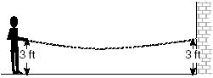
The table below shows the results of an experiment that relates the height at which a ball is dropped, x, to the height of its first bounce, y.
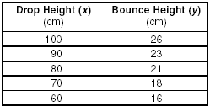
Find , the mean of the drop heights.
Find , the mean of the bounce heights.
Find the linear regression equation that best fits the data.
Show that $(\bar{x},\bar{y})$ is a point on the line of regression. [The use of the grid is optional.]


A company calculates its profit by finding the difference between revenue and cost. The cost function of producing x hammers is C(x) = 4x + 170. If each hammer is sold for $10, the revenue function for selling x hammers is R(x) = 10x.
How many hammers must be sold to make a profit?
How many hammers must be sold to make a profit of $100?

Part IV

Answer all questions in this part. Each correct answer will receive 6 credits. Clearly indicate the necessary steps, including appropriate formula substitutions, diagrams, graphs, charts, etc. For all questions in this part, a correct numerical answer with no work shown will receive only 1 credit.

Given circle O with diameter ; secants and intersect at point H; and chord chord . Find the ratio of to
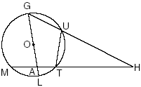

When Joe bowls, he can get a strike (knock down all the pins) 60% of the time. How many times more likely is it for Joe to bowl at least three strikes out of four tries as it is for him to bowl zero strikes out of four tries? Round your answer to the nearest whole number.

