Part I

Answer all questions in this part. Each correct answer will receive 2 credits. No partial credit will be allowed. For each question, write on the separate answer sheet the numeral preceding the word or expression that best completes the statement or answers the question.

Which fraction represents the probability of obtaining exactly eight heads in ten tosses of a fair coin?
(1) (3)
(2) (4)

In a New York City high school, a survey revealed the mean amount of cola consumed each week was 12 bottles and the standard deviation was 2.8 bottles. Assuming the survey represents a normal distribution, how many bottles of cola per week will approximately 68.2% of the students drink?
(1) 6.4 to 12 (3) 9.2 to 14.8
(2) 6.4 to 17.6 (4) 12 to 20.4

What is the solution of the inequality ?
(1) (3)
(2) (4)

What is the domain of?
(1) all integers (3)
(2) all real numbers (4)

A function is defined by the equation y = 5x – 5. Which equation defines the inverse of this function?
(1) (3)
(2) (4)

An architect is designing a building to include an arch in the shape of a semi-ellipse (half an ellipse), such that the width of the arch is 20 feet and the height of the arch is 8 feet, as shown in the accompanying diagram.
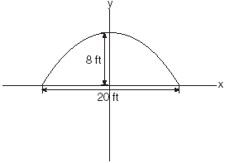
Which equation models this arch?
(1) (3)
(2) (4)

To balance a seesaw, the distance, in feet, a person is from the fulcrum is inversely proportional to the person’s weight, in pounds. Bill, who weighs 150 pounds, is sitting 4 feet away from the fulcrum. If Dan weighs 120 pounds, how far from the fulcrum should he sit to balance the seesaw?
(1) 4.5 ft (3) 3 ft
(2) 3.5 ft (4) 5 ft

What is the last term in the expansion of ?
(1) (3)
(2) (4)

In the equation x is equal to
(1) (3)
(2) (4)

Which expression represents the sum of
(1) (3)
(2) (4)

Which equation has imaginary roots?
(1) (3)
(2) (4)

If equals
(1) (3)
(2) (4)

If represents the number of combinations of items taken at a time, what is the value of ?
(1) 24 (3) 6
(2) 14 (4) 4

In the accompanying diagram of , , , and .

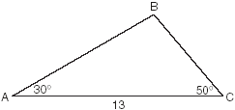
What is the length of side to the nearest tenth?
(1) 6.6 (3) 11.5
(2) 10.1 (4) 12.0

Expressed in simplest form, is equivalent to
(1) 1 (3)
(2) -1 (4) -i

If the point (a, b) lies on the graph , the graph of must contain point
(1) (b,a) (3) (0,b)
(2) (a,0) (4) (–a,–b)

If the sum of the roots of is added to the product of its roots, the result is
(1) 15 (3) –2
(2) –15 (4) –8

The expression is equivalent to
(1) (3)
(2) (4)

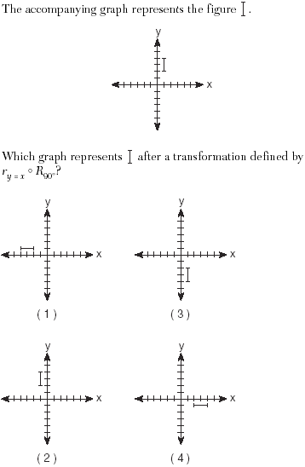

Which expression is equivalent to the complex fraction
(1) (3)
(2) (4)

Part II

Answer all questions in this part. Each correct answer will receive 2 credits. Clearly indicate the necessary steps, including appropriate formula substitutions, diagrams, graphs, charts, etc. For all questions in this part, a correct numerical answer with no work shown will receive only 1 credit.

A used car was purchased in July 1999 for $11,900. If the car depreciates 13% of its value each year, what is the value of the car, to the nearest hundred dollars, in July 2002?

The amount of time that a teenager plays video games in any given week is normally distributed. If a teenager plays video games an average of 15 hours per week, with a standard deviation of 3 hours, what is the probability of a teenager playing video games between 15 and 18 hours a week?

An art student wants to make a string collage by connecting six equally spaced points on the circumference of a circle to its center with string. What would be the radian measure of the angle between two adjacent pieces of string, in simplest form?

The Franklins inherited $3,500, which they want to invest for their child’s future college expenses. If they invest it at 8.25% with interest compounded monthly, determine the value of the account, in dollars, after 5 years. Use the formula $A=P(1+\frac{r}{n})^{\text{nt}},$ where A = value of the investment after t years, P = principal invested, r = annual interest rate, and n = number of times compounded per year.

A toy truck is located within a circular play area. Alex and Dominic are sitting on opposite endpoints of a chord that contains the truck. Alex is 4 feet from the truck, and Dominic is 3 feet from the truck. Meira and Tamara are sitting on opposite endpoints of another chord containing the truck. Meira is 8 feet from the truck. How many feet, to the nearest tenth of a foot, is Tamara from the truck? Draw a diagram to support your answer.

Two sides of a triangular-shaped pool measure 16 feet and 21 feet, and the included angle measures 58°. What is the area, to the nearest tenth of a square foot, of a nylon cover that would exactly cover the surface of the pool?

Part III

Answer all questions in this part. Each correct answer will receive 4 credits. Clearly indicate the necessary steps, including appropriate formula substitutions, diagrams, graphs, charts, etc. For all questions in this part, a correct numerical answer with no work shown will receive only 1 credit.

The cost (C) of selling x calculators in a store is modeled by the equation The store profit (P) for these sales is modeled by the equation . What is the minimum number of calculators that have to be sold for profit to be greater than cost?

Two tow trucks try to pull a car out of a ditch. One tow truck applies a force of 1,500 pounds while the other truck applies a force of 2,000 pounds. The resultant force is 3,000 pounds. Find the angle between the two applied forces, rounded to the nearest degree.

A rock is thrown vertically from the ground with a velocity of 24 meters per second, and it reaches a height of after t seconds. How many seconds after the rock is thrown will it reach maximum height, and what is the maximum height the rock will reach, in meters? How many seconds after the rock is thrown will it hit the ground? Round your answers to the nearest hundredth. [Only an algebraic or graphic solution will be accepted.]


In the accompanying diagram, is not isosceles. Prove that if altitude were drawn, it would not bisect .
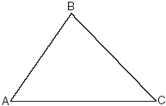

Graph and label the following equations, a and b, on the accompanying set of coordinate axes.
Describe the composition of transformations performed on a to get b.
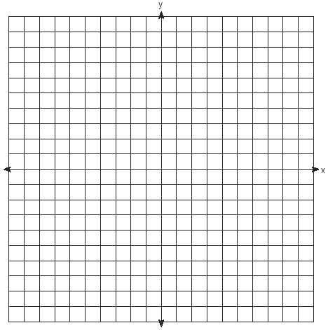

The breaking strength, y, in tons, of steel cable with diameter d, in inches, is given in the table below.
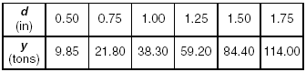
On the accompanying grid, make a scatter plot of these data. Write the exponential regression equation, expressing the regression coefficients to the nearest tenth.


Part IV

Answer all questions in this part. Each correct answer will receive 6 credits. Clearly indicate the necessary steps, including appropriate formula substitutions, diagrams, graphs, charts, etc. For all questions in this part, a correct numerical answer with no work shown will receive only 1 credit.

Carmen and Jamal are standing 5,280 feet apart on a straight, horizontal road. They observe a hot-air balloon between them directly above the road. The angle of elevation from Carmen is 60° and from Jamal is 75°. Draw a diagram to illustrate this situation and find the height of the balloon to the nearest foot.

Electrical circuits can be connected in series, one after another, or in parallel circuits that branch off a main line. If circuits are hooked up in parallel, the reciprocal of the total resistance in the series is found by adding the reciprocals of each resistance, as shown in the accompanying diagram.
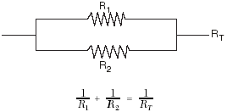
If , and the total resistance, , is 2.25 ohms, find the positive value of to the nearest tenth of an ohm.

