Part I

Answer all questions in this part. Each correct answer will receive 2 credits. No partial credit will be allowed. For each question, write on the separate answer sheet the numeral preceding the word or expression that best completes the statement or answers the question.

Which relation is not a function?
(1) (3)
(2) (4)

The solution set of contains
(1) only negative real numbers
(2) only positive real numbers
(3) both positive and negative real numbers
(4) no real numbers

In the accompanying diagram, cabins B and G are located on the shore of a circular lake, and cabin L is located near the lake. Point D is a dock on the lake shore and is collinear with cabins B and L. The road between cabins G and L is 8 miles long and is tangent to the lake. The path between cabin L and dock D is 4 miles long.
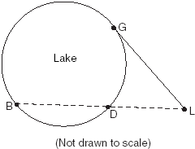
What is the length, in miles, of ?
(1) 24 (3) 8
(2) 12 (4) 4

The solution set of the equation is
(1) {–2,3} (3) {3}
(2) {–2} (4) { }

Which transformation is a direct isometry?
(1) (3)
(2) (4)

The roots of the equation are
(1) real, rational, and equal
(2) real, rational, and unequal
(3) real, irrational, and unequal
(4) imaginary

The new corporate logo created by the design engineers at Magic Motors is shown in the accompanying diagram.
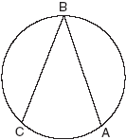
If chords and are congruent and what is ?
(1) 40 (3) 140
(2) 80 (4) 280

At Mogul’s Ski Resort, the beginner’s slope is inclined at an angle of 12.3°, while the advanced slope is inclined at an angle of 26.4°. If Rudy skis 1,000 meters down the advanced slope while Valerie skis the same distance on the beginner’s slope, how much longer was the horizontal distance that Valerie covered?
(1) 81.3 m (3) 895.7 m
(2) 231.6 m (4) 977.0 m

A regular hexagon is inscribed in a circle. What is the ratio of the length of a side of the hexagon to the minor arc that it intercepts?
(1) (3)
(2) (4)

If log 5 = a, then log 250 can be expressed as
(1) 50a (3) 10 + 2a
(2) 2a + 1 (4) 25a

On a trip, a student drove 40 miles per hour for 2 hours and then drove 30 miles per hour for 3 hours. What is the student’s average rate of speed, in miles per hour, for the whole trip?
(1) 34 (3)36
(2) 35 (4)37

A ball is thrown straight up at an initial velocity of 54 feet per second. The height of the ball t seconds after it is thrown is given by the formula . How many seconds after the ball is thrown will it return to the ground?
(1) 9.2 (3) 4.5
(2) 6 (4) 4

What is the period of the function y = 5 sin 3x?
(1) 5 (3) 3
(2) (4)

A cellular telephone company has two plans. Plan A charges $11 a month and $0.21 per minute. Plan B charges $20 a month and $0.10 per minute. After how much time, to the nearest minute, will the cost of plan A be equal to the cost of plan B?
(1) 1 hr 22 min (3) 81 hr 8 min
(2) 1 hr 36 min (4) 81 hr 48 min

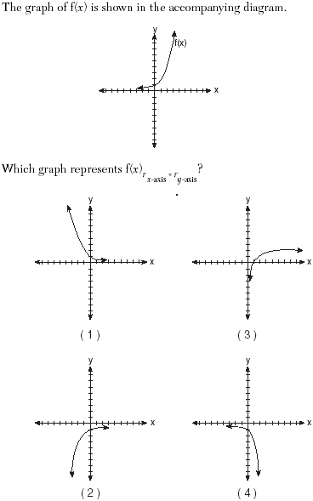

A wedge-shaped piece is cut from a circular pizza. The radius of the pizza is 6 inches. The rounded edge of the crust of the piece measures 4.2 inches. To the nearest tenth, the angle of the pointed end of the piece of pizza, in radians, is
(1) 0.7 (3) 7.0
(2) 1.4 (4) 25.2

If the length of a rectangular garden is represented by and its width is represented by , which expression represents the area of the garden?
(1) x (3)
(2) x + 5 (4)

Determine the value of x and y if and .
(1) x = 6, y = 2 (3) x = 2, y = 6
(2) x = –2, y = –6 (4) x = y

If Jamar can run of a mile in 2 minutes 30 seconds, what is his rate in miles per minute?
(1) (3)
(2) (4)

A box contains one 2-inch rod, one 3-inch rod, one 4-inch rod, and one 5-inch rod. What is the maximum number of different triangles that can be made using these rods as sides?
(1) 1 (3) 3
(2) 2 (4) 4

Part II

Answer all questions in this part. Each correct answer will receive 2 credits. Clearly indicate the necessary steps, including appropriate formula substitutions, diagrams, graphs, charts, etc. For all questions in this part, a correct numerical answer with no work shown will receive only 1 credit.

If the sine of an angle is and the angle is not in Quadrant I, what is the value of the cosine of the angle?

Show that the product of a + bi and its conjugate is a real number.

The price per person to rent a limousine for a prom varies inversely as the number of passengers. If five people rent the limousine, the cost is $70 each. How many people are renting the limousine when the cost per couple is $87.50?

The accompanying diagram shows a semicircular arch over a street that has a radius of 14 feet. A banner is attached to the arch at points A and B, such that $\text{AE}=\text{EB}=5$ feet. How many feet above the ground are these points of attachment for the banner?
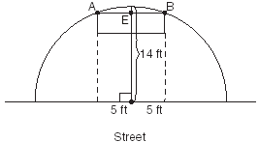

Working by herself, Mary requires 16 minutes more than Antoine to solve a mathematics problem. Working together, Mary and Antoine can solve the problem in 6 minutes. If this situation is represented by the equation , where t represents the number of minutes Antoine works alone to solve the problem, how many minutes will it take Antoine to solve the problem if he works by himself?

If sin x = , where 0° < x < 90°, find the value of cos (x + 180°).

Part III

Answer all questions in this part. Each correct answer will receive 4 credits. Clearly indicate the necessary steps, including appropriate formula substitutions, diagrams, graphs, charts, etc. For all questions in this part, a correct numerical answer with no work shown will receive only 1 credit.

The times of average monthly sunrise, as shown in the accompanying diagram, over the course of a 12-month interval can be modeled by the equation y = A cos (Bx) + D. Determine the values of A, B, and D, and explain how you arrived at your values.
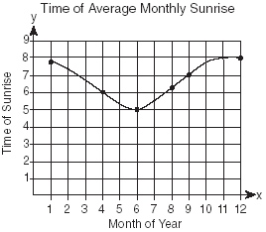

As shown in the accompanying diagram, a circular target with a radius of 9 inches has a bull’s-eye that has a radius of 3 inches. If five arrows randomly hit the target, what is the probability that at least four hit the bull’s-eye?
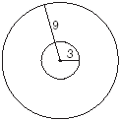

Twenty high school students took an examination and received the following scores:
70, 60, 75, 68, 85, 86, 78, 72, 82, 88, 88, 73, 74, 79, 86, 82, 90, 92, 93, 73
Determine what percent of the students scored within one standard deviation of the mean. Do the results of the examination approximate a normal distribution? Justify your answer.

A small, open-top packing box, similar to a shoebox without a lid, is three times as long as it is wide, and half as high as it is long. Each square inch of the bottom of the box costs $0.008 to produce, while each square inch of any side costs $0.003 to produce.
Write a function for the cost of the box described above.
Using this function, determine the dimensions of a box that would cost $0.69 to produce.

In the accompanying diagram of , , , and the side opposite vertex B is 7. Find the length of the side opposite vertex A, and find the area of .
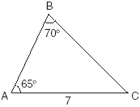

The amount A, in milligrams, of a 10-milligram dose of a drug remaining in the body after t hours is given by the formula . Find, to the nearest tenth of an hour, how long it takes for half of the drug dose to be left in the body.

Part IV

Answer all questions in this part. Each correct answer will receive 6 credits. Clearly indicate the necessary steps, including appropriate formula substitutions, diagrams, graphs, charts, etc. For all questions in this part, a correct numerical answer with no work shown will receive only 1 credit.

The availability of leaded gasoline in New York State is decreasing, as shown in the accompanying table.
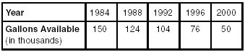
Determine a linear relationship for x (years) versus y (gallons available), based on the data given. The data should be entered using the year and gallons available (in thousands), such as (1984, 150).
If this relationship continues, determine the number of gallons of leaded gasoline available in New York State in the year 2005.
If this relationship continues, during what year will leaded gasoline first become unavailable in New York State?

Given: A(1,6), B(7,9), C(13,6), and D(3,1)
Prove: ABCD is a trapezoid. [The use of the accompanying grid is optional.]


