1 Pete and Sean decide to raise money for a charity by having a carnival in their backyard. In one of the games that they set up, the probability that a person will win is 0.4. If Robyn plays that game nine times, what is the probability that she wins exactly four times?
1) |  | 3)
2) |  | 4)

2 Which number is the largest?
1) | 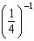 | 3) | 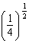
2) | 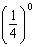 | 4) | 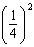

3 The point maps onto under a dilation with respect to the origin. What is the constant of dilation?
1) |  | 3) | 3
2) |  | 4)

4 If 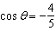 and lies in Quadrant II, what is the value of ?
1) |  | 3)
2) |  | 4)

5 Tracy, a political campaign organizer, realizes that the number of hours needed to get out a mailing for her candidate is inversely proportional to the number of campaign workers she has. If she uses the information in the accompanying graph, how many hours would it take to do the mailing if 125 workers are used?

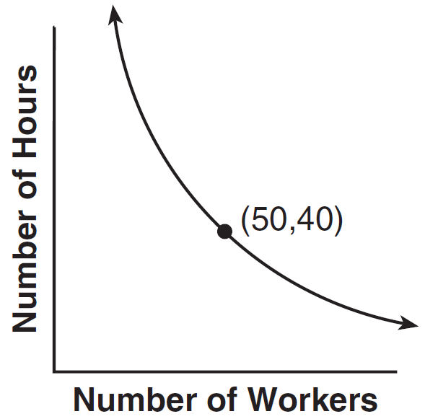
1) | 12 | 3) | 20
2) | 16 | 4) | 24

6 What is 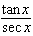 expressed in simplest form?
1) | 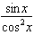 | 3) | 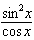
2) | 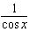 | 4)

7 What is the value of 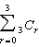?
1) | 8 | 3) | 3
2) | 9 | 4) | 4

8 What is the exact value of 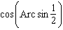?
1) |  | 3)
2) |  | 4)

9 If , then x is equal to
1) |  | 3)
2) |  | 4)

10 The roots of the equation are
1) | rational and unequal | 3) | irrational and unequal
2) | rational and equal | 4) | imaginary

11 If the measure of , , and , how many different triangles can be constucted?
1) | 1 | 3) | 3
2) | 2 | 4) | 0

12 Which is the equation of the axis of symmetry of the graph of the equation ?
1) |  | 3)
2) | 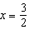 | 4) | 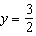

13 The air temperature in Dallas, Texas, over a 5-hour period is shown in the accompanying graph.

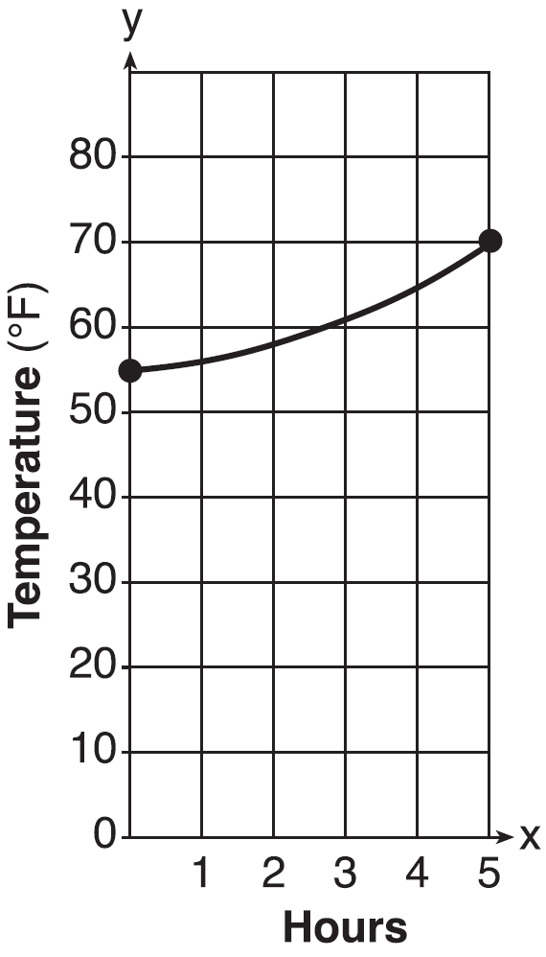

What is the range of this set of data?
1) |  | 3)
2) |  | 4)

14 The expression is equivalent to
1) |  | 3)
2) |  | 4)

15 If and , then is equal to
1) |  | 3)
2) |  | 4)

16 Which equation is represented by the accompanying graph?

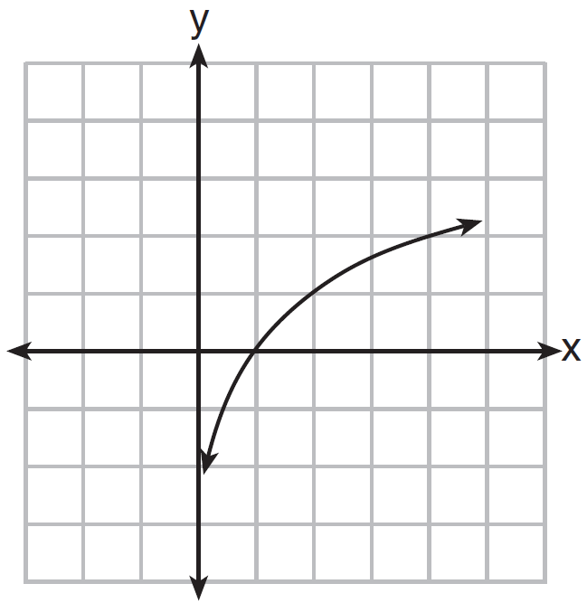
1) |  | 3)
2) |  | 4)

17 Which quadratic equation has the roots and ?
1) |  | 3)
2) |  | 4)

18 What is the solution set of ?
1) |  | 3)
2) |  | 4)

19 The graph of the product of and lies in which quadrant?
1) | I | 3) | III
2) | II | 4) | IV

20 Which equation represents an ellipse?
1) |  | 3)
2) |  | 4)

21 Simplify: 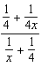

22 In , , , and . Find the area of , to the nearest tenth.

23 Solve for x: 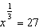

24 Solve for x:

25 During a recent time period, the following Apgar scores were recorded at St. Elizabeth's Hospital:
9, 8, 10, 9, 8, 10, 9, 10, 8, 10
Find the population standard deviation of the scores, to the nearest hundredth.

26 The tip of a pendulum describes an arc 18 centimeters long when the pendulum swings through an angle of of a radian. Find the length, in centimeters, of the pendulum.

27 The data tahle below shows water temperatures at various depths in an ocean.

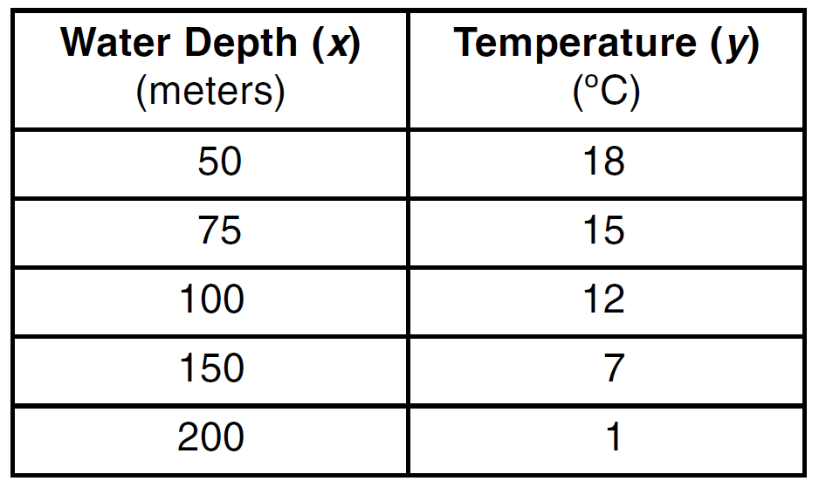

W'rite the linear regression equation for this set of data, rounding all values to the nearest thousandth. Using this equation, predict the temperature (ºC), to the nearest integer, at a water depth of 255 meters.

28 Express 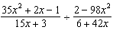 in simplest form.

29 A shape to be used in a computer game is placed on a Cartesian coordinate plane. The equation of the shape is . On the accompanying grid, graph the shape and label it a. In the game, the shape is moved under the composition . Draw this image, label it b, and state its equation.



30 As shown in the accompanying diagram, the hypotenuse of the right triangle is 6 meters long. One leg is 1 meter longer than the other. Find the lengths of both legs of the triangle, to the nearest hundredth of a meter.

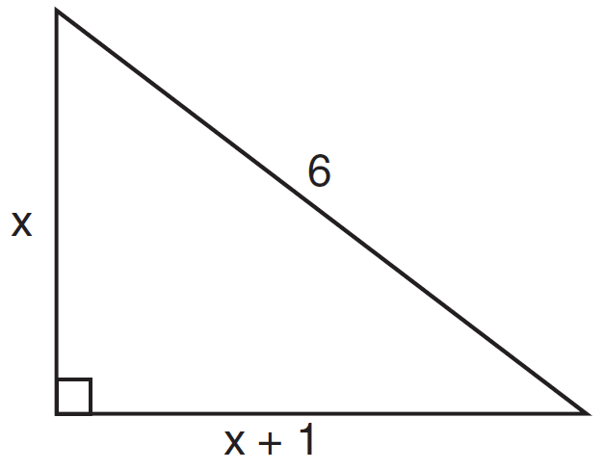

31 Quadrilateral ABCD has vertices , , , and . Prove that ABCD is a parallelogram but not a rhombus. [The use of the grid is optional.]

32 Solve the following systems of equations algebraically.
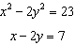

33 In triangle RST, , , and . Find RT, to the nearest tenth. Using your value for RT, find , to the nearest degree.

34 Solve algebraically for all values of in the interval .
Express your answers to the nearest degree.
1 ANS: 3 PTS: 2 REF: 061001b STA: A2.S.15
TOP: Binomial Probability KEY: modeling

2 ANS: 1 PTS: 2 REF: 061002b STA: A2.N.1
TOP: Negative and Fractional Exponents

3 ANS: 1 PTS: 2 REF: 061003b STA: G.G.58
TOP: Dilations

4 ANS: 3
If and lies in Quadrant II, then 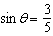. 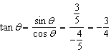

PTS: 2 REF: 061004b STA: A2.A.64 TOP: Using Inverse Trigonometric Functions
KEY: advanced

5 ANS: 2 PTS: 2 REF: 061005b STA: A2.A.5
TOP: Inverse Variation

6 ANS: 4 PTS: 2 REF: 061006b STA: unassigned
TOP: Reciprocal Trigonometric Relationships

7 ANS: 1
r
0 |  |  |  | 1
1 |  |  |  | 3
2 |  |  | 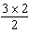 | 3
3 |  |  | 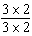 | 1
Σ |  |  |  | 8

PTS: 2 REF: 061007b STA: A2.N.10 TOP: Sigma Notation
KEY: advanced

8 ANS: 3 PTS: 2 REF: 061008b STA: A2.A.64
TOP: Using Inverse Trigonometric Functions KEY: advanced

9 ANS: 3
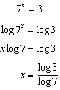

PTS: 2 REF: 061009b STA: A2.A.27 TOP: Exponential Equations
KEY: without common base

10 ANS: 3

PTS: 2 REF: 061010b STA: A2.A.2 TOP: Using the Discriminant
KEY: determine nature of roots given equation

11 ANS: 2
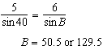. 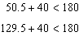

PTS: 2 REF: 061011b STA: A2.A.75 TOP: Law of Sines - The Ambiguous Case

12 ANS: 2
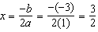

PTS: 2 REF: 061012b STA: unassigned
TOP: Identifying the Vertex of a Quadratic Given Equation

13 ANS: 4 PTS: 2 REF: 061013b STA: A2.A.51
TOP: Domain and Range

14 ANS: 3
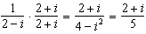. 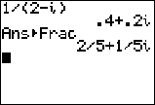

PTS: 2 REF: 061014b STA: A2.N.9
TOP: Multiplication and Division of Complex Numbers

15 ANS: 3

PTS: 2 REF: 061015b STA: A2.A.42 TOP: Compositions of Functions
KEY: variables

16 ANS: 4 PTS: 2 REF: 061016b STA: A2.A.52
TOP: Identifying the Equation of a Graph

17 ANS: 3
The sum of the roots is 4 and the product of the roots is 1. 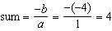. 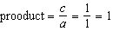.

PTS: 2 REF: 061017b STA: A2.A.21 TOP: Roots of Quadratics
KEY: advanced

18 ANS: 3
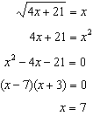. is an extraneous solution.

PTS: 2 REF: 061018b STA: A2.A.22 TOP: Solving Radicals
KEY: extraneous solutions

19 ANS: 4

PTS: 2 REF: 061019b STA: unassigned TOP: Graphing Complex Numbers

20 ANS: 1 PTS: 2 REF: 061020b STA: unassigned
TOP: Properties of Graphs of Functions and Relations

21 ANS:
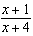. 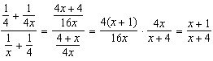

PTS: 2 REF: 061021b STA: A2.A.17 TOP: Complex Fractions

22 ANS:
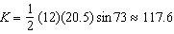

PTS: 2 REF: 061022b STA: A2.A.74 TOP: Using Trigonometry to Find Area
KEY: basic

23 ANS:

PTS: 2 REF: 061023b STA: unassigned TOP: Exponents as Radicals

24 ANS:
. 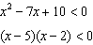. 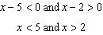

PTS: 2 REF: 061024b STA: A2.A.4 TOP: Quadratic Inequalities
KEY: one variable

25 ANS:
0.83

PTS: 2 REF: 061025b STA: A2.S.4 TOP: Dispersion
KEY: basic

26 ANS:
24. 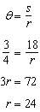

PTS: 2 REF: 061026b STA: A2.A.61 TOP: Arc Length
KEY: radius

27 ANS:
.

PTS: 4 REF: 061027b STA: A2.S.7 TOP: Linear Regression

28 ANS:
. 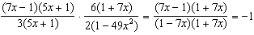

PTS: 4 REF: 061028b STA: A2.A.16 TOP: Multiplication and Division of Rationals

29 ANS:
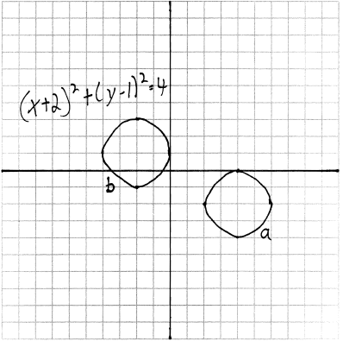

PTS: 4 REF: 061029b STA: G.G.54 TOP: Compositions of Transformations
KEY: grids

30 ANS:
3.71 and 4.71. 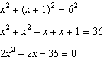. 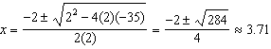

PTS: 4 REF: 061030b STA: A2.A.25 TOP: Quadratics with Irrational Solutions

31 ANS:
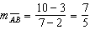, 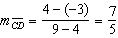, 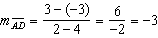, 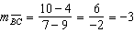 (Definition of slope). , (Parallel lines have equal slope). Quadrilateral ABCD is a parallelogram (Definition of parallelogram). , (Definition of distance). is not congruent to (Congruent lines have equal distance). ABCD is not a rhombus (A rhombus has four equal sides).

PTS: 4 REF: 061031b STA: G.G.69 TOP: Quadrilaterals in the Coordinate Plane

32 ANS:
, . . 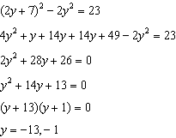. .

PTS: 4 REF: 061032b STA: A2.A.3 TOP: Quadratic-Linear Systems
KEY: equations

33 ANS:
. 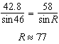

PTS: 6 REF: 061033b STA: A2.A.73 TOP: Law of Cosines
KEY: advanced

34 ANS:
19, 90, 161. 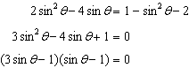. 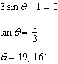. 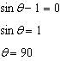.

PTS: 6 REF: 061034b STA: A2.A.68 TOP: Trigonometric Equations
KEY: pythagorean identities

