Part I

Answer all questions in this part. Each correct answer will receive 2 credits. No partial credit will be allowed. For each question, write on the separate answer sheet the numeral preceding the word or expression that best completes the statement or answers the question.

Each graph below represents a possible relationship between temperature and pressure. Which graph does not represent a function?

If $f(x)=x^{−\frac{3}{2}},$ then $f(\frac{1}{4})$ is equal to
(1) 8 (3) $−\frac{1}{8}$
(2) -2 (4) -4

In the accompanying diagram of circle O, chord $\overline{\text{AY}}$ is parallel to diameter$\overline{\text{DOE}},$ $\overline{\text{AD}}$ is drawn, and

What is $m∠\text{DAY}?$
(1) 90 (3) 130
(2) 110 (4) 150

If x is a positive acute angle and $\text{sin}x=\frac{1}{2},$what is $\text{sin}2x?$
(1) $−\frac{1}{2}$ (3) $−\frac{\sqrt{3}}{2}$
(2) $\frac{1}{2}$ (4) $\frac{\sqrt{3}}{2}$

The temperature generated by an electrical circuit is represented by $t=f(m)=0\text{.}3m^{2},$ where m is the number of moving parts. The resistance of the same circuit is represented by $r=g(t)=\text{150}+5t,$ where t is the temperature. What is the resistance in a circuit that has four moving parts?
(1) 51 (3) 174
(2) 156 (4) 8,670

If the equation $x^{2}−\text{kx}−\text{36}=0$ has x = 12 as one root, what is the value of k?
(1) 9 (3) 3
(2) -9 (4) -3

The height, f(x), of a bouncing ball after x bounces is represented by $f(x)=\text{80}(0\text{.}5)^{x}\text{.}$ How many times higher is the first bounce than the fourth bounce?
(1) 8 (3) 16
(2) 2 (4) 4

A radio transmitter sends a radio wave from the top of a 50-foot tower. The wave is represented by the accompanying graph.

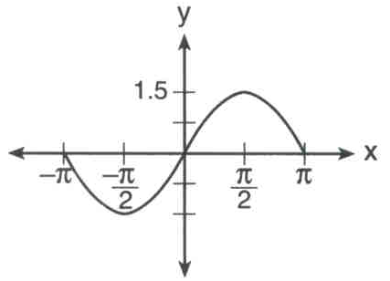

What is the equation of this radio wave?
(1) y = sin x (3) y = sin 1.5x
(2) y = 1.5 sin x (4) y = 2 sin x

If $\text{tan}θ=2\text{.}7$ and $\text{csc}θ<0,$ in which quadrant does $θ$ lie?
(1) I (3) III
(2) II (4) IV

The expression $\frac{1−{\text{cos}}^{2}x}{{\text{sin}}^{2}x}$ is equivalent to
(1) 1 (3) sin x
(2) -1 (4) cos x

The graph of $y=(x−3)^{2}$ is shifted left 4 units and down 2 units. What is the axis of symmetry of the transformed graph?
(1) x = -2 (3) x = 1
(2) x = -1 (4) x = 7

The solution set of $2^{x^{2}+2x}=2^{−1}$ is
(1) {1} (3) {-1,1}
(2) {-1} (4) { }

Which transformation best describes the relationship between the functions $f(x)=2^{x}$ and $g(x)=(\frac{1}{2})^{x}?$
(1) reflection in the line y = x
(2) reflection in the origin
(3) reflection in the x-axis
(4) reflection in the y-axis

What is the multiplicative inverse of 3i?
(1) -3i (3) $\frac{1}{3}$
(2) -3 (4) $−\frac{i}{3}$

Mrs. Donahue made up a game to help her class learn about imaginary numbers. The winner will be the student whose expression is equivalent to -i. Which expression will win the game?
(1) $i^{\text{46}}$ (3) $i^{\text{48}}$
(2) $i^{\text{47}}$ (4) $i^{\text{49}}$

Which equation represents a hyperbola?
(1) $y^{2}=\text{16}−x^{2}$ (3) $y=\text{16}x^{2}$
(2) $y=\text{16}−x^{2}$ (4) $y=\frac{\text{16}}{x}$

The solution set of which inequality is represented by the accompanying graph?

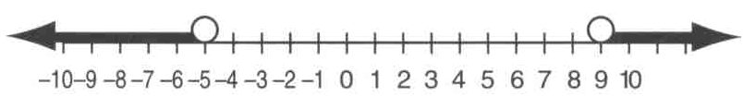

(1) $\left|x−2\right|>7$ (3) $\left|2−x\right|>−7$
(2) $\left|x−2\right|<7$ (4) $\left|2−x\right|<−7$

According to Boyle's Law, the pressure, p, of a compressed gas is inversely proportional to the volume, v. If a pressure of 20 pounds per square inch exists when the volume of the gas is 500 cubic inches, what is the pressure when the gas is compressed to 400 cubic inches?
(1) 16 lb/in² (3) 40 lb/in²
(2) 25 lb/in² (4) 50 lb/in²

What is the fourth term in the expansion of (y - 1) ⁷?
(1) 35y⁴ (3) -35y⁴
(2) 35y³ (4) -35y³

Sam needs to cut a triangle out of a sheet of paper. The only requirements that Sam must follow are that one of the angles must be 60°, the side opposite the 60° angle must be 40 centimeters, and one of the other sides must be 15 centimeters. How many different triangles can Sam make?
(1) 1 (3) 3
(2) 2 (4) 0

Part II

Answer all questions in this part. Each correct answer will receive 2 credits. Clearly indicate the necessary steps, including appropriate formula substitutions, diagrams, graphs, charts, etc. For all questions in this part, a correct numerical answer with no work shown will receive only 1 credit.

Find the sum of -2 + 3i and -1 - 2i.
Graph the resultant on the accompanying set of axes.

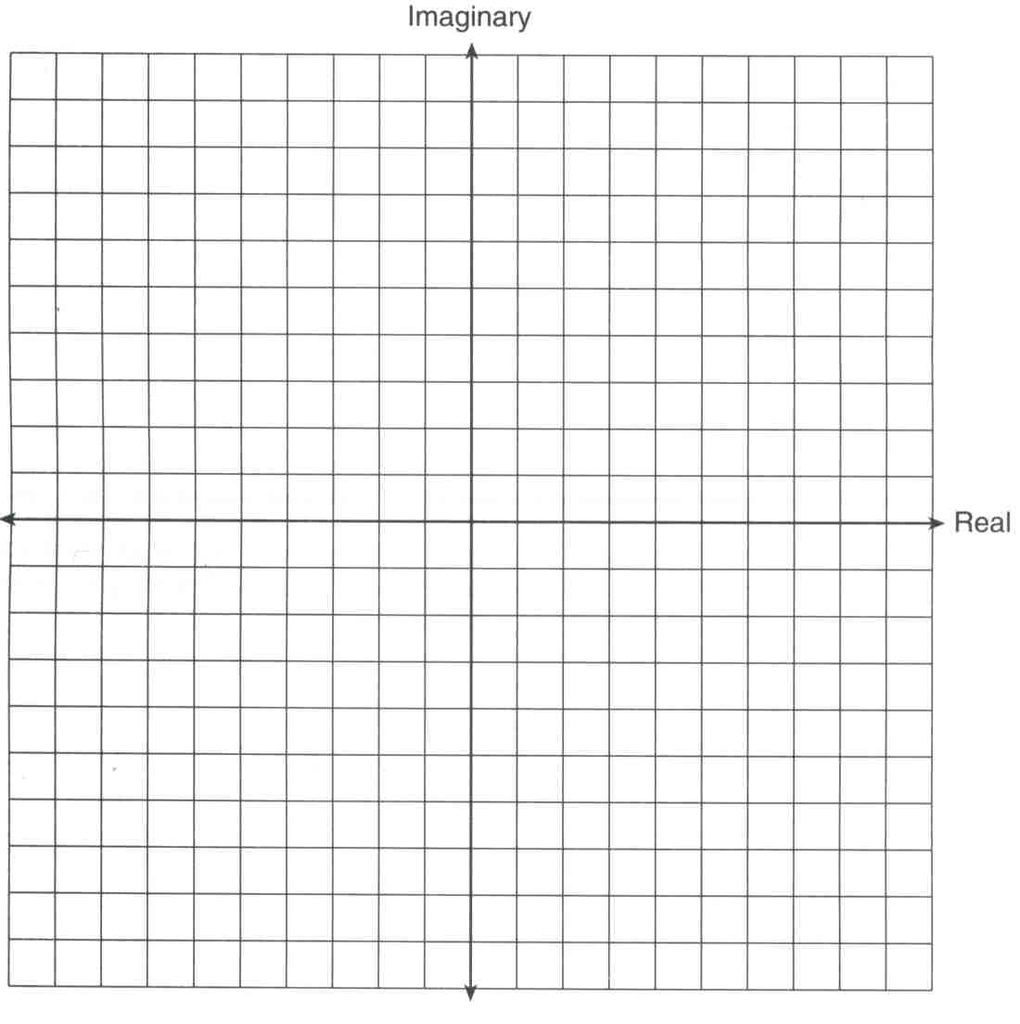

In $Δ\text{ABC},$ $m∠A=\text{53},$ $m∠B=\text{14},$ and a = 10. Find b to the nearest integer.

Solve for x: log₂ (x + 1) = 3

Evaluate: $\sum_{k=1}^{2}{\frac{(−1)^{k−1}}{(2k−1)!}}$

Ginger and Mary Anne are planning a vacation trip to the island of Capri, where the probability of rain on any day is 0.3. What is the probability that during their five days on the island, they have no rain on exactly three of the five days?

The pendulum of a clock swings through an angle of 2.5 radians as its tip travels through an arc of 50 centimeters. Find the length of the pendulum, in centimeters.

Part III

Answer all questions in this part. Each correct answer will receive 4 credits. Clearly indicate the necessary steps, including appropriate formula substitutions, diagrams, graphs, charts, etc. For all questions in this part, a correct numerical answer with no work shown will receive only 1 credit.

Solve the following system of equations algebraically:
$$\begin{aligned}9x^{2}+y^{2}=9 \\ 3x−y=3\end{aligned}$$

Simplify for all values of a for which the expression is defined: $\frac{1−\frac{2}{a}}{\frac{4}{a^{2}}−1}$

Solve algebraically for x: $\sqrt{3x+1}+1=x$

The number of children of each of the first 41 United States presidents is given in the accompanying table. For this population, determine the mean and the standard deviation to the nearest tenth.
How many of these presidents fall within one standard deviation of the mean?

A factory is producing and stockpiling metal sheets to be shipped to an automobile manufacturing plant. The factory ships only when there is a minimum of 2,050 sheets in stock. The accompanying table shows the day, x, and the number of sheets in stock, f(x).

Write the linear regression equation for this set of data, rounding the coefficients to four decimal places.
Use this equation to determine the day the sheets will be shipped.

A small rocket is launched from a height of 72 feet. The height of the rocket in feet, h, is represented by the equation $h(t)=−\text{16}t^{2}+\text{64}t+\text{72},$ where t = time, in seconds. Graph this equation on the accompanying grid.
Use your graph to determine the number of seconds that the rocket will remain at or above 100 feet from the ground. [Only a graphic solution can receive full credit.]

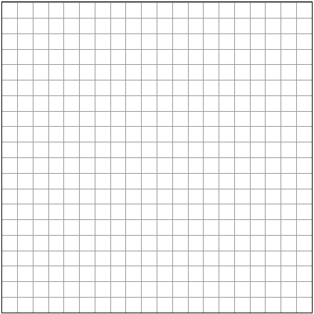

Part IV

Answer all questions in this part. Each correct answer will receive 6 credits. Clearly indicate the necessary steps, including appropriate formula substitutions, diagrams, graphs, charts, etc. For all questions in this part, a correct numerical answer with no work shown will receive only 1 credit.

Given: A(-2,2), B(6,5), C(4,0), D(-4,-3)
Prove: ABCD is a parallelogram but not a rectangle. [The use of the grid is optional.]

A triangular plot of land has sides that measure 5 meters, 7 meters, and 10 meters. What is the area of this plot of land, to the nearest tenth of a square meter?

