Part I

Answer all questions in this part. Each correct answer will receive 2 credits. No partial credit will be allowed. For each question, write on the separate answer sheet the numeral preceding the word or expression that best completes the statement or answers the question.

The accompanying graph shows the heart rate, in beats per minute, of a jogger during a 4-minute interval.
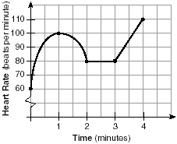
What is the range of the jogger's heart rate during this interval?
(1) 0-4 (3) 0-110
(2) 1-4 (4) 60-110

If is negative and is negative, in which quadrant does the terminal side of lie?
(1) I (3) III
(2) II (4) IV

Expressed as a function of a positive acute angle, sin (-230°) is equal to
(1) sin 50° (3) cos 50°
(2) -sin 50° (4) -cos 50°

Written in simplest form, the expression is equivalent to
(1) (3)
(2) (4)

Which graph represents the solution set for the expression
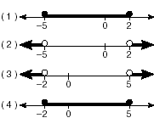

What are the coordinates of the center of the circle represented by the equation
(1) (3,4) (3) (-3,4)
(2) (3,-4) (4) (-3-4)

What is the mean of the data in the accompanying table?
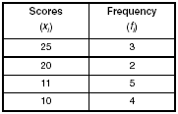
(1) 11 (3) 15
(2) 14.5 (4) 16

In a given rectangle, the length varies inversely as the width. If the length is doubled, the width will
(1) be divided by 2 (3) be multiplied by 2
(2) remain the same (4) increase by 2

Impedance measures the opposition of an electrical circuit to the flow of electricity. The total impedance in a particular circuit is given by the formula What is the total impedance of a circuit, , if and
(1) (3)
(2) (4)

If and what is
(1) (3)
(2) (4)

Which relation is a function?
(1) (3)
(2) (4)

Which equation, when graphed on a Cartesian coordinate plane, would best represent an elliptical racetrack?
(1) (3)
(2) (4)

The expression is equivalent to
(1) (3)
(2) (4)

For which quadratic equation is the axis of symmetry x = 3?
(1) (3)
(2) (4)

A crate weighing w pounds sits on a ramp positioned at an angle of θ with the horizontal. The forces acting on this crate are modeled by the equation where M is the coefficient of friction. What is an expression for M in terms of θ?
(1) (3)
(2) (4)

If what is the value of x?
(1) 1 (3) -3
(2) 2 (4) -1

What is the third term in the expansion of
(1) (3)
(2) (4)

Which equation has imaginary roots?
(1) x(5 + x) = 8 (3) x(x + 6) = -10
(2) x(5 - x) = -3 (4) (2x + l)(x - 3)=7

The graphs of the equations and intersect in Quadrant I for which values of a?
(1) (3)
(2) (4)

In the accompanying diagram, is tangent to circle O at R, and
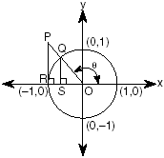
Which measure represents
(1) SO (3) PR
(2) RO (4) QS

Part II

Answer all questions in this part. Each correct answer will receive 2 credits. Clearly indicate the necessary steps, including appropriate formula substitutions, diagrams, graphs, charts, etc. For all questions in this part, a correct numerical answer with no work shown will receive only 1 credit.

The graph of the function g(x) is shown on the accompanying set of axes. On the same set of axes, sketch the image of g(x) under the transformation $D_{2}\text{.}$
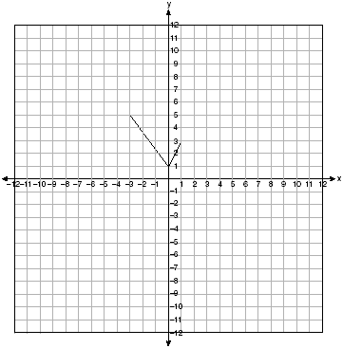

Solve for m:

Evaluate:

Express in simplest form:

A landscape architect is designing a triangular garden to fit in the corner of a lot. The corner of the lot forms an angle of 70°, and the sides of the garden including this angle are to be 11 feet and 13 feet, respectively. Find, to the nearest integer, the number of square feet in the area of the garden.

A certain drug raises a patient's heart rate, in beats per minute, according to the function where x is the bloodstream drug level, in milligrams. The level of the drug in the patient's bloodstream is a function of time, t, in hours, according to the formula Find the value of the patient's heart rate in beats per minute, to the nearest whole number.

Part III

Answer all questions in this part. Each correct answer will receive 4 credits. Clearly indicate the necessary steps, including appropriate formula substitutions, diagrams, graphs, charts, etc. For all questions in this part, a correct numerical answer with no work shown will receive only 1 credit.

As shown in the accompanying diagram, two tracking stations, A and B, are on an east-west line 110 miles apart. A forest fire is located at F, on a bearing 42° northeast of station A and 15° northeast of station B. How far, to the nearest mile, is the fire from station A?
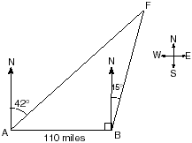

Solve for all values of q that satisfy the equation

The probability that a planted watermelon seed will sprout is If Peyton plants seven seeds from a slice of watermelon, find, to the nearest ten thousandth, the probability that at least five will sprout.

Find, to the nearest degree, all values of θ in the interval 0° < θ < 360° that satisfy the equation

Kathy and Tami are at point A on a circular track that has a radius of 150 feet, as shown in the accompanying diagram. They run counterclockwise along the track from A to S, a distance of 247 feet. Find, to the nearest degree, the measure of minor arc AS.
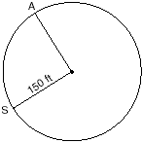

The height of a projectile is modeled by the equation where x is time, in seconds, and y is height, in feet. During what interval of time, to the nearest tenth of a second, is the projectile at least 125 feet above ground? [The use of the accompanying grid is optional.]


Part IV

Answer all questions in this part. Each correct answer will receive 6 credits. Clearly indicate the necessary steps, including appropriate formula substitutions, diagrams, graphs, charts, etc. For all questions in this part, a correct numerical answer with no work shown will receive only 1 credit.

Given: parallelogram ABCD, diagonal and
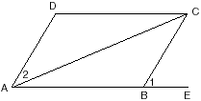
Prove:

An architect is designing a park with an entrance represented by point C and a circular garden with center O, as shown in the accompanying diagram. The architect plans to connect three points on the circumference of the garden, A, B, and D, to the park entrance, C, with walkways so that walkways and are tangent to the garden, walkway is a path through the center of the garden, BC = 60 meters, and EC = 43.6 meters.
Find the measure of the angle between walkways and .
Find the diameter of the circular garden, to the nearest meter.
