Part I

Answer all questions in this part. Each correct answer will receive 2 credits. No partial credit will be allowed. For each question, write on the separate answer sheet the numeral preceding the word or expression that best completes the statement or answers the question.

What is the sum of and expressed in a + bi form?
(1) (3)
(2) (4)

The Hiking Club plans to go camping in a State park where the probability of rain on any given day is 0.7. Which expression can be used to find the probability that it will rain on exactly three of the seven days they are there?
(1) (3)
(2) (4)

What is the amplitude of the function ?
(1) (3)
(2) (4)

Which quadratic function is shown in the accompanying graph?
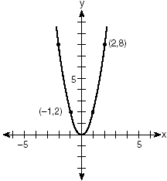
(1) (3)
(2) (4)

In the accompanying graph, the shaded region represents set A of all points (x,y) such that The transformation T maps point (x, y) to point (2x, 4y).
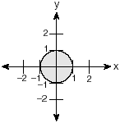
Which graph shows the mapping of set A by the transformation T?
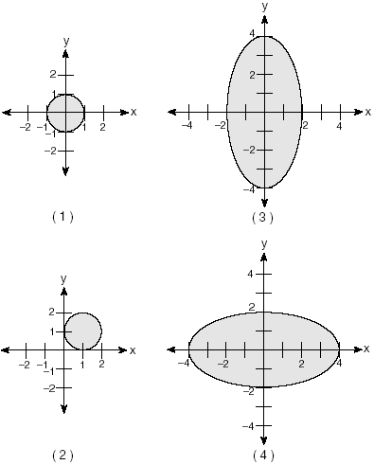

If what is the value of
(1) (3)
(2) (4)

What is the domain of the function
(1) all real numbers except 0
(2) all real numbers except 3
(3) all real numbers except 3 and –3
(4) all real numbers

Which graph represents an inverse variation between stream velocity and the distance from the center of the stream?
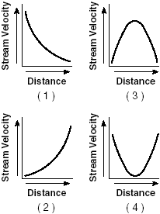

If then x equals
(1) (3)
(2) (4)

The expression is equal to
(1) 1 (3) i
(2) -1 (4) -i

Which equation models the data in the accompanying table?
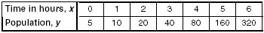
(1) (3)
(2) (4) $y=5(2^{x})$

The amount of juice dispensed from a machine is normally distributed with a mean of 10.50 ounces and a standard deviation of 0.75 ounce. Which interval represents the amount of juice dispensed about 68.2% of the time?
(1) 9.00–12.00 (3) 9.75–11.25
(2) 9.75–10.50 (4) 10.50–11.25

If is an acute angle such that what is the value of
(1) (3)
(2) (4)

Which function is symmetrical with respect to the origin?
(1) (3)
(2) (4)

The expression is equivalent to
(1) (3)
(2) (4)

Sam is designing a triangular piece for a metal sculpture. He tells Martha that two of the sides of the piece are 40 inches and 15 inches, and the angle opposite the 40-inch side measures 120°. Martha decides to sketch the piece that Sam described. How many different triangles can she sketch that match Sam’s description?
(1) 1 (3) 3
(2) 2 (4) 0

If and the expression equals 0 when x is equal to
(1) 1 and –1 (3) –2, only
(2) 0, only (4) 0 and –2

If is a positive acute angle and which expression represents in terms of a?
(1) (3)
(2) (4)

The expression is equivalent to
(1) (3)
(2) (4)

In the accompanying diagram, bisects and
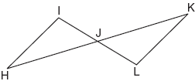
What is the most direct method of proof that could be used to prove
(1) (3)
(2) (4)

Part II

Answer all questions in this part. Each correct answer will receive 2 credits. Clearly indicate the necessary steps, including appropriate formula substitutions, diagrams, graphs, charts, etc. For all questions in this part, a correct numerical answer with no work shown will receive only 1 credit.

The projected total annual profits, in dollars, for the Nutyme Clothing Company from 2002 to 2004 can be approximated by the model $\sum_{n=0}^{2}{(\text{13},\text{567}n+\text{294}),}$ where n is the year and $n=0$ represents 2002. Use this model to find the company’s projected total annual profits, in dollars, for the period 2002 to 2004.

Solve algebraically for x:

Find all values of k such that the equation has imaginary roots.

In the accompanying diagram of square ABCD, F is the midpoint of , G is the midpoint of , H is the midpoint of , and E is the midpoint of .
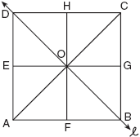
Find the image of after it is reflected in line .
Is this isometry direct or opposite? Explain your answer.

Given:
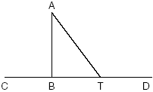
Write an indirect proof to show that is not perpendicular to .

The equation relates speed of sound, V, in meters per second, to air temperature, C, in degrees Celsius. What is the temperature, in degrees Celsius, when the speed of sound is 320 meters per second? [The use of the accompanying grid is optional.]


Part III

Answer all questions in this part. Each correct answer will receive 4 credits. Clearly indicate the necessary steps, including appropriate formula substitutions, diagrams, graphs, charts, etc. For all questions in this part, a correct numerical answer with no work shown will receive only 1 credit.

Navigators aboard ships and airplanes use nautical miles to measure distance. The length of a nautical mile varies with latitude. The length of a nautical mile, L, in feet, on the latitude line is given by the formula .
Find, to the nearest degree, the angle at which the length of a nautical mile is approximately 6,076 feet.

Two equal forces act on a body at an angle of 80°. If the resultant force is 100 newtons, find the value of one of the two equal forces, to the nearest hundredth of a newton.

Solve for x and express your answer in simplest radical form:

A baseball player throws a ball from the outfield toward home plate. The ball’s height above the ground is modeled by the equation where y represents height, in feet, and x represents time, in seconds. The ball is initially thrown from a height of 6 feet.
How many seconds after the ball is thrown will it again be 6 feet above the ground?
What is the maximum height, in feet, that the ball reaches? [The use of the accompanying grid is optional.]


An archaeologist can determine the approximate age of certain ancient specimens by measuring the amount of carbon-14, a radioactive substance, contained in the specimen. The formula used to determine the age of a specimen is where A is the amount of carbon-14 that a specimen contains, is the original amount of carbon-14, t is time, in years, and 5760 is the half-life of carbon-14.
A specimen that originally contained 120 milligrams of carbon-14 now contains 100 milligrams of this substance. What is the age of the specimen, to the nearest hundred years?

Mrs. Ramírez is a real estate broker. Last month, the sale prices of homes in her area approximated a normal distribution with a mean of $150,000 and a standard deviation of $25,000.
A house had a sale price of $175,000. What is the percentile rank of its sale price, to the nearest whole number? Explain what that percentile means.
Mrs. Ramírez told a customer that most of the houses sold last month had selling prices between $125,000 and $175,000. Explain why she is correct.

Part IV

Answer all questions in this part. Each correct answer will receive 6 credits. Clearly indicate the necessary steps, including appropriate formula substitutions, diagrams, graphs, charts, etc. For all questions in this part, a correct numerical answer with no work shown will receive only 1 credit.

The accompanying diagram shows a circular machine part that has rods and attached at points T, A, and R, which are located on the circle; RA = 12 centimeters; and PA = 5 centimeters.
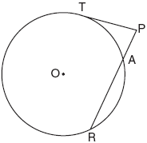
Find the measure of , in degrees, and find the length of rod , to the nearest tenth of a centimeter.

A surveyor is mapping a triangular plot of land. He measures two of the sides and the angle formed by these two sides and finds that the lengths are 400 yards and 200 yards and the included angle is 50°.
What is the measure of the third side of the plot of land, to the nearest yard?
What is the area of this plot of land, to the nearest square yard?

