Part I

Answer all questions in this part. Each correct answer will receive 2 credits. No partial credit will be allowed. For each question, write on the separate answer sheet the numeral preceding the word or expression that best completes the statement or answers the question.

For which value of x is y = log x undefined?
(1) (3)
(2) (4)

If sin > 0 and sec < 0, in which quadrant does the terminal side of angle lie?
(1) I (3) III
(2) II (4) IV

What is the value of x in the equation ?
(1) (3)
(2) (4)

The relationship between voltage, E, current, I, and resistance, Z, is given by the equation E = IZ. If a circuit has a current I = 3 + 2i and a resistance Z = 2 – i, what is the voltage of this circuit?
(1) 8 + i (3) 4 + i
(2) 8 + 7i (4) 4 – i

Which expression is equivalent to ?
(1) (3)
(2) (4)

What are the coordinates of point P, the image of point (3,–4) after a reflection in the line y = x?
(1) (3,4) (3) (4,–3)
(2) (–3,4) (4) (–4,3)

The roots of the equation are real, rational, and equal when a has a value of
(1) 1 (3) 3
(2) 2 (4) 4
Two objects are centimeters apart. A message from one object travels to the other at a rate of centimeters per second. How many seconds does it take the message to travel from one object to the other?
(1) (3)
(2) (4)

If f(x) = cos x, which graph represents f(x) under the composition ?
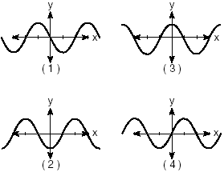

Which diagram represents a relation in which each member of the domain corresponds to only one member of its range?
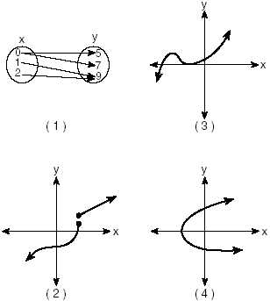
The accompanying diagram represents the elliptical path of a ride at an amusement park.
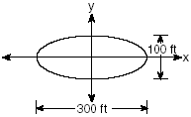
Which equation represents this path?
(1) (3)
(2) (4)

If A and B are positive acute angles, sin A =, and cos B = , what is the value of sin (A + B)?
(1) (3)
(2) (4)

Which transformation is an opposite isometry?
(1) dilation (3) rotation of 90°
(2) line reflection (4) translation

Which equation is represented by the accompanying graph?
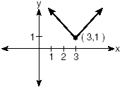
(1) (3)
(2) $y=(x−3)^{2}+1$ (4)

What is the value of ?
(1) (3)
(2) (4)

If log a = 2 and log b = 3, what is the numerical value of ?
(1) 8 (3) 25
(2) –8 (4) –25
In simplest form, is equal to
(1) (3)
(2) (4)

What is the solution set of the inequality
(1) $\left\{x|\frac{7}{2}≤x≤−\frac{1}{2}\right\}$ (3) $\left\{x|x≤−\frac{1}{2} \text{or} x≥\frac{7}{2}\right\}$
(2) $\left\{x|−\frac{1}{2}≤x≤\frac{7}{2}\right\}$ (4) $\left\{x|x≤\frac{7}{2} \text{or} x≥−\frac{1}{2}\right\}$

What value of x in the interval satisfies the equation
(1) –30° (3) 60°
(2) 30° (4) 150°

In the accompanying diagram, , , , , and .
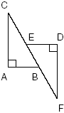
Which statement would not be used to prove
(1) (3)
(2) (4)

Part II

Answer all questions in this part. Each correct answer will receive 2 credits. Clearly indicate the necessary steps, including appropriate formula substitutions, diagrams, graphs, charts, etc. For all questions in this part, a correct numerical answer with no work shown will receive only 1 credit.

Vanessa throws a tennis ball in the air. The function represents the distance, in feet, that the ball is from the ground at any time t. At what time, to the nearest tenth of a second, is the ball at its maximum height?

If and , determine the value of

When air is pumped into an automobile tire, the pressure is inversely proportional to the volume. If the pressure is 35 pounds when the volume is 120 cubic inches, what is the pressure, in pounds, when the volume is 140 cubic inches?

In a certain school district, the ages of all new teachers hired during the last 5 years are normally distributed. Within this curve, 95.4% of the ages, centered about the mean, are between 24.6 and 37.4 years. Find the mean age and the standard deviation of the data.

Express the following rational expression in simplest form:

Evaluate:

Part III

Answer all questions in this part. Each correct answer will receive 4 credits. Clearly indicate the necessary steps, including appropriate formula substitutions, diagrams, graphs, charts, etc. For all questions in this part, a correct numerical answer with no work shown will receive only 1 credit.

The coordinates of quadrilateral ABCD are A(–1,–5), B(8,2), C(11,13), and D(2,6). Using coordinate geometry, prove that quadrilateral ABCD is a rhombus. [The use of the grid is optional.]


The price of a stock, A(x), over a 12-month period decreased and then increased according to the equation , where x equals the number of months. The price of another stock, B(x), increased according to the equation over the same 12-month period. Graph and label both equations on the accompanying grid. State all prices, to the nearest dollar, when both stock values were the same.


A pair of figure skaters graphed part of their routine on a grid. The male skater’s path is represented by the equation , and the female skater’s path is represented by the equation . On the accompanying grid, sketch both paths and state how many times the paths of the skaters intersect between and .


Sean invests $10,000 at an annual rate of 5% compounded continuously, according to the formula , where A is the amount, P is the principal, e = 2.718, r is the rate of interest, and t is time, in years.
Determine, to the nearest dollar, the amount of money he will have after 2 years.
Determine how many years, to the nearest year, it will take for his initial investment to double.

On any given day, the probability that the entire Watson family eats dinner together is . Find the probability that, during any 7-day period, the Watsons eat dinner together at least six times.

While sailing a boat offshore, Donna sees a lighthouse and calculates that the angle of elevation to the top of the lighthouse is 3°, as shown in the accompanying diagram. When she sails her boat 700 feet closer to the lighthouse, she finds that the angle of elevation is now 5°. How tall, to the nearest tenth of a foot, is the lighthouse?
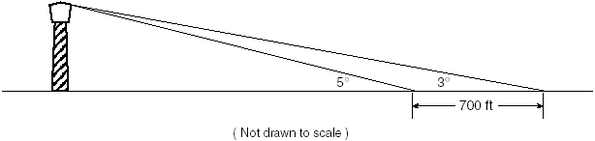

Part IV

Answer all questions in this part. Each correct answer will receive 6 credits. Clearly indicate the necessary steps, including appropriate formula substitutions, diagrams, graphs, charts, etc. For all questions in this part, a correct numerical answer with no work shown will receive only 1 credit.

A farmer has determined that a crop of strawberries yields a yearly profit of $1.50 per square yard. If strawberries are planted on a triangular piece of land whose sides are 50 yards, 75 yards, and 100 yards, how much profit, to the nearest hundred dollars, would the farmer expect to make from this piece of land during the next harvest?

For a carnival game, John is painting two circles, V and M, on a square dartboard.
a On the accompanying grid, draw and label circle V, represented by the equation , and circle M, represented by the equation .

b A point, (x,y), is randomly selected such that and . What is the probability that point (x,y) lies outside both circle V and circle M?

